In Response to Rocket Fire, IDF Targets Terror Sites in Gaza
IDF Blog
June 17, 2014
https://web.archive.org/web/20140806024923/http://www.idfblog.com/blog/2014/06/17/response-rocket-fire-idf-targets-terror-sites-gaza-2/

Earlier tonight, a rocket was launched at Israel from the Gaza Strip. In response, an IAF aircraft targeted a terror activity site in the southern Gaza Strip, a weapon manufacturing facility in the northern Gaza Strip and two weapon storage facilities in the central and southern Gaza Strip.
Direct hits were confirmed.
Update, June 19th:
Today alone 5 rockets have been launched at Israeli communities, 2 of which hit the Sha’ar HaNegev Regional Council. In response, an IAF aircraft targeted a terror activity site, a terror infrastructure site and a concealed rocket launcher in the northern Gaza Strip and 2 terror activity sites in the central Gaza Strip.
Direct hits were confirmed.
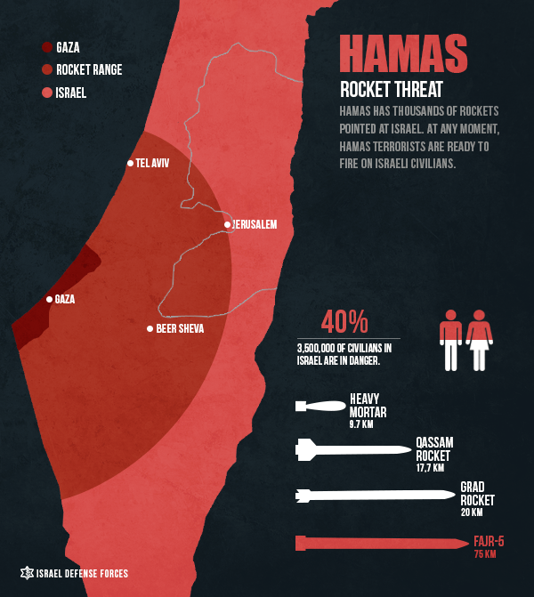

In response to rocket attack earlier tonight, the #IDF tageted a terror activity site & 2 weapons-storages & manufacturing facility in #Gaza
— IDF (@IDFSpokesperson) June 16, 2014

