Israel halts 'weapons shipment from Iran'
BBC News
March 5, 2014
https://www.bbc.com/news/world-middle-east-26451421

Israel says it has seized a ship carrying advanced Iranian weapons made in Syria that was heading towards Gaza.

The Panamanian-flagged vessel was boarded by Israeli naval commandos in the Red Sea off the coast of Sudan, the Israel Defense Forces (IDF) said.

They found M-302 surface-to-surface missiles that were flown to Iran before being loaded onto the ship, it added.

Hamas, the militant Palestinian Islamist movement that governs Gaza, strenuously denied any involvement.

It accused Israel of concocting a story to "justify the blockade" of the coastal territory.

Israel tightly controls its border with Gaza, restricting what is allowed in for what it says are reasons crucial to its security. It also maintains a naval blockade. Egypt blockades Gaza's southern border.

Critics say the blockade is tantamount to collective punishment.

'Unaware of cargo'
Israeli Prime Minister Benjamin Netanyahu said the shipment was a "clandestine operation" by Iran, and added that the weapons would have been used against Israel.

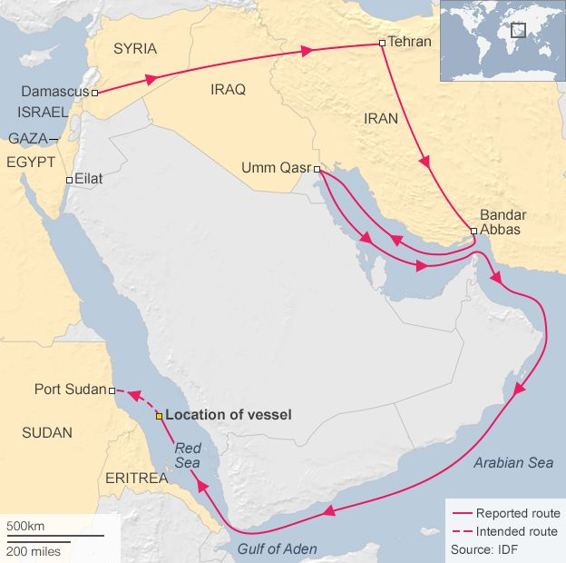

The IDF said it had tracked the weapons for several months as they were flown from Damascus to Tehran and then taken to a port in southern Iran.

From there, it added, they were placed onto a civilian vessel, the KLOS-C, which sailed to Iraq, where containers of cement were added. The ship was eventually intercepted while on its way to Sudan.

The vessel is being brought to the Israeli port of Eilat, where the 17-member crew will be questioned and the weapons unloaded.

IDF spokesman Lt Col Peter Lerner said the crew had appeared to be unaware of their cargo and were not suspects.

The BBC's Yolande Knell in Jerusalem says Israeli television is showing footage of what appear to be commandos inspecting a large rocket in a ship's hold.

The IDF noted that this was not the first ship smuggling arms that it had stopped, but that it was "distinguished by the lethality and quality of its cargo".

News of the rockets being seized comes during the visit of Israel's Prime Minister Benjamin Netanyahu to the US.

He has been pushing for tougher international action against Iran because of its controversial nuclear programme and support for militant groups, our correspondent adds.

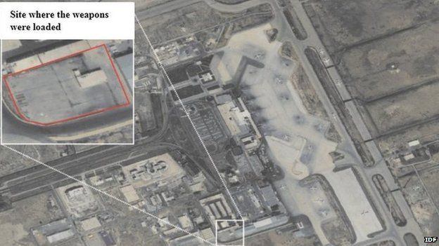

Israel has accused Iran of arming groups such as Hamas and Lebanon's Hezbollah.

More than 60 rockets fired from the Gaza Strip have hit Israel since the start of last year, Israel says.

Hamas denies that it has fired any rockets since a 2012 ceasefire agreement with Israel, with other Gaza-based groups claiming responsibility.

However, Israel says it hold Hamas responsible for any attacks from Gaza and has repeatedly launched air strikes, causing several deaths of militants and civilians.

