Operation Protective Edge: Israel under fire, IDF responds
Israel Ministry of Foreign Affairs
August 26, 2014
https://mfa.gov.il/MFA/ForeignPolicy/Terrorism/Pages/Rise-in-rocket-fire-from-Gaza-3-Jul-2014.aspx

On Tuesday evening, August 26, the Egyptian Foreign Minister announced a ceasefire, which entered into effect at 7 pm.​ Israel has agreed to Egyptian proposal for ceasefire that will be unlimited in time.
Since the start of Operation Protective Edge, 4,562 rockets were fired at Israel from Gaza - 1,042 since the violation of the ceasefire on August 19 - killing seven civilians and wounding 126.
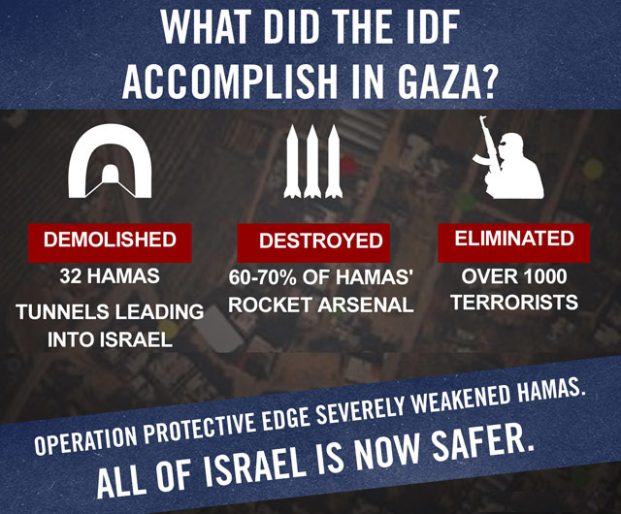
What did the IDF accomplish in Gaza?
Copyright: IDF Spokesperson
August 26
A rocket hit an Ashkelon home Tuesday morning, wounding over 20 people, including six young children.Hamas claimed responsibility for the attack. In the afternoon, a rocket exploded in the playground of a kindergarten in Ashdod.
Shortly before 6:00 pm, Ze'ev Etzion, 55, and Shahar Melamed, 43, of Kibbutz Nirim were killed and four wounded in a mortar attack on the Eshkol region.
On Tuesday evening, the Egyptian Foreign Minister announced a ceasefire, which entered into effect at 7 pm. Until then, rocket alerts sounded throughout Israel's south. Hamas claimed responsibility for a rocket fired towards Tel Aviv.
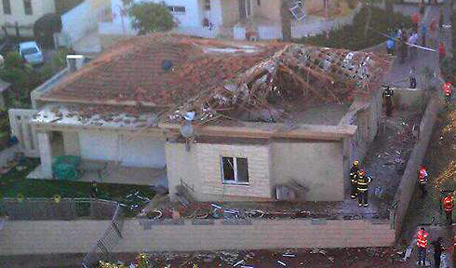
Ashkelon home hit by rocket from Gaza, August 26
Courtesy: IDF Spokesperson
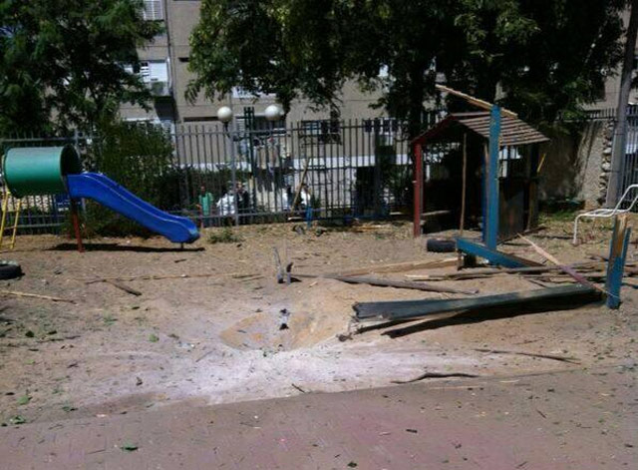
Playground in Ashdod
Photo: Courtesy United Hatzolah
August 25
Again, over 100 rockets were fired at Israeli cities and communities in the south and the Tel Aviv area. Two rockets fired from Lebanon at northern Israel.

August 24
A total of 135 rockets were fired at Israel in the course of the day - over 600 since the violation of the ceasefire on August 19. A rocket launched towards Jerusalem was intercepted.
Three Israeli-Arab taxi drivers waiting to pick up Gazan residents and bring them into Israel for medical treatment were wounded - two seriously - by mortar shells fired at the Erez Crossing as Palestinians from Gaza were entering Israel for medical care, forcing the closing of the crossing. Soldiers evacuated the wounded as mortars continued to fall on the crossing specifically designated for the passage of Palestinians in need of medical and humanitarian assistance.
Overnight, a rocket fired from Lebanon hit a building in the Upper Galilee, injuring two children with shrapnel. Later five rockets fired from Syria, exploding in the Golan Heights.
August 22
6:30 pm - A 4-year-old boy, Daniel Tregerman, was killed in a direct mortar hit outside his home in a kibbutz in the Sha'ar Hanegev area.
4-year-old Daniel Tregerman killed by mortar fire
IDF Spokesperson: The mortar was launched near the Jafar Ali Ibn Taleb school in the Zeitoun neighborhood of Gaza City. The school is currently serving as a shelter for displaced residents of Gaza.
A total of nine civilians were wounded - one critically - in rocket attacks, including a direct hit on an Ashdod synagogue, a Sderot home, near a preschool in Beersheba, and in the Ashdod area.
Sgt. Netanel Maman, 21, critically wounded by a Grad rocket that landed next to his car as he drove with his brother in Gan Yavne on Friday night (Aug 22), died of his wounds on August 29.

Ashdod synagogue damaged by rocket
Copyright: Magen David Adom
August 21
In a rocket barrage directed at a kibbutz in the Eshkol Regional Council, one man suffered serious chest wounds when a rocket exploded in a building that houses 3-year-old children. He had come to celebrate his son's third birthday, and shielded the children with his body.
Israel targeted senior Hamas commanders in Gaza.

August 20
Rocket fire directed at cities and communities in southern Israel continues since 6 am. In the early evening, a rocket was also intercepted over Tel Aviv. According to the IDF Spokesperson, more than 200 rockets have been fired at Israel since Tuesday afternoon.
August 19
At about 3:30 pm, three rockets fired from Gaza hit Beersheva and Netivot, violating the ceasefire.​
The rocket fire on Israel today was a gross violation of the ceasefire. This is the eleventh ceasefire that Hamas has either rejected or violated.
Following the renewed rocket fire, the IDF struck terrorist targets in Gaza.
Israel will not negotiate under fire; the Cairo talks were premised on the cessation of all hostilities. The Israeli negotiating team has been called back from Cairo as a result of today's rocket fire.
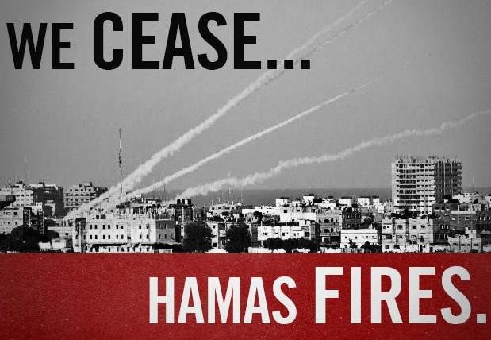

Rockets struck throughout southern Israel, including a shopping center in the Ashkelon coast region, as well as in Tel Aviv and, shortly before midnight, the Jerusalem area.​ A total of 50 rockets were fired from Gaza during the day.
August 18
PM Netanyahu: "The Israeli team in Cairo has been instructed to insist on Israel's security needs and the IDF is prepared for very strong action if fire is resumed."
DM Yaalon: "Operation Protective Edge is not over. As we promised, we will not stop until we bring quiet and security. We are prepared for the results of the discussions in Cairo whether it brings quiet or if someone tries to challenge us with escalation."
August 17
PM Netanyahu at Cabinet meeting: "From the first day, the Israeli delegation to Cairo has worked under clear instructions: Insist on the security needs of the State of Israel. Only if there is a clear response to our security needs will we agree to reach understandings... If Hamas thinks that it can cover up its military loss with a diplomatic achievement, it is mistaken. If Hamas thinks that continued sporadic firing will cause us to make concessions, it is mistaken."
August 14
Despite the firing of eight rockets towards the end of the 72-hour ceasefire at midnight on Wednesday, 13 August, the ceasefire has been extended for five days, until midnight on Monday, 18 August.
August 11
The Kerem Shalom Crossing, closed on Sunday due to rocket fire, was reopened.
August 10
Since the end of the ceasefire (8:01 on Friday, August 8), Hamas has fired over 130 rockets at Israel.
At 12:30pm a barrage of rockets struck inside the Kerem Shalom Crossing through which humanitarian supplies are transfered from Israel to Gaza, forcing its temporary closure until workers can safely operate in the area, and preventing 280 trucks of humanitarian aid, including food and medical supplies, from reaching the people of Gaza.
PM Netanyahu to Cabinet: "Operation Protective Edge is continuing. At no stage did we declare its conclusion. The operation will continue until its goal is met - the restoration of quiet for a long period... Israel will not negotiate under fire and Israel will continue to take all action in order to change the current reality and bring quiet to all of its citizens..."
PM Netanyahu to Pres Rivlin: "We said at the start of the operation that Israel would not negotiate under fire and we have proven that we stand behind these words. Since Hamas violated the ceasefire on Friday, the IDF has struck it very hard. We are determined to achieve the goal of Operation Protective Edge - the restoration of quiet for the residents of Israel for a lengthy period while striking significantly at the terrorist organizations. I said at the beginning of the operation: We will achieve this either militarily or diplomatically, or by a combination of both."
An Egyptian-brokered 72-hour ceasefire came into effect at midnight on Sunday, after Israel said it would not negotiate in Cairo unless the rockets stopped. Minutes before the declared ceasefire, rockets were fired at Beersheba and Tel Aviv, following a day of rocket fire directed at Israel's south.
August 8
Israel agreed to Egypt's call to extend the 72-hour ceasefire. Shortly after 4 am, with the ceasefire still in effect, two rockets struck in open areas near the Eshkol Regional Council.
At 8:01, two rockets were fired towards Ashkelon, marking the renewal of rocket fire from Gaza, as Hamas refused to extend the 72-hour ceasefire.
By 10 am, over 18 rockets were fired from Gaza at Israel: 2 were intercepted over Ashkelon, 14 hit open areas and 2 landed in Gaza.​ At 10:30 rockets were fired at Sderot.
After 2.5 hours of rocket fire from Gaza, PM Netanyahu and DM Yaalon ordered the IDF to respond with force.
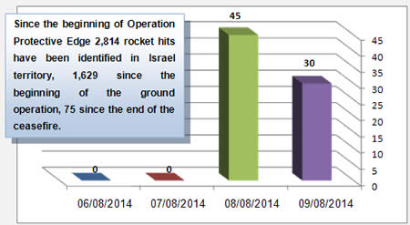
Copyright: ITIC
Lt. Col. Peter Lerner, IDF Spokesman: "The renewed rocket attacks by terrorists at Israel are unacceptable, intolerable and shortsighted. Hamas' bad decision to breach the ceasefire will be pursued by the IDF, we will continue to strike Hamas, its infrastructure, its operatives and restore security for the State of Israel."​
Two people were wounded in Shaar Hanegev when a rocket exploded near a residential building. A home in Sderot was also struck by a rocket. A total of 61 rockets were fired at Israel from Gaza, 13 of them exploding inside Gaza.
August 7
The 72-hour ceasefire between Israel and Hamas is holding as it enters its third day, with no rockets being fired at Israel. All IDF forces have moved out of the Gaza Strip.
During the 29 days of fighting, the IDF forces dealt a significant blow to the terrorist infrastructures of Hamas, the PIJ and the other terrorist organizations in the Gaza Strip. Thirty-two known tunnels used for terrorist purposes were destroyed. During the operation 4,762 terrorist targets were attacked from the air.
A total of 64 IDF soldiers and three civilians were killed, and about 450 soldiers and 80 civilians were wounded.
August 5
MFA Spokesperson: "Israel has notified Egypt that it has agreed to their ceasefire proposal." The 72-hour ceasefire went into effect at 8:00 AM.
IDF Spokesperson: All ground troops will have pulled out of the Gaza Strip by the start of the ceasefire. The IDF will maintain defensive positions near the Gaza border. Israel completed the destruction of 32 cross-border tunnels.
In the last hour before the ceasefire, rocket barrages are fired at Ashdod, Ashkelon, Beersheba, Rishon Lezion, Gush Etzion, Bethlehem and Maale Adumim, east of Jerusalem.
An M-75 rocket fired from Gaza in the minutes before the ceasefire took effect landed near a mosque, striking a home in Beit Sahour, located between Jerusalem and Bethlehem.
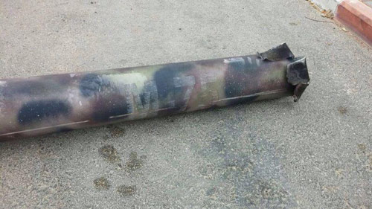
Copyright: IDF Spokesperson
August 4
Israel authorized a humanitarian window to take place in the Gaza Strip from 10:00 AM to 5:00 PM. The IDF will continue to neutralize the Hamas tunnel network and will respond to any attempt to harm Israeli civilians or IDF soldiers.
August 3
IDF Spokesperson: On the evening of Monday, July 28, IDF forces operating in the area of the Karni Crossing engaged terrorists emerging from a terror tunnel inside Israeli territory. Five soldiers were killed. During the operational activity to neutralize the tunnel, IDF forces found a wide array of weaponry, including rocket-propelled grenades, mortars, explosives, launchers, and AK-47 assault rifles. In addition, three motorcycles were found, ready for use, facing the opening of the tunnel into Israeli territory, intended for use in a complex terror attack on Israeli residential communities in close proximity to the Gaza border. (See video below)
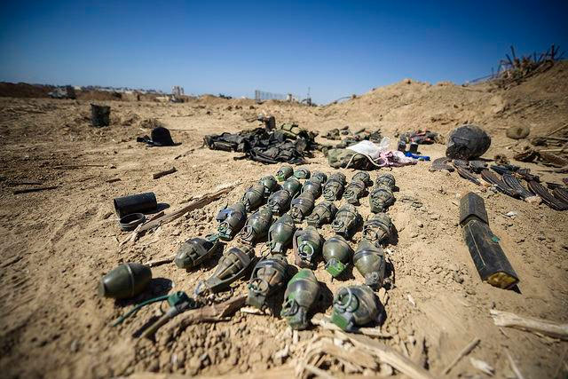
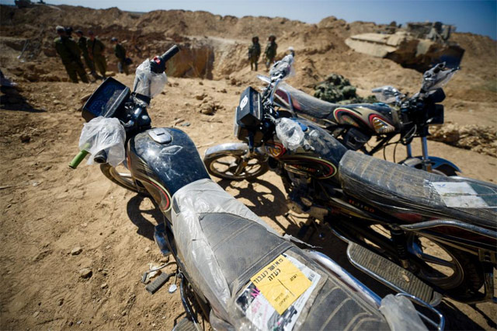
Copyright: IDF Spokesperson
[YOUTUBE LINK: https://youtu.be/3CHt3FxoolI]

August 2
At 11:30 pm, a special committee led by the IDF Chief Rabbi announced the death of Lt. Hadar Goldin, 23, an infantry officer in the Givati Brigade who was killed in battle in the Gaza Strip on Friday.
Over the past 24 hours, the IDF struck 200 terror targets in the Gaza Strip, including tunnels, weapon manufacturing and storage facilities, and command and control centers. Among the targets was a Hamas military wing facility that was used for research and development of weapon manufacturing located within the Islamic University. In addition, weapon caches and Hamas command and training facilities concealed within five Gazan mosques were targeted. IAF aircraft targeted the launcher used to fire at the Tel Aviv area earlier this morning.
Palestinian terrorists fired 11 mortars from the vicinity of an UNRWA school in Zeitoun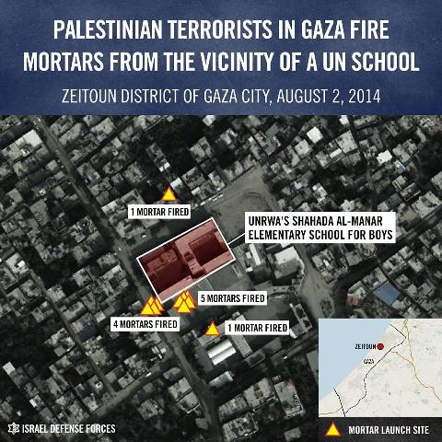

August 1
Hamas fired at IDF forces in southern Gaza at 9:30 this morning in violation of the humanitarian ceasefire. IDF soldier suspected kidnapped. Extensive search underway.
Two IDF soldiers were killed in the suspected kidnapping of 2nd-Lt. Hadar Goldin in Rafah.
- IDF statement
- PM Netanyahu speaks with US Secretary Kerry
Once again, Hamas and the terror organizations in Gaza have violated the ceasefire to which they committed themselves to the UN Secretary-General and US Secretary of State Kerry.
UN special envoy Robert Serry issues statement: He was informed by Israel of "a serious incident this morning" during the truce involving "a tunnel behind IDF lines in the Rafah area of the Gaza Strip." If confirmed, "this would constitute a serious violation of the humanitarian ceasefire in place since 8 am this morning by Gazan militant factions, which should be condemned in the strongest terms."
White House press calls the reported kidnapping of an IDF soldier by Hamas a "barbaric violation of ceasefire agreement" negotiated by the United States and United Nations.
US President Obama: "I have - unequivocally condemned Hamas and the Palestinian factions that were responsible for killing two Israeli soldiers and abducting a third almost minutes after a ceasefire had been announced...
I have been very clear throughout this crisis that Israel has a right to defend itself. No country can tolerate missiles raining down on its cities and people having to rush to bomb shelters every twenty minutes or half hour. No country can or would tolerate tunnels being dug under their land that can be used to launch terrorist attacks...
It's going to be very hard to put a ceasefire back together again if Israelis and the international community can't feel confident that Hamas can follow through on a ceasefire commitment. And it's not particularly relevant whether a particular leader in Hamas ordered this abduction, the point is that when they sign onto a ceasefire, they're claiming to speak for all the Palestinian factions. If they don't have control of them and just moments after a ceasefire's signed you have Israeli soldiers being killed and captured, then it's hard for the Israelis to feel confident that a ceasefire can actually be honored. "
US Secretary Kerry: "The United States condemns in the strongest possible terms today’s attack, which led to the killing of two Israeli soldiers and the apparent abduction of another. It was an outrageous violation of the cease-fire negotiated over the past several days, and of the assurances given to the United States and the United Nations. Hamas, which has security control over the Gaza Strip, must immediately and unconditionally release the missing Israeli soldier... The international community must now redouble its efforts to end the tunnel and rocket attacks by Hamas terrorists on Israel and the suffering and loss of civilian life."
UN Secretary-General Ban Ki-moon: "The Secretary-General condemns in the strongest terms the reported violation by Hamas of the mutually agreed humanitarian ceasefire which commenced this morning. He is shocked and profoundly disappointed by these developments... Such moves call into question the credibility of Hamas' assurances to the United Nations. The Secretary-General demands the immediate and unconditional release of the captured soldier."

1:00am: Israel accepts humanitarian ceasefire
In accordance with the authority granted by the Security Cabinet to the Prime Minister and the Minister of Defense, Israel has accepted the UN/US proposal for a 72-hour humanitarian cease-fire beginning 8:00 am Friday, 1 August 2014.
- Joint statement by UN Secretary-General Ban Ki-moon and US Secretary of State John Kerry on humanitarian ceasefire
7:00-8:00am: Barrage of rocket fire at southern Israel.
10:00am: Despite ceasefire, rockets fired at Gaza periphery, including the Kerem Shalom Crossing for humanitarian aid to Gaza, which was closed due to rocket fire.

July 31
Five IDF soldiers were killed by mortar fire from Gaza near the Gaza border.
IDF soldiers detonated the route of an offensive tunnel in the Gaza Strip. They also uncovered several additional tunnel access points. IAF aircraft targeted a squad of over 5 terrorists planting an explosive device in the southern Gaza Strip. IAF aircraft targeted 40 terror activity sites across the Gaza Strip, among them a tunnel used for terror activity and a weapons manufacturing facility.
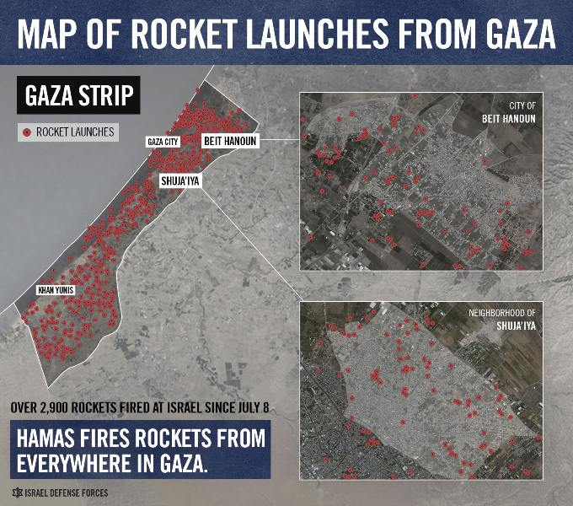
[YOUTUBE LINK: https://youtu.be/aWkjwfkh-qM]
[YOUTUBE LINK: https://youtu.be/7CrOq8gd6kQ]

July 30
Three IDF soldiers were killed while uncovering an offensive tunnel shaft in a residence in the southern Gaza Strip. The house and the tunnel were booby-trapped with explosive devices that were detonated against the soldiers.
The IDF authorized a temporary humanitarian window in the Gaza Strip today between 15:00-19:00, which did not apply to the areas in which IDF soldiers were operating. During these four hours, 26 rockets were fired at Israel, two of which were intercepted over Ashkelon and Netivot.
In the past 24 hours, IDF infantry and engineering forces detonated three tunnel routes in the Gaza Strip. Since midnight, the IDF targeted over 75 terror sites in Gaza. Overnight, the IAF targeted five mosques which were utilized for terror purposes, such as concealing weapons and housing tunnel access shafts.
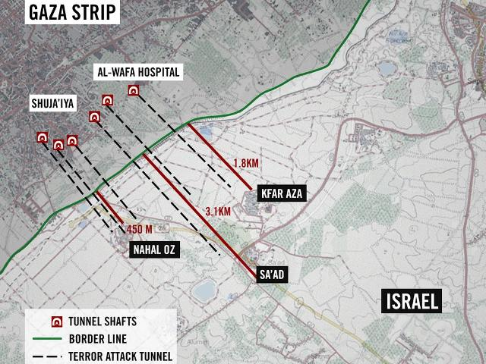
July 29
Overnight, the IDF targeted over 70 terror sites throughout the Gaza Strip, including two sites used as Hamas command and control centers, four weapon storage sites concealed within mosques, a concealed rocket launcher near a mosque and an offensive tunnel.
In the early hours of the morning, infrastructure of the treasury wing of Hamas used to fund and manage Hamas' terror activities was targeted in Gaza City.
The IDF also targeted the Al-Aqsa broadcastingstation used to incite Palestinians against Israel, to transmit orders and messages to Hamas terrorists, and to instruct Gaza residents to ignore IDF warnings regarding upcoming military activity in specific areas.
8:00pm: UNRWA announced it has found another rocket arsenal at one of its schools in the central Gaza Strip.
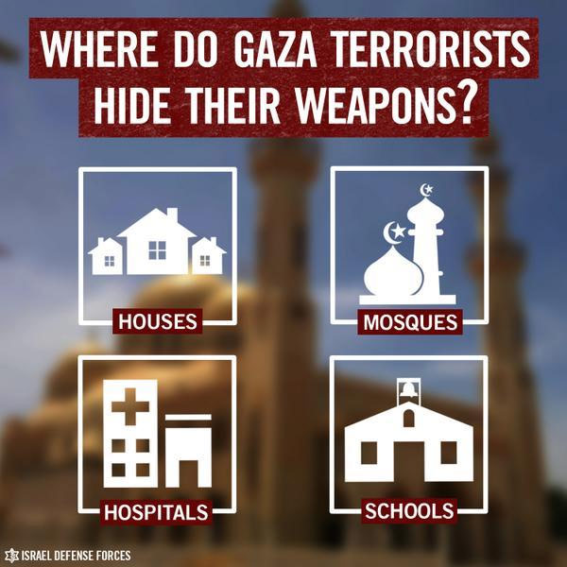

July 28
Despite requested humanitarian ceasefire, one rocket was fired at Ashkelon (7:30am) and six at communities near the border with the Gaza Strip (2pm). The IDF returned fire at rocket launchers.
Four IDF soldiers were killed and six wounded in a mortar attack on an army staging area in the Eshkol regional council, near the Gaza Strip. Hamas claims responsibility for the attack.
IDF thwarted attempt by terrorists from Gaza to infiltrate Israel near Kibbutz Nahal Oz. A squad of Hamas terrorists emerged from a tunnel 150 meters inside Israel and opened fire on an an army position, killing five soldiers. The soldiers in the lookout tower opened fire, killing at least one of the terrorists, who failed to carry out a planned abduction.
IDF denies involvement in the blast at Shifa Hospital in the Gaza Strip on Monday afternoon: "Al-Shifa Hospital and Al-Shati Refugee Camp were struck by failed rocket attacks launched by Gaza terrorists."
News report: The Hamas Fajr-5 rocket aimed at central Israel which was fired from a playground outside Shifa Hospital and exploded on the site causing casualties, had at least a 100 kg (220 lbs) warhead. IDF places responsibility on Islamic Jihad.
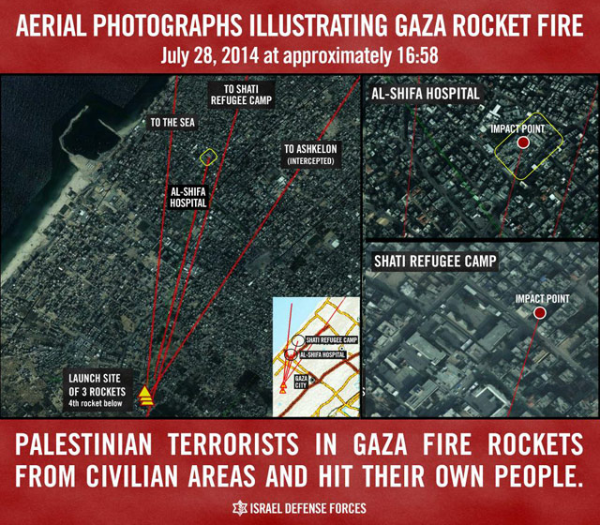

July 27
Despite Hamas’ fire, Israel decided to extend the humanitarian ceasefire a second time, until midnight Sunday night (27 July). In face of the continued Hamas fire at Israeli cities and civilians, the IDF resumed aerial, naval and ground activity in Gaza at 10:00 am. Hamas then asked for a ceasefire which it itself continued to violate by continuing to fire rockets at Israeli cities.
July 26
IDF Spokesman: "From 8:00 AM to 8:00 PM, there will be a humanitarian window in Gaza. During this time, operational activities to locate and neutralize terror tunnels will continue. The IDF will respond if terrorists exploit the lull to fire at Israeli soldiers or civilians."
Israel respected the UN-requested humanitarian ceasefire from 8 am to 8 pm and was ready to prolong it, but a few minutes after 8 pm Hamas resumed the rocket barrage at Israel's cities.
July 25
At noon on Friday, terrorists fired mortars and anti-tank missiles from near an UNRWA school in Gaza, killing an IDF soldier. Another soldier was killed Friday morning during fighting in the northern Gaza Strip.
IDF destroys rocket launchers ready for firing near two schools and a mosque in the Gaza Strip.

July 23
A Thai agricultural worker was killed by a mortar fired from Gaza while working in a greenhouse in one of the Israeli communities in the Ashkelon Coast Regional Council.
Hamas terrorists have turned Wafa Hospital in Gaza into a command center and a rocket-launching site. The IDF is targeting specific sites and terrorists within the grounds of the hospital, from which Hamas continues to fire at our forces. The IDF repeatedly conveyed warnings to the hospital staff and urged civilians to leave the area in advance. Hamas is telling them to stay.
IDF Spokesman Peter Lerner: "Hamas terrorists have been intentionally abusing the hospital and other international protected symbols to indiscriminately attack Israel and its civilians. The IDF is determined in preventing the ongoing aggression by Hamas that is directed by a strategy of exploitation and abuse of the civilian population and its wellbeing.”
Three Paratroopers were killed in Gaza.
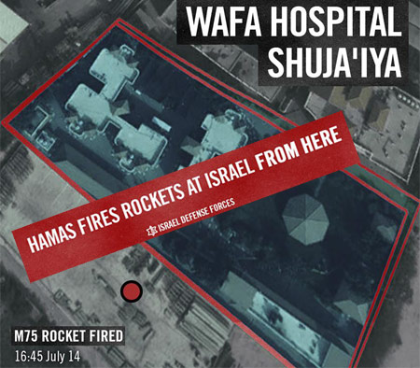

July 21: Terror infiltration from northern Gaza
Four IDF soldiers were killed early in the morning by a rocket-propelled grenade, fired by Hamas gunmen who emerged from a tunnel dug from Gaza into Israel near Kibbutz Nir Am. The Hamas cell, clad in IDF uniforms, emerged from the tunnel, and waited for an approaching IDF jeep before opening fire, killing the IDF officer and the three soldiers in the vehicle.
Five more were killed fighting terrorists in Gaza.
The tunnel infiltration involved two groups of Hamas gunmen. The second cell emerged near Erez, on Israeli territory. Surveillance soldiers spotted the infiltrators and summoned an aircraft to the area. The aircraft opened fire, killing the gunmen.
July 20: 13 Israeli soldiers of the Golani Brigade were killed overnight in the course of the IDF operation in Gaza.
In the first incident, terrorists detonated an explosive device on an armored vehicle, causing the death of seven soldiers.
In the second attack, terrorists opened fire at two IDF soldiers in the northern Gaza Strip, killing one. Later, IDF soldiers were attacked by a terrorist squad in northern Gaza, leading to the death of two soldiers. Lastly, three IDF soldiers lost their lives when they became trapped in a burning building.
Israel agrees to humanitarian window
Israel agreed to the Red Cross request for a humanitarian window in Sejaiya and will hold fire there from 13:30-15:30. Since July 8, Hamas has fired over 140 rockets at Israel from Sejaiya, and 10 tunnel openings have been uncovered.
IDF: Although we agreed to the Red Cross' request to extend the a ceasefire in Sejaiya until 17:30, Hamas has not stopped shooting from Sejaiya and opened fire from near Wafa Hospital.
Israel opened a field hospital on the Israeli side of the Erez Crossing for Palestinians in Gaza.
July 19: Terror infiltration from central Gaza
Two IDF soldiers were killed when Hamas terrorists infiltrated Israeli territory through a tunnel from the central Gaza Strip and ambushed a military vehicle patrolling on the Israeli side of the border.
Items found after the attack, including handcuffs and bottles containing sedatives, indicate that Hamas planned to kill and kidnap soldiers and/or civilians and take them back to Gaza.
The IDF has uncovered 13 tunnels and over 30 tunnel entrances.
July 17: Terror tunnel
Early Thursday morning (July 17), just a few hours before the start of a humanitarian ceasefire, IDF forces thwarted an attack by Hamas terrorists who attempted to infiltrate Israel via a terror tunnel, preventing the terrorists from attacking an Israeli kibbutz.
"Humanitarian window"
Following requests by representatives of the UN and other international organizations on Wednesday evening (July 16, 2014), the IDF has declared a "humanitarian window" in Gaza on Thursday, 17 July between 10:00-15:00. The purpose of the humanitarian window is to allow the civilian population in Gaza to get needed supplies such as food and medications. During this time the IDF will not initiate military actions in Gaza, but will respond in case Israel is attacked.
July 15: Egyptian ceasefire proposal
Israel accepted an earlier Egyptian proposal for a ceasefire to begin on Tuesday morning, 15 July 2014, at 09:00. This proposal was rejected by Hamas.
- PM Netanyahu: "If Hamas rejects the Egyptian proposal, and the rocket fire from Gaza does not cease, and that appears to be the case now, we are prepared to continue and intensify our operation to protect our people. For this we have kept full support from the responsible members of the international community."
- IDF Spokesman Lt. Col. Peter Lerner: “In according with the government directives, the IDF now holds fire. We remain alert and preserve high preparedness levels, both defensive and offensive. If the Hamas terror organization will fire at Israel, we shall respond.”
Five hours later, following the continuation of rocket fire from Gaza, PM Netanyahu said: "Hamas's rejection of the cease fire gives Israel full legitimacy to expand the operation to protect our people."
At 3pm the IDF Spokesperson announced: “After six hours of unilateral attacks by Hamas, the IDF has resumed operational activity in the Gaza Strip. Since 9am Tuesday, about 50 rockets were fired at Israel.” The IDF struck at Hamas tunnels, 20 concealed rocket launchers, weapons storage facilities and other operational infrastructure.

July 14
During the course of the day, at keast 115 rockets were fired from Gaza towards Israel, of which at least 92 rockets struck Israel and 15 were intercepted by the Iron Dome missile defense system.
July 13
During the course of the day, at least 102 rockets struck Israel and 22 were intercepted by the Iron Dome missile defense system.
Shortly after 6 am, Code Red sirens sounded across central and southern Israel: Rehovot, Rishon LeZion, Modi'in, Ashdod, Lod, Ashkelon, Ramle, and Ben Gurion Airport. Later, a 16-year-old boy was seriously wounded and a 50-year-old man was lightly injured by a rocket blast in Ashkelon.
July 12
During the course of the day, at least 129 rockets were fired from Gaza towards Israel, of which at least 117 rockets struck Israel and 9 were intercepted by the Iron Dome missile defense system.
July 11
During the course of the day, more than 140 rockets were fired from Gaza towards Israel, of which at least 107 rockets struck Israel and 27 were intercepted by the Iron Dome missile defense system.
July 10
Palestinian terrorists in Gaza fired 192 rockets at Israel on Thursday, July 10. 141 of them hit Israel, and an additional 44 were intercepted by Iron Dome.
July 8 - IDF commences Operation Protective Edge against Hamas
Since June 12, southern Israel has been the target of ever-increasing rocket and other terrorist attacks from the Gaza Strip, aimed deliberately at civilian targets.

Cabinet approves ground operation - July 17
PM Netanyahu and DM Yaalon (17 July 2014) instructed the IDF to commence ground action to strike at the terrorist tunnels from the Gaza Strip into Israeli territory.
- The cabinet approved the ground operation after Israel agreed to the Egyptian cease-fire proposal and Hamas rejected it and continued to fire rockets on Israel's cities. Hamas also violated the UN-requested humanitarian cease-fire by continuing to fire on Israel.
- Israel will defend its citizens in response to Hamas's unceasing aggression and infiltrations into Israeli territory, as it did Thursday morning when Hamas terrorists crossed into Israel via one of the tunnels with the goal of carrying out a mass casualty attack against Israeli civilians.
- Operation Protective Edge will continue until its goals are reached - restoring sustained peace and quiet to the citizens of Israel, while striking hard at the terrorist infrastructure of Hamas and the other Palestinian terrorist groups in Gaza.
- Israel is doing everything it can to avoid civilian casualties. By contrast, Hamas is using Palestinian civilians as human shields and is responsible for any harm that comes to them. To give but one example, the UN announced today that Hamas had hidden rockets in an UNRWA school in Gaza.
- The international community has recognized that Israel has made significant efforts to restore peace and quiet and that it has the right to defend itself.

* * *
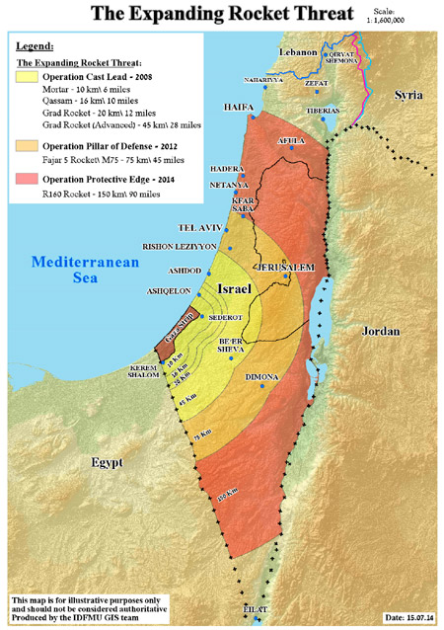

Daily distribution of rocket fire from the Gaza Strip during Operation Protective Edge
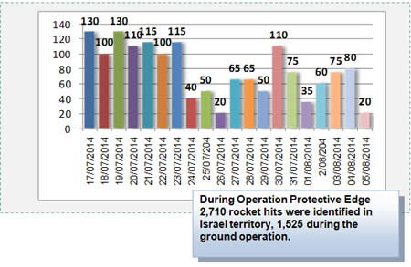
Source: ITIC
Note: Rocket hits inside Israeli territory, not including the massive mortar shell fire into the western Negev or rocket launches that failed.

Some of the rockets fired from Gaza have fallen within the Gaza Strip.
Hamas fires from civilian areas... and hits its own people.

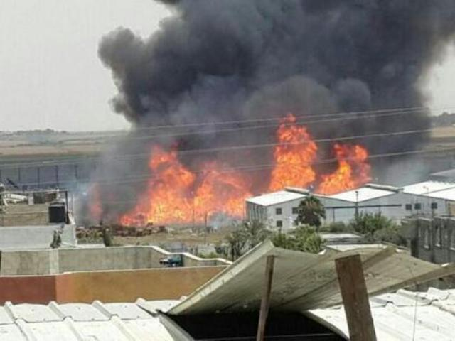
A rocket fired from Gaza fell short and exploded at the UNRWA warehouses causing a massive fire
Copyright: IDF Spokesperson
On Sunday, July 13, a rocket fired from Gaza hit electricity infrastructure in Israel that supplied power to Gaza, cutting power to about 70,000 people in Gaza.
On July 16, two out of the ten high-power lines that Israel uses to provide electricity to Gaza were again hit by Hamas rockets. The Israeli Electricity Corporation (IEC), which provides power to Gaza, will not be able to repair the two lines due to the immediate threat to the lives of its technicians when doing repairs in open areas subject to frequent rocket attacks.

Background
Since the beginning of the year, until the launching of Operation Protective Edge, Gaza terrorists fired more than 450 rockets towards Israeli citizens. The attacks sent thousands running into bomb shelters, threatening millions of Israeli lives. In order to restore quiet to the region and stop Hamas terrorism, the IDF has commenced Operation Protective Edge.
Since Operation Pillar of Defense in November 2012, Hamas has continued to arm itself with vast amounts of weaponry and is currently in possession of 10,000 rockets. Hamas deliberately and systematically exploits Palestinians and uses them as human shields when firing at Israel. With the increased range of rockets, some 6 million Israelis are currently living under the threat of rocket attacks. No nation would accept this reality.
Although Israel's Iron Dome Missile Defense system stops some of the attacks, most rockets are capable of reaching Israel’s biggest cities. More than half a million Israelis have less than 60 seconds to find shelter after a rocket is launched from Gaza into Israel. Many have only 15 seconds.
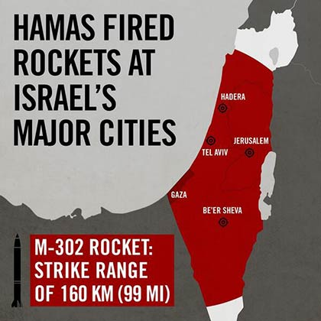
Monday, June 30 saw a sharp escalation in rocket fire, with the intensification in attacks beginning in the morning, prior to the discovery of the boys' bodies. That day, Hamas itself fired rockets.
These rockets have injured Israelis, damaged cars, homes and property. On Thursday morning (3 July) a rocket hit a nursery school and rockets burned two factories in Sderot to the ground (28 June).
In addition to the rocket attacks, Palestinians have carried out cross-border attacks from Gaza. A terrorist armed with a grenade infiltrated an Israeli village (22 June) and Israeli forces were attacked on 28 and 29 June.
Hamas controls the Gaza Strip since 2007 and bears responsibility for the rocket attacks.

