Looking for the Enduring Photo in Gaza
By: James Estrin
New York Times
August 5, 2014
https://lens.blogs.nytimes.com/2014/08/05/looking-for-the-enduring-photo-in-gaza/?_php=true&_type=blogs&smid=tw-share&_r=0

Tyler Hicks, a New York Times staff photographer, covered Gaza during the first two weeks of the current conflict. He spoke about that experience in a phone interview with James Estrin. The conversation has been edited.
Mr. Hicks won the Pulitzer Prize for Breaking News Photography in 2014 for his coverage of the massacre at the Westgate Mall in Nairobi, Kenya. He was also a member of the team that won the Pulitzer Prize for International Reporting in 2009 for coverage of Afghanistan and Pakistan.

Q.
When did you arrive in Gaza, and what was it like to cover this conflict?
A.
I arrived in Gaza City at the very beginning of the conflict, and I was there for two weeks. The last time I had been there was two years ago and in a very similar circumstance, but one that was resolved after only a week of fighting. I was hoping that would be the case this time around, but as we have seen, this time it has been much more intense with more casualties and a much more prolonged campaign.
My memories of the civilian casualties from two years ago are still fresh, but that experience could not prepare me for the civilian casualties in this current crisis. Obviously, when you are covering a war, you are with one side or the other. It is very difficult to try to cover both sides.
I was stationed in Gaza, and covered the Palestinian side of the war where you saw most of the casualties. One of the reasons for that is because the Hamas fighters are living among the civilian population. Where you have a separate army that is fighting from a front line, it is easy to differentiate between soldiers and civilians.
Photo
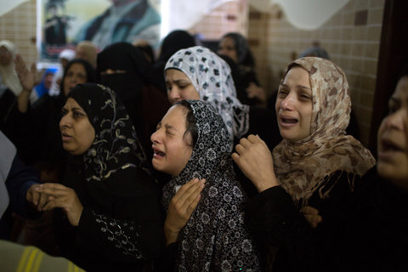
Palestinians in Gaza City prepared to bury a member of Hamas. July 12, 2014.Credit Tyler Hicks/The New York Times
This is a situation where the fighters fire rockets from all over the Gaza Strip, from neighborhoods to cemeteries, from parking lots, from any number of places. They move quickly and then retaliation often comes quickly from Israel. That retaliation can be very severe, hitting residential neighborhoods, homes, killing and injuring scores of women and children.
Q.
We have many photos of the casualties and destruction in Gaza. Why don’t we have many photos of Hamas fighters or missiles?
A.
This is a war fought largely behind the scenes. Hamas fighters are not able to expose themselves. If they were to even step a foot on the street they would be spotted by an Israeli drone and immediately blown up. We don’t see those fighters. They are operating out of buildings and homes and at night. They are moving around very carefully. You don’t see any signs of authority on the streets. If you can imagine every police officer, every person of authority in America gone, this is what that would look like.
If we had access to them, we would be photographing them. I never saw a single device for launching the rockets to Israel. It’s as if they don’t exist.
Sometimes people assume that you can have access to everything, that you can see everything. But the fighters are virtually invisible to us. What we do as photographers is document what we can to show that side of the war. There are funerals, there are people being rushed to the hospital, but you can’t differentiate the fighters from the civilians. They are not wearing uniforms. If there is someone coming into the hospital injured, you can’t tell if that’s just a shopkeeper or if this is someone who just fired a rocket towards Israel. It’s impossible to know who’s who. We tried to cover this as objectively as possible.
Q.
Who were you working with when you were in Gaza?
A.
I was working with a driver who I had also worked with a few years ago, and who I trust and who has the skills to get to these scenes quickly. It’s all about getting information quickly and getting there quickly.
Our routine is that he could come and meet me in my hotel as early as possible. But early mornings tend to be the most dangerous places to move around, because there is no one driving around at that time. However, there are a lot of Israeli drones and jets overhead. Being the only moving car on the ground means you are the only moving target on the ground. This is a major concern.
The reasons for going out early is because a lot of the bombs happen overnight, so it’s important to get out to these areas at first light to see the destruction and to get it out to the public. You have to balance this.
Photo
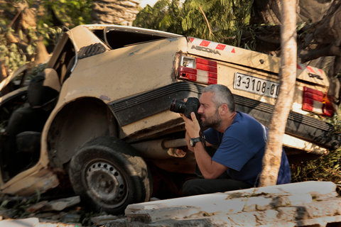
The New York Times photographer Tyler Hicks in Gaza, 2014.Credit Carolyn Cole
Q.
This is your third Gaza conflict. And you also covered the Israeli war in Lebanon. Does it feel like you’re likely to be back?
A.
Unfortunately, it does feel like I will be back there again. This current conflict, more than any, has proven how little negotiating room there is. I have lost count of how many cease-fires there have been that have fallen apart or never even taken affect.
Q
You’ve talked about how important it is to remember what you witnessed and not to forget. Why is that important?
A.
Any time I cover something as intense as what I’ve seen in Gaza, there is a single event that really stays, that is burned into your memory. You can go for weeks or longer of seeing horrible scenes everyday, but there will be one that really stays with you. In this case it was when four young boys were killed on the beach (slide 8).
I was in my room in a modest hotel in Gaza City when I heard a loud explosion near the window. I looked outside and saw terrified children running away from the explosion.
Just as I was grabbing my protective clothing and helmet, a second explosion came again. I could see that the very children I had seen running away from that initial explosion were now dead on the beach. To see young boys running for their lives and then a moment later they’re dead is something I will never forget.
Normally we arrive after the fact to see the aftermath. In this case it was unfolding in front of me.
Q.
What did you accomplish while you were there?
A.
I try to take photos that are going to bring recognition to a situation that needs attention. There are a lot of photographers in Gaza. There are very talented local Palestinian photographers who have grown up with these conflicts. And there is also the foreign press that comes there only when something is going on.
So I ask myself, what contribution am I making as an individual when I show up and there are 10 other photographers on the scene? How are my photos going to make a difference compared to the others’?
Photo
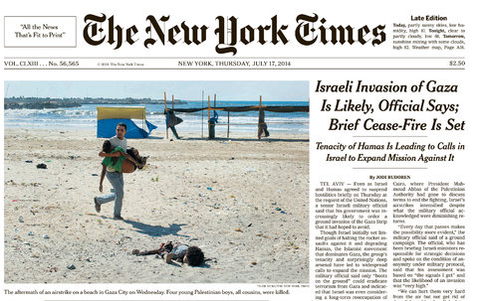
Tyler Hick's photograph of the aftermath of an airstrike on a beach in Gaza City on the front page of The New York Times. July 17, 2014.Credit
My goal is to find that specific image that is going to have a lasting effect. For me it was a man running with a lifeless body of a boy on the beach. That one photograph was my contribution of my two weeks there. It’s like distilling everything down to one photo or one scene that you photograph.
I have spent many years working in Afghanistan throughout the war there. I always felt that if I had spent a month out on patrols with the Americans and I had one day of work — one small set of photographs — that I felt were important, then that was a successful trip.
I try to look at this not in terms of time but what photograph will stay with people. If you look back at even the most famous photographers that have ever lived, there are only a handful of photographs that you can say made a difference, that brought awareness.
Q.
You’ve spent a lot of your professional life in conflict zones.
A.
In some ways the payoff can be very little. It’s a lot of time spent in the field to try to bring that awareness. If I look back at the past decade, I might pick out only 10 pictures that I felt are really important.
There are a lot of photographs that tell pieces of a story, but those really important photos are very rare and are what we strive for. There’s a lot of patience and a lot of work involved in it. People often ask me how is it that you are always in a place where bad things are happening. The answer is just time. You spend a lot of time working and being there and eventually you will get the opportunity to document something that will have a lasting impression.
Photo
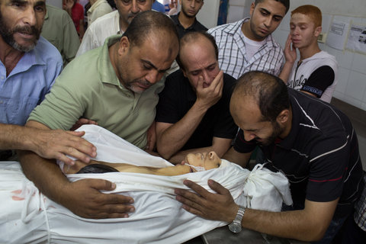
Grief engulfed the family of a victim in Gaza City. July 18, 2014.Credit Tyler Hicks/The New York Times

