Contents
October 7 1
UN Secretary-General Antonio Guterres 1
UN Special Coordinator For The Middle East Peace Process, Tor Wennesland 3
UN High Commissioner for Human Rights Volker Türk 4
UN Special Rapporteur for the Situation of Human Rights in the Occupied Palestinian Territories Francesca Albanese 6
UN Committee on the Exercise of the Inalienable Rights of the Palestinian People 9
UN General Assembly President Dennis Francis (Trinidad and Tobago) 10
UNRWA 11
Executive Director of UN Women Sima Bahous 13
UNICEF 13
OCHA 14

October 7

UN Secretary-General Antonio Guterres
11:05 AM · Oct 7, 2023
07 October 2023
Statement attributable to the Spokesperson for the Secretary-General - regarding the situation in the Middle East

Stéphane Dujarric, Spokesman for the Secretary-General

https://www.un.org/sg/en/content/sg/statement/2023-10-07/statement-attributable-the-spokesperson-for-the-secretary-general-regarding-the-situation-the-middle-east
The Secretary-General condemns in the strongest terms this morning’s attack by Hamas against Israeli towns near the Gaza Strip and central Israel, including the firing of thousands of rockets toward Israeli population centers. The attacks have so far claimed numerous Israeli civilian lives and injured many hundreds. The Secretary-General is appalled by reports that civilians have been attacked and abducted from their own homes. The Secretary-General is deeply concerned for the civilian population and urges maximum restraint. Civilians must be respected and protected in accordance with international humanitarian law at all times. The Secretary-General extends his deepest condolences to the families of the victims and calls for the immediate release of all abducted persons. The Secretary-General urges all diplomatic efforts to avoid a wider conflagration. He stresses that violence cannot provide a solution to the conflict, and that only through negotiation leading to a two-state solution can peace be achieved.

https://twitter.com/UN_Spokesperson/status/1710672770894324203

UN Spokesperson

@UN_Spokesperson

UN SG
@antonioguterres
condemns Hamas attacks against #Israel , urges diplomatic efforts to avoid wider conflagration: https://un.org/sg/en/content/sg/statement/2023-10-07/statement-attributable-the-spokesperson-of-the-secretary-general-regarding-the-situation-the-middle-east…
11:05 AM · Oct 7, 2023

**********
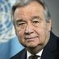

António Guterres

@antonioguterres
https://twitter.com/antonioguterres/status/1710701778864382339
I condemn in the strongest terms this morning’s attack by Hamas against Israeli towns. I urge all diplomatic efforts to avoid a wider conflagration. https://un.org/sg/en/content/sg/statement/2023-10-07/statement-attributable-the-spokesperson-of-the-secretary-general-regarding-the-situation-the-middle-east…
1:01 PM · Oct 7, 2023
·
641.1K
Views
*************
******
5:00 AM · Oct 7, 2023

UN Special Coordinator For The Middle East Peace Process, Tor Wennesland
STATEMENT BY UN SPECIAL COORDINATOR FOR THE MIDDLE EAST PEACE PROCESS, TOR WENNESLAND, ON THE SITUATION IN ISRAEL AND THE OCCUPIED PALESTINIAN TERRITORY
https://unsco.unmissions.org/statement-un-special-coordinator-middle-east-peace-process-tor-wennesland-situation-israel-and
“I vehemently condemn this morning’s multi-front assault against Israeli towns and cities near the Gaza Strip, and barrage of rockets reaching across central Israel by Hamas militants.
These events have resulted in horrific scenes of violence and many Israeli fatalities and injuries, with many believed to be kidnapped inside the Strip. These are heinous attacks targeting civilians and must stop immediately.
I am deeply concerned for the well-being of all civilians. I am in close contact with all concerned to urge maximum restraint and call on all sides to protect civilians.
This is a dangerous precipice and I appeal to all to pull back from the brink.”

Tor Wennesland
https://twitter.com/TWennesland/status/1710580726800797995

@TWennesland

I vehemently condemn the multi-front assault against Israeli towns & cities near #Gaza, & barrage of rockets reaching across central #Israel by Hamas militants. These are heinous attacks targeting civilians & must stop immediately. https://unsco.unmissions.org/statement-un-special-coordinator-middle-east-peace-process-tor-wennesland-situation-israel-and… My full statement

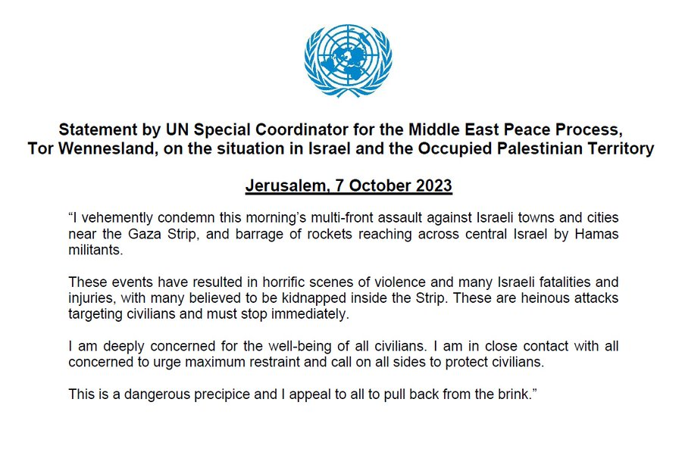

Lynn Hastings and 6 others
5:00 AM · Oct 7, 2023
·

*****************

UN High Commissioner for Human Rights Volker Türk

6:51 AM · Oct 7, 2023
Comment by UN Human Rights Chief on unfolding situation in Israel and Gaza
07 October 2023
Share
DELIVERED BY
Volker Türk, UN High Commissioner for Human Rights
https://www.ohchr.org/en/statements/2023/10/comment-un-human-rights-chief-unfolding-situation-israel-and-gaza
I am shocked and appalled at reports this morning that hundreds, possibly thousands, of indiscriminate rockets have been fired by Palestinian armed groups towards Israel, and that at least 22 Israelis have been killed and hundreds injured. I am also deeply concerned at reports that Israeli civilians have been taken hostage.
This attack is having a horrific impact on Israeli civilians. Civilians must never be the target of attack. I note also that Israeli forces have responded with air strikes into the densely populated Gaza Strip, reportedly killing at least two people. I call on them to take all precautions to avoid civilian casualties there.
I call for an immediate stop to the violence, and appeal to all sides and key countries in the region to de-escalate to avoid further bloodshed.
ENDS
****
UN Human Rights
https://twitter.com/UNHumanRights/status/1710608805652754676
@UNHumanRights

#Israel #OPT -
@volker_turk
calls for immediate stop to violence & urges de-escalation to avoid further bloodshed as indiscriminate rockets fired into Israel by Palestinian armed groups, Israeli air strikes in response:

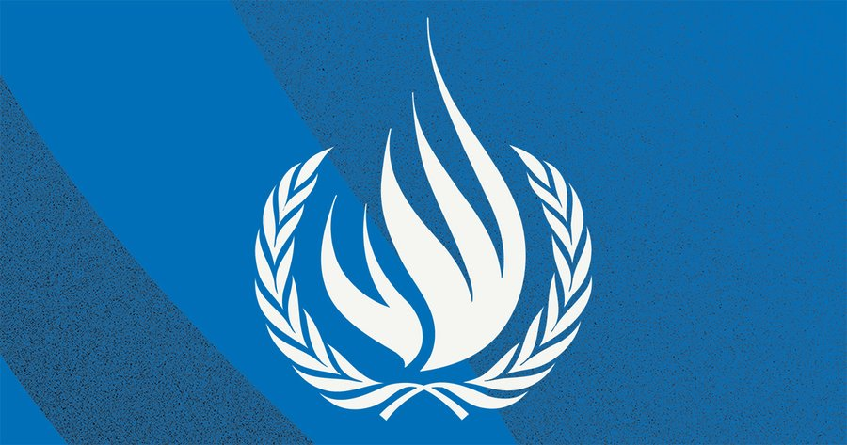
ohchr.org

6:51 AM · Oct 7, 2023
********

UN Special Rapporteur for the Situation of Human Rights in the Occupied Palestinian Territories Francesca Albanese
Francesca Albanese, UN Special Rapporteur oPt

@FranceskAlbs
https://twitter.com/FranceskAlbs/status/1710562233124598083
While awaiting further verified information on recent developments in oPt/Israel, I appreciate
@DaliaHatuqa
's insights. In these trying times, calm and respect for lives & dignity of all should prevail. Neither Palestinians nor Israelis need more death and violence.
Quote
Dalia Hatuqa
@DaliaHatuqa
Oct 7
A summary of what's going on in Gaza atm: This morning, fighters from Gaza carried out an operation that took Israeli by surprise, reaching Sderot, and taking Israeli hostages amidst a barrage of rocket fire.
3:46 AM · Oct 7, 2023
123.8K
Views
*************
https://twitter.com/FranceskAlbs/status/1710652724147065023
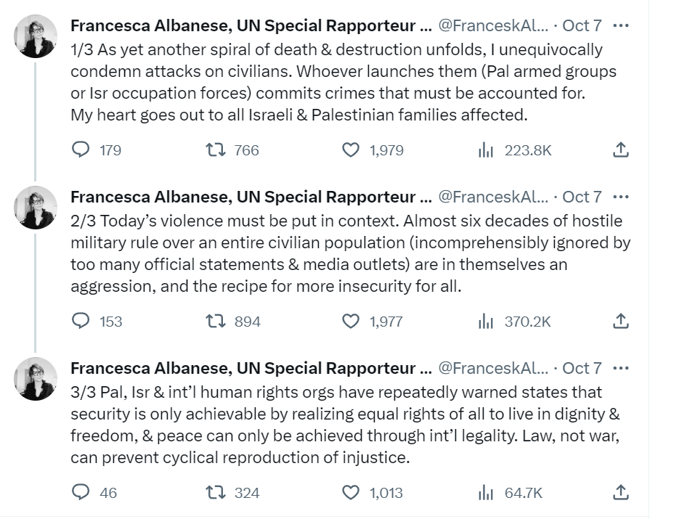
9:46 AM · Oct 7, 2023
*****
Francesca Albanese, UN Special Rapporteur oPt

@FranceskAlbs
https://twitter.com/FranceskAlbs/status/1710742582890725621
Wait: Is Israel lifting the 16yo blockade? Otherwise this is a joke. Palestinians in Gaza have nowhere to go.
Quote
Barak Ravid
@BarakRavid
Oct 7
BREAKING: Israeli Prime Minister Benjamin Netanyahu called on Palestinian civilians in Gaza to “leave now” because the Israeli military is going to “turn all Hamas hiding places into rubble”
3:43 PM · Oct 7, 2023
********

UN Committee on the Exercise of the Inalienable Rights of the Palestinian People

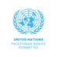

UN Palestinian Rights Committee

@UNISPAL
https://twitter.com/UNISPAL/status/1710778860785016917

@UNISPAL
expresses concern by the alarming security situation prevailing in Israel & the Occupied Palestinian Territory. "This proves again that only negotiations based on the two-state solution will ensure a lasting peace between Israelis and Palestinians," said Amb. Niang.
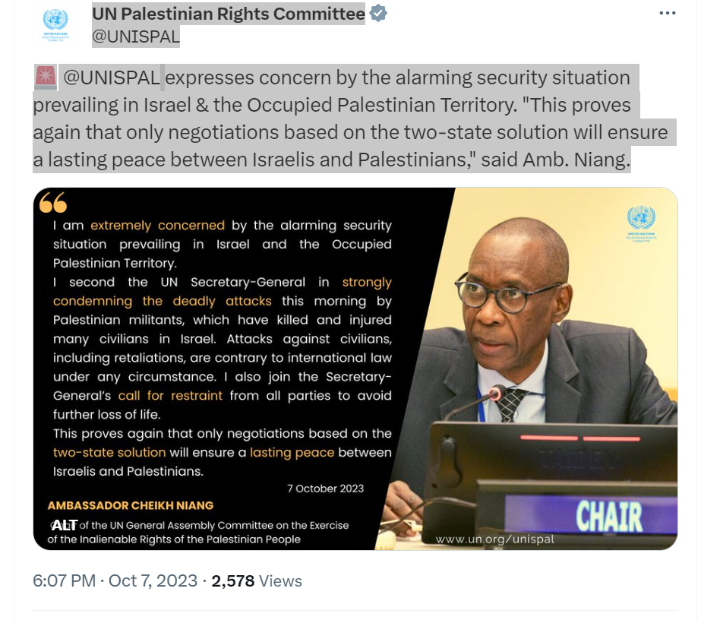
6:07 PM · Oct 7, 2023

********

UN General Assembly President Dennis Francis (Trinidad and Tobago)

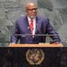

UN GA President

@UN_PGA
https://twitter.com/UN_PGA/status/1710653291611218143
I strongly condemn the attack by Hamas militants against Israel, which killed & injured hundreds of innocent civilians. My deepest condolences to the families & relatives of the victims. I urge all parties to refrain from further violence & to seek an immediate path to peace.
9:48 AM · Oct 7, 2023
·
103.2K
Views
**********

UNRWA
October 7, 2023
2:56 pm
UNRWA SITUATION REPORT # 1 ON THE SITUATION IN THE GAZA STRIP
Saturday, October 7, 2023
https://www.unrwa.org/resources/reports/unrwa-situation-report-1-situation-gaza
General area updates:
- At 06:30 on the morning of 7 October 2023, Hamas launched “Operation Al-Aqsa Flood” with more than 5,000 rockets reportedly fired towards Israel from multiple locations in Gaza, as well as ground operation into Israel.
- In response to this attack, Israeli authorities declared that the country is in a state of war and called up military reservists. At 12:00 noon, the Israeli Forces launched operation ‘Iron Sword’ with strikes on the Gaza strip by air, land and sea.
- As of 21:00, the Ministry of Health in Gaza reported 232 killed and 1,697 injuries. Two boys, both UNRWA students at UNRWA schools in Khan Younis and Beit Hanoun, are confirmed to be among those killed.
- According to different sources, between 150-200 Israelis have been reportedly killed.
- By 18:00, at least 20,363 Internally Displaced People were sheltering in 44 UNRWA schools in all areas in the Gaza Strip, except Khan Younis. Of those, 28 are Designated Emergency Shelters and 16 are not.
- Three UNRWA schools were affected by collateral damages caused by Israeli Armed Forces (IAF) airstrikes.
​
​Health services provision
- All UNRWA 22 Health Centres are closed.
- Emergency health-care services are available exclusively through the toll-free hotline (1-800-444-666).
- Primary health-care services are planned to resume with a limited number of staff as of tomorrow, 8 October.

Sanitation services provision
- All solid waste collection and transfer to landfills put on hold.
- The operation of water wells was stopped around 09:30am on 7 October.
- Water wells operations are planned to resume tomorrow in Jabalia, Khan Younis and Rafah.

Relief and Social Services
- UNRWA food distribution is on hold as of today until further notice, disrupting the third food distribution cycle. All 14 UNRWA Food Distribution Centres are closed. A total of 112,759 families (541,640 individuals) are yet to receive food assistance.
- UNRWA Relief and Social Services Helplines will be operational as of tomorrow, Sunday 8 October.
​
​General UNRWA operations
- All staff movement is restricted.
- Food and non-food items are prepositioned in the sub-stores across the five areas in Gaza and the main warehouses.
- Information to be shared with communities on UNRWA services. Social media content put out already on the emergency health-care services through the toll-free hotline.

UNRWA Installations
- Shrapnel was found in one school in Jabalia camp in the northern area.
- Two schools, one in Jabalia camp (northern area) and one in the city of Gaza, were affected by collateral damage due to Israeli Air Force airstrikes.

**********

Executive Director of UN Women Sima Bahous
Sima Bahous

@unwomenchief
https://twitter.com/unwomenchief/status/1710833472095269002
The escalation of hostilities in #Israel & the Occupied Palestinian Territory #OPT is gravely concerning. It is imperative that all civilians, including women & girls, are protected. We call for immediate deescalation & for upholding & respecting international humanitarian law.
9:44 PM · Oct 7, 2023
**********************

UNICEF
Statement by UNICEF Executive Director Catherine Russell on violence in Israel and the State of Palestine
07 October 2023
3:07 pm
https://www.unicef.org/press-releases/statement-unicef-executive-director-catherine-russell-violence-israel-and-state
NEW YORK, 7 October 2023 – “I am deeply concerned for the wellbeing of children in Israel and the State of Palestine.
“With hundreds of civilians reportedly killed or injured, we are closely monitoring the situation for reports of grave rights violations committed against children.
“Today’s events continue the trend of spikes in violence that have wracked Israel and the State of Palestine, leaving 199 children dead and more than 2,800 injured in the last three years.
“UNICEF calls for the immediate cessation of hostilities, and for all parties to protect children from harm and afford them the special protection to which they are entitled, in accordance with their obligations under international humanitarian law.
“More than anything, the children of Israel and the State of Palestine need a lasting political solution to the crisis, so that they can grow up in peace and free from the shadow of violence.”
***********

OCHA
Israel/Occupied Palestinian Territory: UN relief chief appeals to all sides to stop fighting
Statement by Martin Griffiths, Under-Secretary-General for Humanitarian Affairs and Emergency Relief Coordinator, on developments in Israel and the Occupied Palestinian Territory
https://www.unocha.org/news/israeloccupied-palestinian-territory-un-relief-chief-appeals-all-sides-stop-fighting
New York: I am extremely alarmed by the rapidly escalating events in Israel and the Occupied Palestinian Territory. The number of civilian casualties on both sides is reportedly already in the hundreds – and rising rapidly.
Violence is never the answer. I appeal to all sides to stop the fighting immediately and protect civilians everywhere and at all times.
Not doing so will only lead to more bloodshed.
Posted on 7 October 2023
**********
Escalation in the Gaza Strip and Israel | Flash Update #1 as of 18:00, 7 October 2023
https://www.ochaopt.org/content/escalation-gaza-strip-and-israel-flash-update-1
SITUATION OVERVIEW
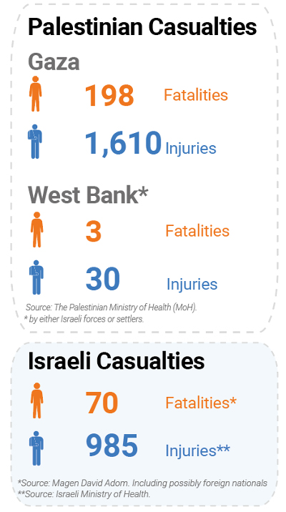
- On 7 October 2023, since the early morning hours, Palestinian armed groups in Gaza launched thousands of rockets toward Israel and breached through the perimeter fence of Gaza at multiple locations. Members of armed groups entered into Israeli towns, communities, and military facilities near the Gaza Strip, killing and capturing Israeli forces and civilians. The Israeli military declared “a state of war alert,” and begun striking targets in the Gaza Strip.
- Palestinian armed groups who had entered Israel initially claimed to have captured about 52 people, including members of Israeli forces and civilians, taking them to Gaza as rocket fire continued.
- As of 17:30, Magen David Adom reported that at least 70 Israelis and possibly also foreign nationals had been killed, including one paramedic. At least 985 people had been injured, according to the Israeli Ministry of Health. According to media reports, over 200 people have been killed and 1,500 injured in Israel.
- At around 10:45, Israeli forces began striking targets in the Gaza strip.
- As of 18:00, the Ministry of Health (MoH) in Gaza reported that 198 Palestinians had been killed and 1,610 others had been injured.
- During airstrikes, Israeli forces hit the Indonesian hospital in Beit Lahiya, northern Gaza, with a missile, killing two Palestinian men, including a staff member of the hospital, and injuring five others. Damage was also caused to the oxygen station inside the hospital. Additionally, at about 14:00, Israeli forces reportedly hit an ambulance stationed in front of Nasser Hospital in the city of Khan Yunis, in the southern Gaza Strip. Several Palestinian paramedics were reported injured.
- At about 11:00, Israeli forces reportedly killed a Palestinian journalist east of Al Bureij, in Gaza city, while he was covering the events.
- By 18:00, at least 20,000 internally displaced people were sheltering in 44 UNRWA schools, including 28 designated emergency shelters, in all areas in the Gaza Strip, except Khan Younis.
- Exchanges of fire in the towns and communities surrounding Gaza took place throughout the day, the afternoon and evening. Palestinian armed groups in Gaza continued to fire rockets at Israel. Israeli airstrikes also continued throughout the afternoon and evening targeting multi-storey buildings. At least one high rising building comprising tens of apartments was destroyed.
- In the West Bank, including East Jerusalem, confrontations have been increasing in multiple locations. As of 17:00, the Palestine Red Crescent Society (PRCS) reported to have treated 23 Palestinians injured by Israeli forces, including nine who were hit with live ammunition, six injured by rubber-coated metal bullets, four who required treatment for teargas inhalation, three who had shrapnel wounds and one who was physically assaulted. PRCS also reported seven Palestinians injured by Israeli settlers, including two injured with live ammunition in Salfit. According to initial reports, three Palestinians were killed by either Israeli forces or settlers and a child was critically injured.
- Also in the West Bank, the Israeli authorities put in place multiple movement restrictions, including the closure of several checkpoints leading to Jerusalem. Additionally, they closed the Allenby Bridge crossing with Jordan for Palestinian travellers.
- The humanitarian coordinator has activated a contingency plan for Gaza and is working to secure access with all parties for a scale up of the needed humanitarian response.

