Operation Brother’s Keeper: 191 Arrested in Connection with Hamas Kidnapping
IDF Blog
June 15, 2014
http://web.archive.org/web/20140617222126/http://www.idfblog.com/2014/06/15/idf-searches-hamas-kidnappers/

A widespread IDF operation aims to find the Hamas terrorists who kidnapped three Israeli teenagers last Thursday. Israeli forces have arrested 190 Palestinian suspects in connection with the abduction.
IDF soldiers arrested 40 terrorist suspects late Monday night in connection with Operation Brother’s Keeper, the mission to find Hamas operatives who abducted three Israeli teenagers last week. IDF forces detained the suspects in the Judea and Samaria region, where Hamas terrorists abducted the three teens last Thursday.
Last night’s arrests increased the number of detained terrorists to 190, including several Hamas operatives. IDF forces carried out similar arrests over the weekend as a result of the kidnapping.
IDF and Israeli security forces have been conducting a relentless search for the teenagers and their kidnappers for more than three days.
Israeli forces also arrested 80 Palestinian suspects late Saturday night. Hours later, on Sunday morning, the IDF confirmed that Hamas terrorists were responsible for the abduction. [EDITOR’S NOTE: LINK GOES TO A DECEMBER 4, 2013 IDF BLOG ARTICLE ENTITLED “Palestinian Terrorists Determined to Kidnap Israeli Soldiers”]
The IDF’s soldiers are working around the clock, on all fronts, to find Gilad Shaar, Eyal Yifrach and Naftali Frenkel – the three Israeli teenagers abducted last Thursday.
[MISSING IMAGE OR VIDEO]
IDF Chief of Staff Lt. Gen. Benny Gantz briefed Israeli security officials during an assessment of the operation Sunday night.
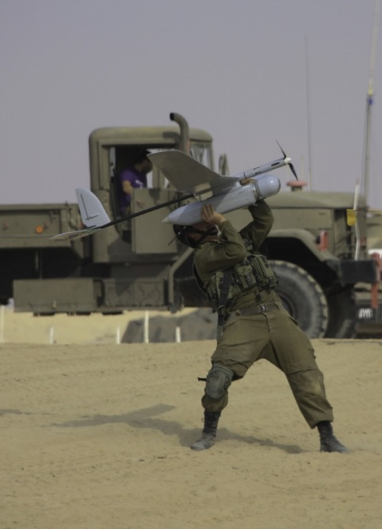
Soldier guides a drone during an IDF exercise
Soldiers controlling drones on the ground are enhancing Israel’s operation. Their technology provides crucial intelligence to forces trying to find the kidnappers. [EDITOR’S NOTE: LINK GOES TO AN AUGUST 16, 2013 IDF BLOG ARTICLE ENTITLED “Leaving No Stone Unturned: How the IDF Locates Missing Soldiers “] “As soon as we identify [a target], we’ll be able to notify forces in the area,” said Captain Yochai Varso, an IDF company commander. “When they ask to see a house, we’ll be able to show them the structure and movement nearby.”

[EMBEDDED VIDEO: http://humanrightsvoices.org/site/documents/?d=22004]
During an overnight operation Saturday, IDF forces arrested about 80 Palestinian suspects connected to the terrorist kidnapping. [EDITOR’S NOTE: LINK GOES TO A JUNE 25, 2013 IDF BLOG ARTICLE ENTITLED “Seven Years Since Shalit Kidnapping: Motivation to Kidnap Still High “] “Palestinian terrorists will not feel safe,” IDF Spokesman Lt. Col. Peter Lerner stressed after the operation. “They will not be able to hide and will feel the heavy arm of Israel’s military capabilities.”
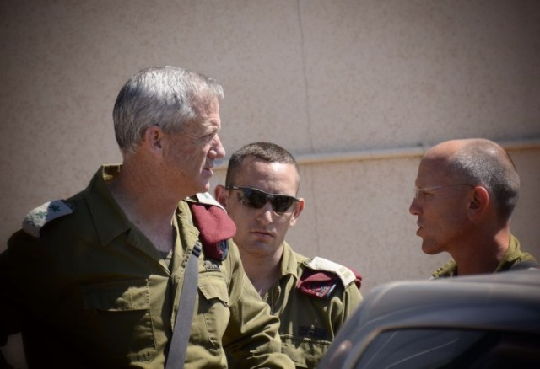
During a press conference on Saturday evening, IDF Chief of Staff Lt. Gen. Benny Gantz discussed the IDF’s broad search effort. “We are operating wherever needed and our efforts are growing,” Lt. Gen. Gantz stressed. “We remain determined to achieve our operational objectives, and will act with responsibility, poise and determination to accomplish whatever is required of us.”
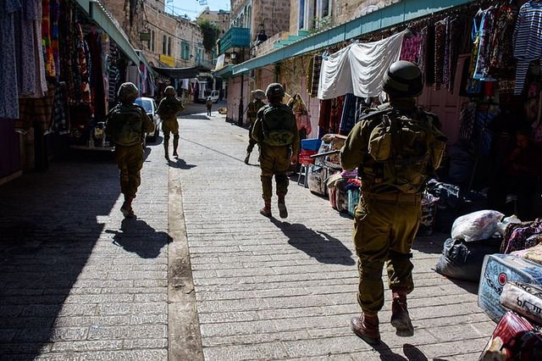
Israeli forces searched throughout Hebron [EDITOR’S NOTE: LINK GOES TO A MARCH 4, 2014 IDF BLOG ARTICLE ENTITLED “Three Years in Hebron: A First-Person Account From The Field”] for signs of the young Israelis. Their operation took them between alleys, on top of houses and through the city’s markets. Israeli forces performed similar operations across the Judea and Samaria [EDITOR’S NOTE: LINK GOES TO A DECEMBER 2, 2013 IDF BLOG ARTICLE ENTITLED “IDF Prepares to Combat Rising Terror Threats in Judea and Samaria”] region.
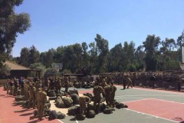
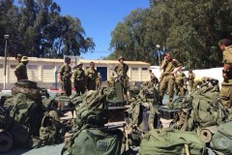
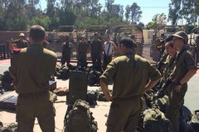

IDF Paratroopers joined the IDF mission on Saturday. Moments before setting out on their search, they gathered for a briefing in Judea and Samaria. Their participation expanded and strengthened Israel’s efforts to find the kidnapped Israelis.

During an extensive part of the operation on Friday, IDF soldiers searched the streets and entered the houses of Judea and Samaria. [EDITOR’S NOTE: LINK GOES TO A SEPTEMBER 10, 2013 IDF BLOG ARTICLE ENTITLED “Terrorism in Judea and Samaria Becoming More Sophisticated”] The forces continued late into the night, working with determination to bring the teens home as quickly as possible.

