Operation Protective Edge – The First 10 Days
IDF Blog
July 8, 2014
http://web.archive.org/web/20140825040549/http://www.idfblog.com/blog/2014/07/08/breaking-idf-commences-operation-protective-edge-against-hamas/#

In order to restore quiet to the region and stop Hamas terrorism, the IDF has commenced Operation Protective Edge. The operation has one goal: to stop Hamas’ incessant rocket attacks against Israel’s civilians. During the first 10 days of the operation:
- Over 1497 rocket were launched at Israel.
- 1093 of those rockets hit Israel
- Approximately 301 rockets were intercepted by the Iron Dome missile defense system.
- The IDF targeted over 2,037 terror targets, with both naval and aerial capabilities.

Thursday, July 17
Summary of the day:
- More than 158 rockets were fired from Gaza towards Israel.
- At least 118 rockets struck Israel.
- 34 rockets were intercepted by the Iron Dome missile defense system.
- The IDF accepted the UN request for a 5 hour humanitarian window
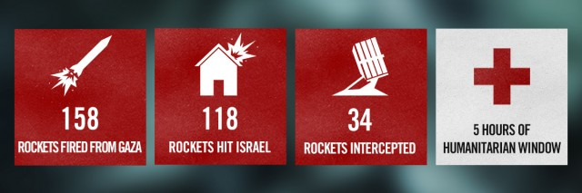

Updates by the Hour
8:40 PM: The IDF intercepted a UAV above Ashkelon. The IDF engaged the UAV with a “Patriot” surface to air missile.
7:50 PM: Since the end of the humanitarian window, Gazan terrorists have fired over 100 rockets at Israel.
6:40 PM: An IDF soldier was lightly injured by a mortar fired from Gaza.
6:20 PM: Two rockets were just intercepted over the Tel Aviv metropolitan area. 5 additional rockets hit open areas in southern Israel.
5:20 PM: UNRWA: We found 20 rockets in one of our schools in Gaza http://www.unrwa.org/newsroom/press
4:00 PM: A rocket fired from Gaza just hit an open area near Beersheba.
Despite incessant Hamas rocket fire, tons of goods have reached Palestinians in Gaza from Israel. pic.twitter.com/zfTZSWRfGf
— IDF (@IDFSpokesperson) July 17, 2014

2:00 PM: An IDF soldier was lightly injured by an explosion during an operational activity near southern Gaza. The IDF responded with mortar fire.
As the IDF holds to the humanitarian cease-fire, Gazan terrorists violate the truce by firing 3 mortars at Israel.
— IDF (@IDFSpokesperson) July 17, 2014

8:00 AM: IDF forces identified approximately 13 terrorists attempting to infiltrate Israel through a terror tunnel constructed by Hamas: http://www.idfblog.com/blog/2014/07/17/breaking-idf-thwarts-infiltration-attempt-hamas-terrorists/
2:25 AM: Two rockets were intercepted by Iron Dome above southern Israel and an additional rocket hit Kiryat Malakhi.
1:55 AM: Moments ago, two rockets hit southern Israel and sirens continue to sound in several locations.

Wednesday, July 16
Summary of the day:
- More than 132 rockets were fired from Gaza towards Israel.
- At least 82 rockets struck Israel.
- 33 rockets were intercepted by the Iron Dome missile defense system.
- The IDF hit 176 terror targets in the Gaza Strip.
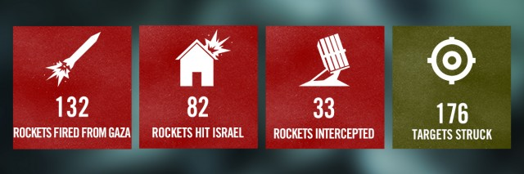

Updates by the Hour
10:56 PM: IDF will hold fire for humanitarian window between 10:00 and 15:00 tomorrow. Should the humanitarian window be exploited by Hamas or other terror organizations for the purpose of launching attacks against Israeli civilian or military targets the IDF will respond firmly and decisively.
During this time, we will hold our fire in Gaza. This humanitarian window is meant to allow civilians to resupply needed goods.
— IDF (@IDFSpokesperson) July 16, 2014

9:00 PM: A rocket fired from Gaza struck near a school in Ashdod.
6:11 PM:
Hamas fired a rocket from Gaza today and severely damaged this house in Ashkelon. #IsraelUnderFire pic.twitter.com/SRrnzoG1Sv
— IDF (@IDFSpokesperson) July 16, 2014
5:30 PM: Hamas aims for Israel, but its rockets have hit Gaza over 100 times in 9 days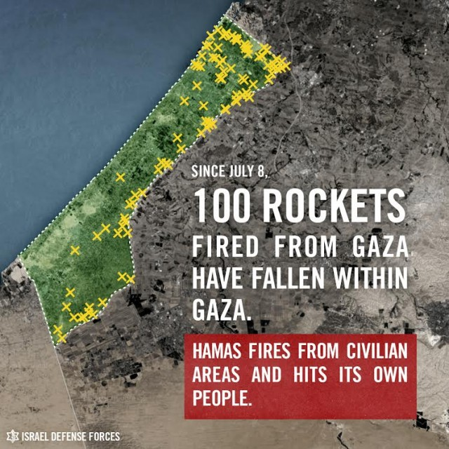
5:00 PM: Today we struck 50 Hamas targets in Beit Lahiya, Shuja’iya, Zeitoun & other areas in N. Gaza from which we warned civilians to evacuate.
2:41 PM: Two rockets fired from Gaza struck the Ashkelon area, and five rockets struck elsewhere in southern Israel.
2:15 PM: The IAF distributed evacuation leaflets to residents of Northern Gaza this morning.
http://youtu.be/yoK9YL6D5RE
1:15 PM: Hamas terrorists fired 10 rockets at Be’er Sheva moments ago. The Iron Dome intercepted six of them, and the remaining four fell in open areas.
10:13 AM:
Today we dropped these leaflets urging civilians to move away from Hamas targets before IDF strikes in Gaza. pic.twitter.com/K6JIcCnRfX
— IDF (@IDFSpokesperson) July 16, 2014

9:30 AM: Four rockets fired from Gaza have been intercepted over Tel Aviv.
9:28 AM: Rocket sirens and blasts heard in Tel Aviv moments ago.
7:53 AM: Hamas terrorists fired eight rockets at southern Israel. Of them, six were intercepted by Iron Dome and two landed in open area
7:00 AM: The Iron Dome intercepted a Hamas rocket over the area of Kiryat Malakhi. Four others fell in open areas.
6:00 AM: IDF postpones strikes on Hamas targets after identifying civilians in the area.
http://youtu.be/yE7ykidY7FA?list=UUawNWlihdgaycQpO3zi-jYg
4:09 AM: Yesterday, Hamas fired rockets towards the Kerem Shalom crossing. Even so, the IDF continued transferring goods into Gaza.
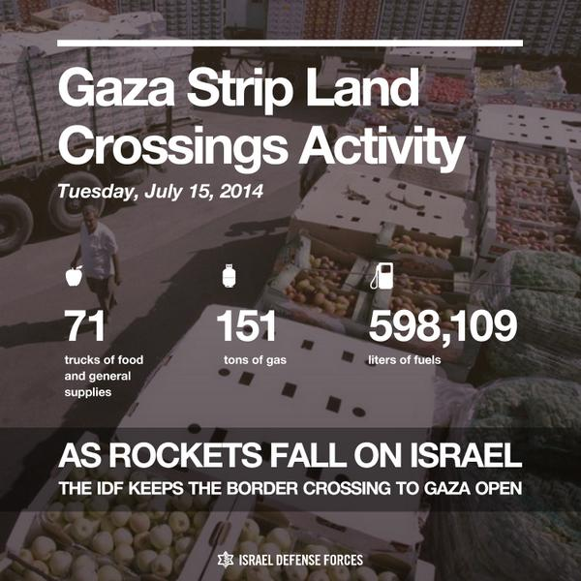

Tuesday, July 15
Summary of the day:
- More than 155 rockets were fired from Gaza towards Israel.
- At least 122 rockets struck Israel.
- 26 rockets were intercepted by the Iron Dome missile defense system.
- The IDF hit 96 terror targets in the Gaza Strip.
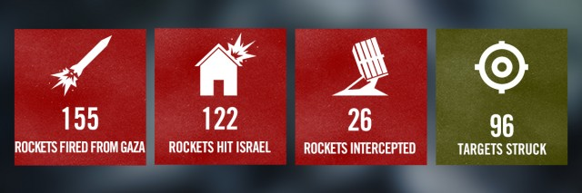

Updates by the Hour
11:52 PM: As part of our effort to avoid harming civilians, we are sending messages to residents of northern Gaza to leave homes for their own safety.
11:10 PM: A barrage of rockets were fired at southern Israel. Three were intercepted by the Iron Dome missile defense system and two hit open area.
8:25 PM: Rocket sirens heard across the Jerusalem area, the Jordan Valley, and Judea.
9:20 PM: The Iron Dome just intercepted 2 rockets over Ashdod and Ashkelon.
http://youtu.be/m1WSjuidJVw?list=UUawNWlihdgaycQpO3zi-jYg
8:40 PM: Since 9 AM, about 125 rockets were fired from Gaza at Israel. Around 100 of them hit Israel and the Iron Dome intercepted 20.
7:40 PM: An Israeli civilian was killed by a rocket that struck the Erez crossing on the Gaza border.
7:20 PM: A rocket fired from Gaza struck a house in Ashkelon moments ago.
Hamas is suffering. The terrorist group erred in thinking that it would benefit by attacking Israel. It is paying the price for its actions.
— IDF (@IDFSpokesperson) July 15, 2014
7:00 PM: Two rockets were intercepted over Gush Dan
5:35 PM: So far today, we have struck Hamas’ tunnels, 20 concealed rocket launchers, weapons storage facilities & other operational infrastructure.
5:30 PM: Since 9 am, Hamas in Gaza has fired 76 rockets at Israel. The Iron Dome intercepted 9 of them.
3:00 PM: Hamas has fired 47 rockets since we suspended our strikes in Gaza at 9 am. As a result, we have resumed our operation against Hamas.
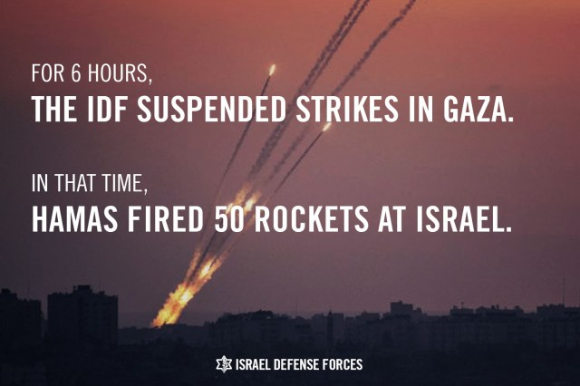
13:05 PM: The Iron Dome intercepted 3 rockets fired from Gaza a short time ago: 1 over Rehovot, 1 over Ashkelon, and 1 over Ofakim.
12:10 PM: Since we suspended strikes in Gaza, terrorists there fired 22 rockets at Israel. One of them struck a house in Ashdod & caused damage.
10:50 AM: Israel’s leadership has directed our forces to suspend strikes in Gaza. We remain prepared to respond to Hamas attacks and defend Israel.
2:03 AM: Two rockets hit Eilat and an additional rocket hit an open area. Damage reported and initial reports suggest that two people were injured.
Update: 4 lightly injured in recent rocket attack on Eilat pic.twitter.com/hp99Bi1xIK
— IDF (@IDFSpokesperson) July 14, 2014

Monday, July 14
Summary of the day:
- More than 115 rockets were fired from Gaza towards Israel.
- At least 92 rockets struck Israel.
- 15 rockets were intercepted by the Iron Dome missile defense system.
- The IDF hit 163 terror targets in the Gaza Strip.
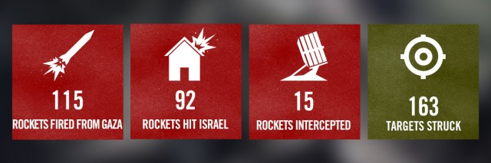

Updates by the Hour
22:48 PM: A few minutes ago, a rocket fired from Lebanon struck near the northern Israeli city of Nahariya.
19:30 PM: A rocket fired from Gaza hit Lakiya, located near Beer Sheva, and wounded two girls aged 11 and 13, one was severely and one moderately.
A short while ago, a rocket attack from Gaza wounded 2 girls aged 11 and 13 in Lakiya (near Beersheba), 1 seriously and 1 moderately.
— IDF (@IDFSpokesperson) July 14, 2014
6:30 PM: A rocket fired from Syria fell in an open area in El Rom in the Golan Heights.
5:00 PM: An anti-tank missile was fired from Gaza at an IDF tank in Israel. The tank’s Trophy Active Protection System intercepted the missile.
4:37 PM: In the past 3 hours, four rockets fired from Gaza have been intercepted by Iron Dome above southern Israel.
1:05 PM: The Iron Dome just intercepted one rocket over the Tel Aviv metropolitan area.
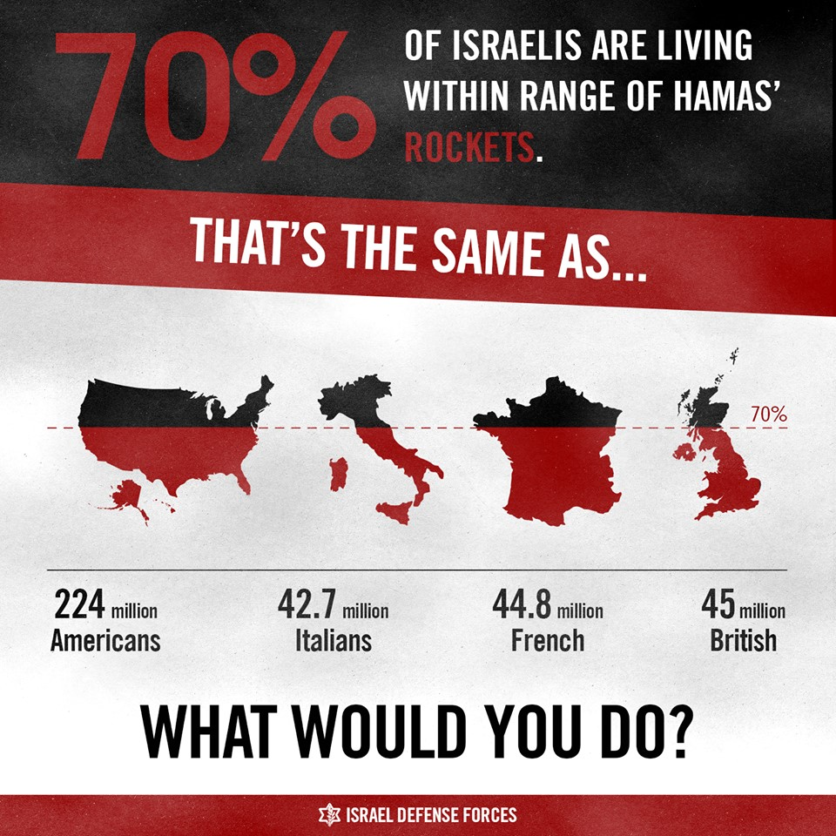
1:00 PM: A boy was lightly wounded from shrapnel after a rocket fired from Gaza struck Ashdod.
11:15 AM: The Iron Dome shot down a Gaza rocket above Ashkelon.
8:16 AM: An aerial drone from Gaza infiltrated Israel a short time ago. IDF forces shot it down with a Patriot missile above Ashdod.
1:22 AM: A short while ago, several rockets were fired from Lebanon at Israel. One hit an open area. IDF immediately responded towards the source with artillery fire. UNIFIL has been notified of the severity of the incident.
12:32 AM: Rocket sirens sounded in northern Israel.
12:26 AM: Iron Dome just intercepted seven rockets above Ashkelon.
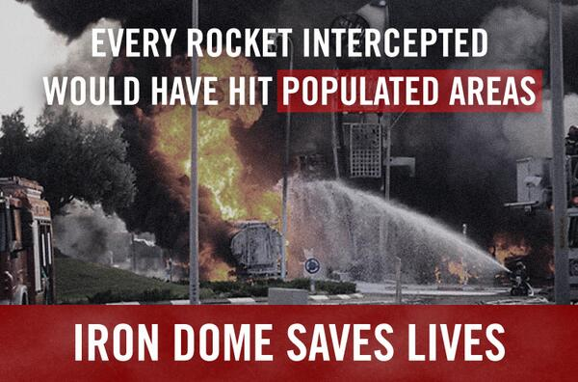

Sunday, July 13
Summary of the day:
- More than 130 rockets were fired from Gaza towards Israel.
- At least 102 rockets struck Israel.
- 22 rockets were intercepted by the Iron Dome missile defense system.
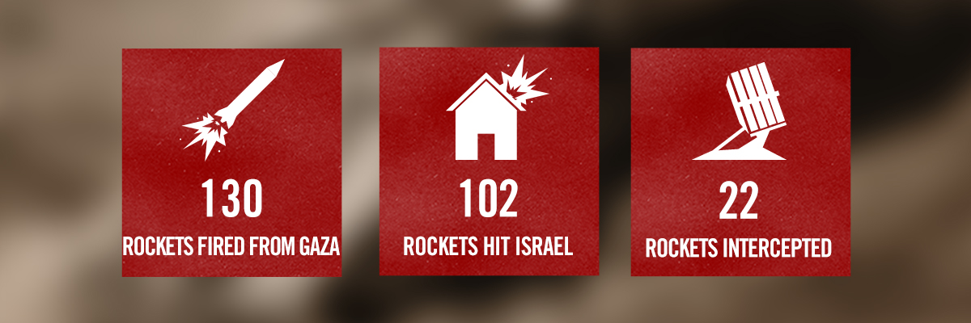

Updates by the Hour
11:15 PM: This evening a rocket fired from Syria hit Israel, likely intentionally. The IDF responded with artillery toward Syrian military posts. Hits were confirmed.
9:23 PM: A rocket fired from Gaza hit electricity infrastructure in Israel that supplied power to Gaza, cutting power to about 70,000 people in Gaza.
8:25 PM: Three more rockets fired from Gaza just intercepted by the Iron Dome over the Ashdod area.
8:21 PM: The Iron Dome intercepted two rockets over the Ashdod area.
5:00 PM: IDF aircraft struck two rocket launchers used to attack Ashdod and Be’er Sheva, as well as another that fired medium-range rockets from Northern Gaza.
4:31 PM: Rocket sirens are heard in Tel Aviv and the Iron Dome intercepted two rockets over the Tel Aviv metropolitan area.
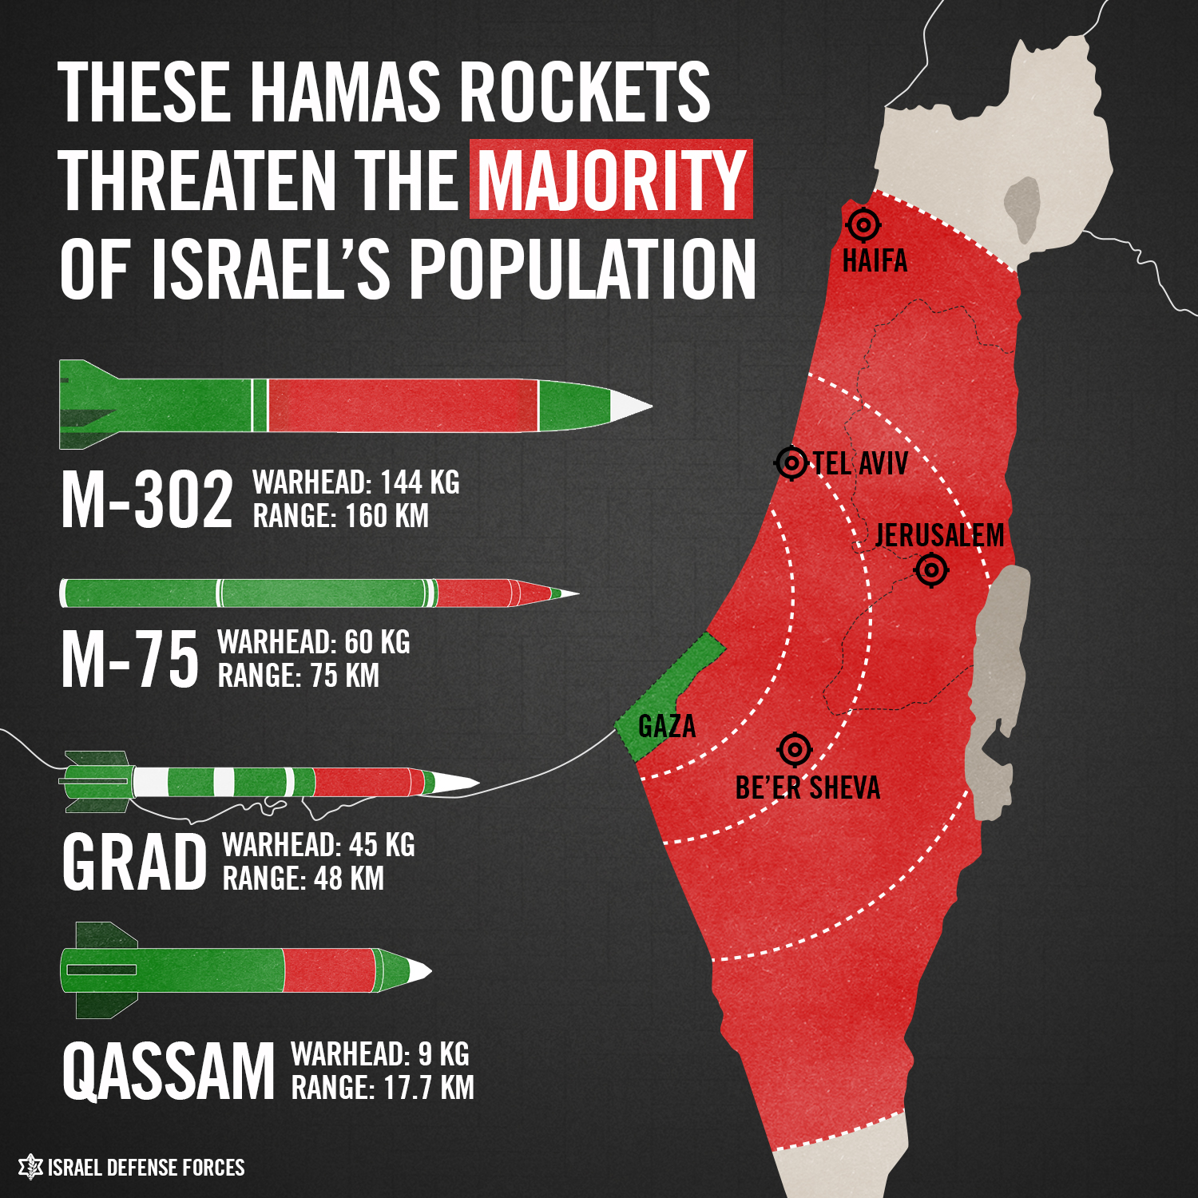
2:59 PM: Six rockets are fired from Gaza. Of them, one struck a building in Ashkelon, two hit Ashdod, and three others were intercepted by the Iron Dome.
1:11 PM: A rocket fired from Gaza hit Ashkelon and severely wounded an Israeli teenager.
10:41 AM: Rocket sirens sound in Be’er Sheva.
10:08 AM: Rocket sirens are heard in Ashkelon and other areas of southern Israel. The Iron Dome intercepted one rocket over Ashkelon.
6:38 AM: Moments ago, a rocket was intercepted by Iron Dome over Ashdod. Three additional rockets were intercepted above Ramla.
4:54 AM: IDF forces raided a launching site used to fire long-range rockets at Israel. During the mission, there was an exchange of fire initiated by terrorists on site. Four soldiers were lightly injured and all returned home safely. The mission was accomplished.

Saturday, July 12
Summary of the day:
- More than 129 rockets were fired from Gaza towards Israel.
- At least 117 rockets struck Israel.
- 9 rockets were intercepted by the Iron Dome missile defense system.
- The IDF hit 120 terror targets in the Gaza Strip.
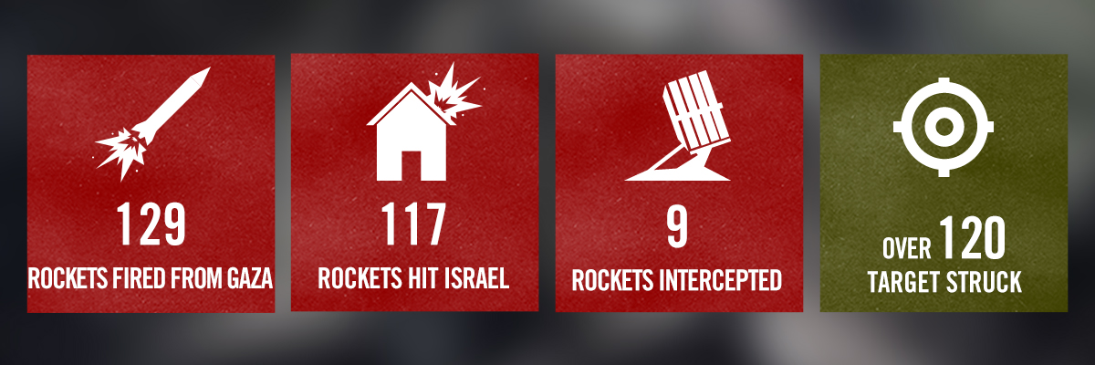

Updates by the Hour

Friday, July 11
Summary of the day:
- More than 140 rockets were fired from Gaza towards Israel.
- At least 107 rockets struck Israel.
- 27 rockets were intercepted by the Iron Dome missile defense system.
- The IDF hit 235 terror targets in the Gaza Strip.
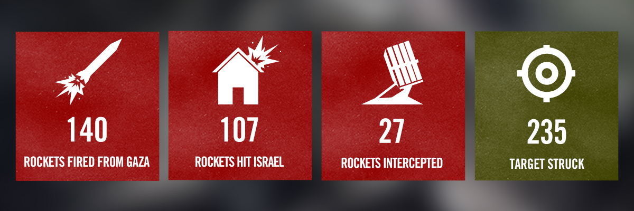

Updates by the Hour
9:58 PM: Four rockets were fired from Gaza to Beer Sheva. One hit a house, injuring a woman. Two were intercepted by the Iron Dome, and one hit an open area
9:23 PM: A short while ago, the Israel Air Force targeted the rocket launcher in Gaza that fired at central Israel about two and a half hours ago.
9:20 PM: A few minutes ago, the Iron Dome intercepted two rockets over Beer Sheva and one rocket over the Tel Aviv metropolitan area.
8:56 PM: Moments ago, two rockets were intercepted over the Tel Aviv metropolitan area.
7:16 PM: Initial report: An anti-tank missile fired from northern Gaza lightly wounded two IDF soldiers patrolling the security fence.
6:43 PM: The Iron Dome intercepted one rocket over the Tel Aviv metropolitan area.
4:55 PM: Over 70 rockets were fired at Israel since midnight, out of which 53 hit Israel and 18 were intercepted.
4:02 PM: Two rockets fired from Gaza struck Beer Sheva
2:00 PM: IDF Chief of Staff: Terrorists in Gaza made a grave mistake by attacking the people of Israel. They are bringing disaster upon themselves.
This is how Israelis woke up this morning. A rocket fired from Gaza hit Ashdod & caused a massive fire. pic.twitter.com/b9JoM42khb
— IDF (@IDFSpokesperson) July 11, 2014
8:00 AM: A rocket fired from Lebanon hit an open area near Metula a short time ago. In response, IDF forces opened fire at the source of rocket fire
3:28 AM: Rocket sirens sounded in the Haifa area, located more than 140 km (87 miles) from the Gaza Strip.

Thursday, July 10
Summary of the day:
- More than 192 rockets were fired from Gaza towards Israel.
- At least 141 rockets struck Israel.
- 44 rockets were intercepted by the Iron Dome missile defense system.
- The IDF hit 210 terror targets in the Gaza Strip.
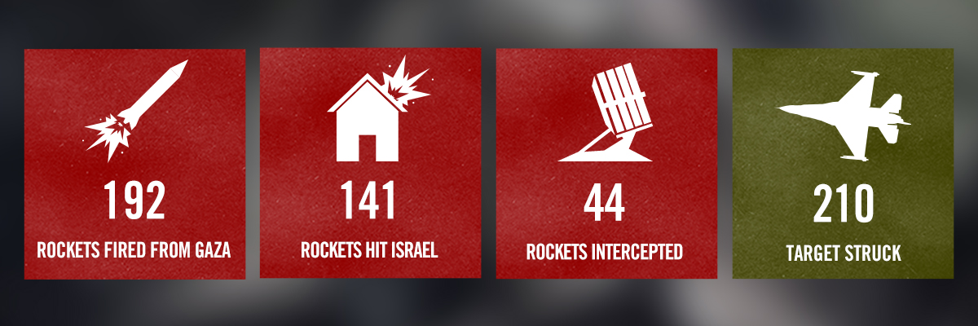

Updates by the Hour
11:30 PM: Today, 192 rockets were fired towards Israel. 141 of them hit Israel, and an additional 44 were intercepted by Iron Dome. The IDF struck over 210 terror targets.
10:00 PM: In less than 24 hours, more than 120 rockets fired from Gaza struck Israel and an additional 24 rockets were intercepted by the Iron Dome missile defense system.
9:31 PM: A short time ago, a mortar fired from Gaza at southern Israel wounded two IDF soldiers, one lightly and one moderately.
9:17 PM: A few minutes ago, a rocket hit Ashdod.

[EMBEDDED VIDEO: https://www.youtube.com/watch?v=51g8ruJi-gg]

9:07 PM: A short time ago, a house in Beer Sheva was hit by a rocket fired from Gaza. In the past hour, 20 rockets were fired at Israel.
8:00 PM: So far today, 169 rockets have been fired at Israel, of them 117 rockets landed in Israel, and 24 were intercepted by Iron Dome.
7:45 PM: The IDF keeps border crossing open all day despite 120 rockets being fired at Israel. 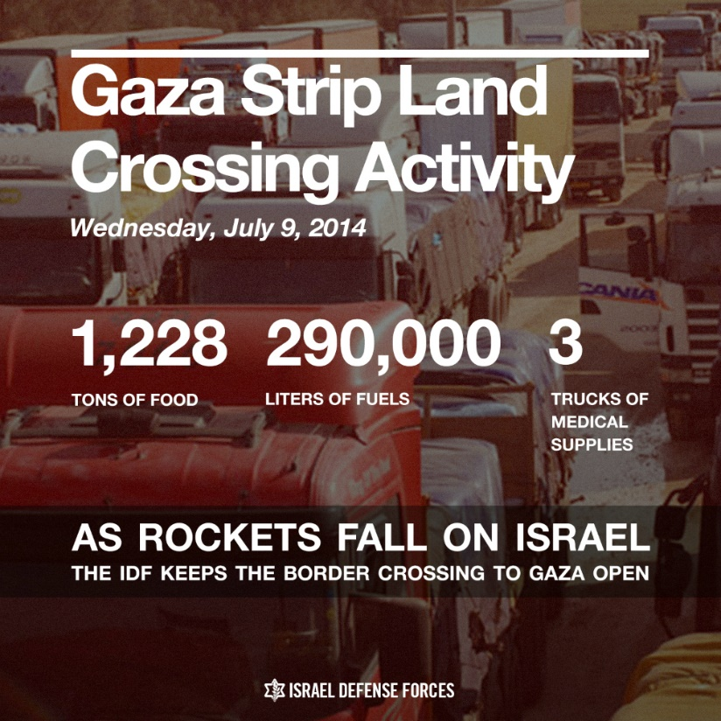
6:10 PM: 4 rockets fired at Jerusalem; 2 intercepted and 2 land in an open field.
4:40 PM: The IDF targeted 3 Palestinian Islamic Jihad terrorists in Gaza: Mahmoud Walud, Hazm Balusha & Alla’a Abd Al-Nabi. Al-Nabi was a senior PIJ terrorist who was responsible for launching rockets capable of reaching Tel Aviv.
4:10 PM: Iron dome intercepts rockets over Ashkelon.
4:00 PM: Palestinian terrorists in Gaza have fired 96 rockets at Israel today, and 442 in the past 3 days.
Minutes ago, 20 rockets were fired from Gaza; the Iron Dome intercepted 8 of them above the Shfela area (Judean foothills).
— IDF (@IDFSpokesperson) July 10, 2014

11:30 AM: Rocket siren sounded in Tel Aviv.
10:00 AM: Initial report: At least 3 rockets have hit residential communities in the Negev.
9:18 AM: The Iron Dome intercepted a rocket above the Israeli community of Netivot.
8:15 AM: The Iron Dome system intercepted at least one rocket above Tel Aviv.
8:00 AM: IDF targeted three PIJ terrorists involved in rocket manufacturing in northern Gaza.
7:52 AM: Earlier this morning, the IDF targeted three Palestinian Islamic Jihad terrorists who were involved in the manufacturing of medium-range rockets. A hit was identified.
6:20 AM: Since midnight, 8 rockets have been fired at Israel by Hamas terrorists and the IDF has hit 54 terror targets in the Gaza Strip.
4:00 AM: Yesterday, 90 rockets hit Israel. An additional 24 were intercepted by Iron Dome.
1:33 AM: Two rockets intercepted over Beer Sheva. An additional rocket landed nearby.
12:57 AM: In the past 24 hours, more than 105 rockets were launched from Gaza towards Israel. In response to the continued rocket fire, the IDF struck 326 targets across the Gaza Strip including concealed rocket launchers, terror tunnels, training bases, military compounds, weapons storage and manufacturing facilities, and additional sites utilized as control centers by senior Hamas terrorists.
12:00 AM: Two rockets fired from Gaza were intercepted above Kiryat Malakhi.

Wednesday, July 9
Summary of the day:
- More than 113 rockets were fired from Gaza towards Israel.
- At least 90 rockets struck Israel.
- 24 rockets were intercepted by the Iron Dome missile defense system.
- The IDF hit 320 terror targets in the Gaza Strip.
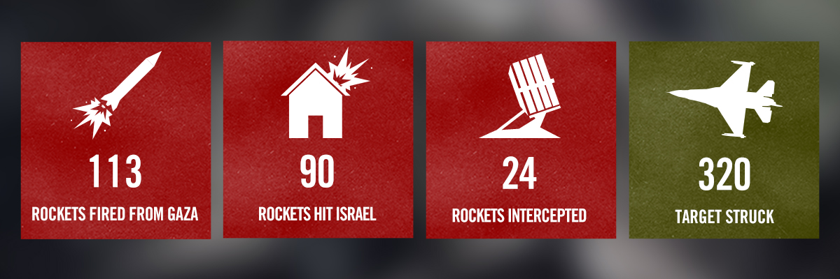
One of the terror targets the IDF hit was a site used by Ahmed Naji R’andur, who directs all of Hamas’ forces in northern Gaza. He is personally responsible for terror activities in the region, including firing rockets and planning terrorist attacks.

Updates by the Hour
11:27 PM: Today, 82 rockets hit Israel. An additional 21 rockets were intercepted by the Iron Dome.
8:00 PM: So far today, over 93 rockets have been fired at Israel.
7:35 PM: A rocket hit a building near a kindergarden in the Sha’ar HaNegev regional council. An additional rocket hit an open area.
6:25 PM: From start of Operation Protective Edge, 300 rockets have been fired at Israel; 220 have struck.
5:20 PM: The Iron Dome just intercepted a rocket over the Tel Aviv metropolitan area (Gush Dan).
#PHOTOS: the unbearable reality of millions of Israelis under #Gaza rocket fire https://t.co/ec4gkGcjz7
— IDF (@IDFSpokesperson) July 9, 2014
4:00 PM: Since midnight, 48 rockets fired from the Gaza Strip have struck Israel; the Iron Dome has intercepted an additional 14 rockets.
3:07 PM: The IDF has struck about 130 terror targets in the Gaza Strip since this morning, including 31 terror tunnels, 60 concealed rocket launchers, terror command centers and weapons caches.
2:50 PM: A rocket siren was just heard in Zichron Yaakov, which is about 120 km (75 mi) from Gaza.
2:00 PM: Iron Dome intercepted a rocket over the town of Kiryat Gat.
12:05 PM: The Iron Dome just intercepted 3 rockets over Ashdod. A total of 8 rockets fired from Gaza have been intercepted since this morning.
11:00 AM: IDF targeted Abdullah Diyfallah, a Palestinian Islamic Jihad terrorist who was responsible for firing rockets at Israel.
9:00 AM: Overnight summary: Last night the IDF struck 160 Hamas terror sites in Gaza. Among the terror targets the IDF struck are: 118 concealed rocket launching sites, consisting of long-range rockets launchers; weapon storage facilities; 10 tunnels, out of which 7 terror tunnels and 3 smuggling tunnels; 6 Hamas official facilities, and 10 terror command positions.
8:45 AM: Two rockets were intercepted over Tel Aviv. Since the start of the operation, 155 rockets have been fired at Israel.
In the past 24 hours, Hamas fired rockets at Tel Aviv, Jerusalem & other major cities. M302 can strike most of Israel pic.twitter.com/fHJgGsVT7V
— IDF (@IDFSpokesperson) July 9, 2014
8:30 AM: Rocket sirens sound again in Tel Aviv.
12:00 AM-7:00 AM: Overnight, 4 more rockets were fired at Israel; all hit southern Israel.
12:00 AM: In the past 24 hours, 117 rockets struck Israel and an additional 29 were intercepted by the Iron Dome.
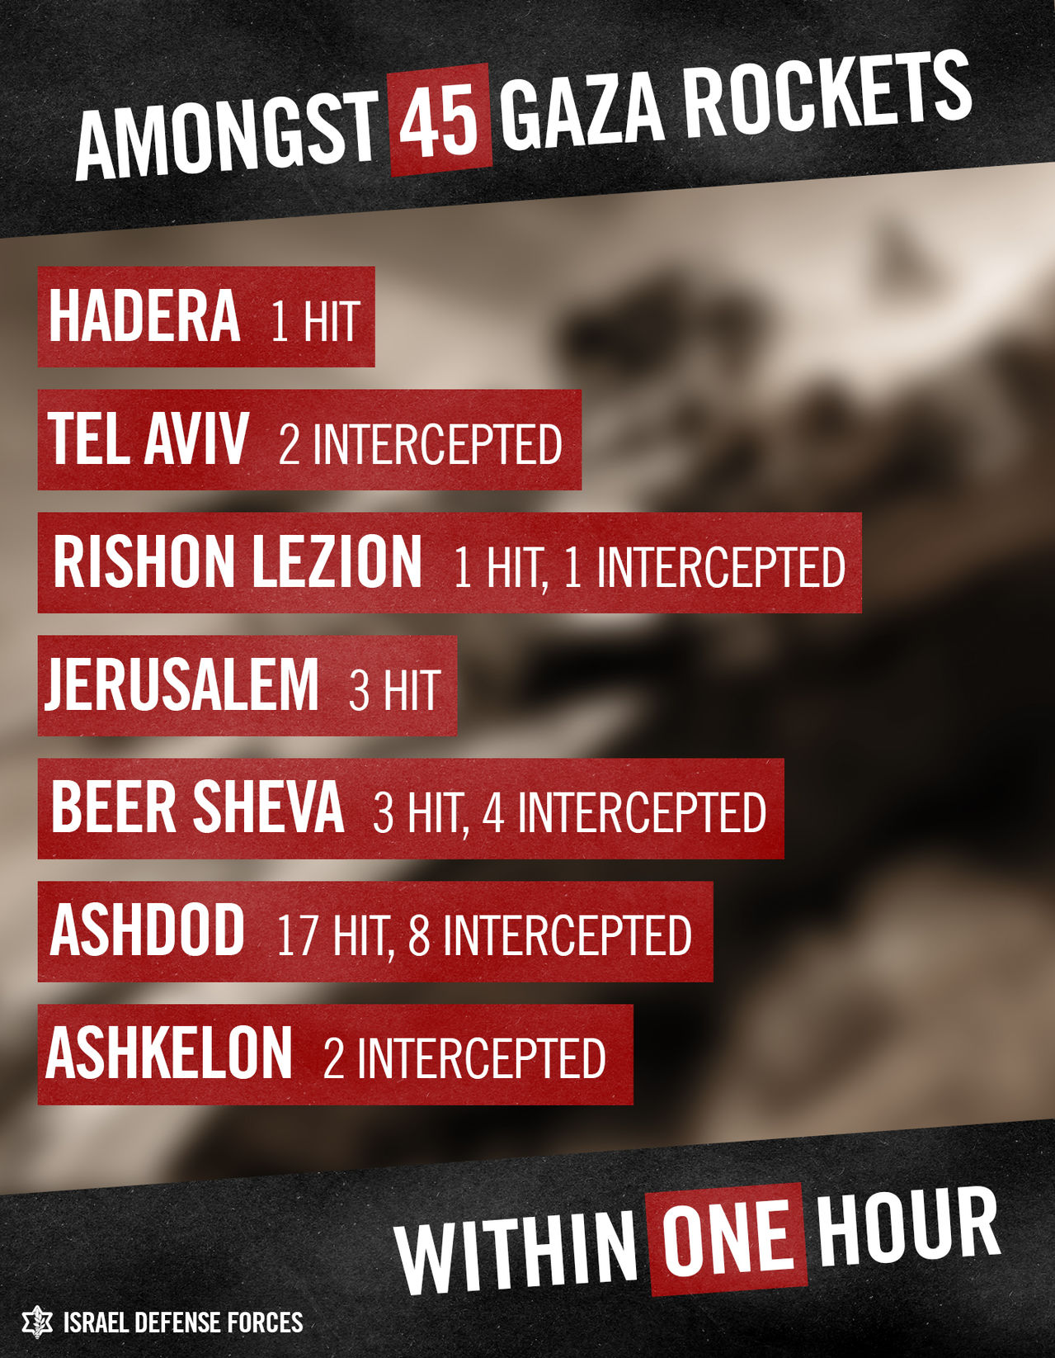

Tuesday, July 8
Summary of the day:
- More than 154 rockets were fired from Gaza towards Israel.
- At least 117 rockets struck Israel.
- 29 rockets were intercepted by the Iron Dome missile defense system
- The IDF hit 150 terror targets in the Gaza Strip.
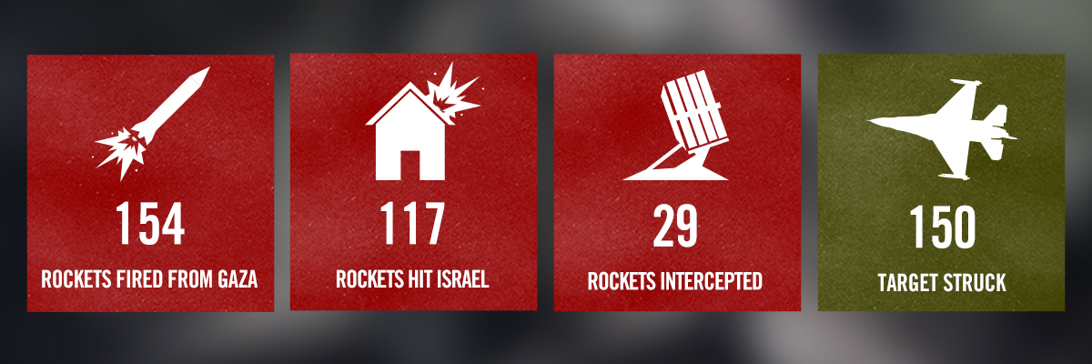

Updates by the Hour
11:51 PM: The IDF confirmed that a rocket fired from the Gaza Strip hit the city of Hadera, which is 100 km (62 miles) away from the Gaza Strip.
10:50 PM: A rocket from Gaza hit Israel’s capital city, Jerusalem.
10:05 PM: In the past 25 minutes, rocket sirens sounded across central Israel including the country’s biggest cities, Jerusalem and Tel Aviv. Within the last three hours, the sirens sounded multiple times in Tel Aviv.
9:50 PM: For the second time in less than 3 hours, rocket sirens sounded in Tel Aviv.
9:13 PM: Since the beginning of Operation Protective Edge, about 160 rockets have been fired at Israel. 116 of them hit Israel and 23 were intercepted. One of the rockets was intercepted over Tel Aviv. In response, the IDF has targeted 150 terror sites across the Gaza Strip. 5 senior Hamas operatives, 10 terror tunnels, 98 concealed rocket launchers, and 18 weapon storage and manufacturing facilities have been targeted. Of the weapon storage facilities, 5 of them were located inside mosques.
8:35 PM: Terrorists attempted to infiltrate a military base in southern Israel. Several gunmen arrived from the coast and attacked with grenades. Infantry forces were immediately called to the scene and with the assistance of the IAF and Israeli Navy, four terrorists were killed. One soldier was lightly injured. The IDF is currently searching the area for other perpetrators.
8:00 PM: Terrorists are attempting to infiltrate Israel from the sea. The IDF is currently confronting the threat.
7:05 PM: Rocket sirens sounded in Tel Aviv for the first time since Operation Pillar of Defense in November 2012.
5:00 PM: Hamas fired a rocket at Ashkelon. Iron Dome intercepted the rocket.
3:00 PM: In response to rocket fire at Israel, IDF aircraft struck Muhammad Sha’aban, a senior Hamas terrorist.
1:50 PM: IDF targeted a terror command center embedded within civilian infrastructure, alongside 40 other terror sites in Gaza.
11:00 AM: In the past hour, at least 16 rockets were fired at Israel. 5 were intercepted.
10:51 AM: The Iron Dome intercepted four rockets above Ashdod
10:50 AM: the Iron Dome system intercepted a rocket above Ashkelon
1:30 AM: IDF begins Operation Protective Edge, targeting terror sites throughout the Gaza Strip. The Hamas terrorist organization is responsible for all attacks originating in Gaza.

Monday, July 7
Gaza terrorists fired approximately 80 rockets at Israel throughout the day.

Updates by the Hour
8:16 PM: 20 rockets fired from Gaza at Israel. Four were intercepted by Iron Dome. 16 landed in open areas near Be’er Sheva.
Since “Operation Pillar of Defense” in November 2012, Hamas has continued to arm itself with vast amounts of weaponry and is currently in possession of 10,000 rockets. Hamas deliberately and systematically exploits Palestinians and uses them as human shields when firing at Israel. Over 3.5 million Israelis are currently living under the threat of rocket attacks. No nation would accept this reality.
