PHOTOS: IDF Exposes Hundreds of Palestinian Weapons in Nablus
IDF Blog
June 17, 2014
http://web.archive.org/web/20140806022323/http://www.idfblog.com/blog/2014/06/17/photos-idf-exposes-hundreds-palestinian-weapons-nablus/

IDF soldiers conducted an extensive operation last night, uncovering hundreds of weapons and explosives in Nablus. The forces arrested over 40 terrorist suspects and seized several Palestinian weapons caches. The mission continued Operation Brother’s Keeper, Israel’s extensive effort to find three Israeli teens kidnapped by Hamas terrorists.
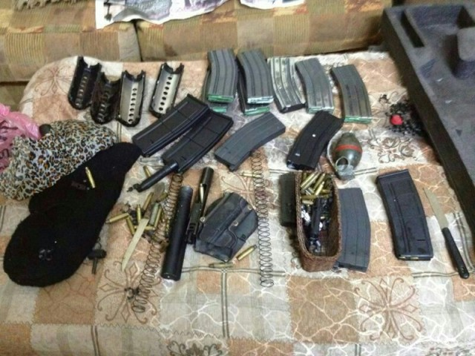
Weapons seized by the IDF in Judea and Samaria
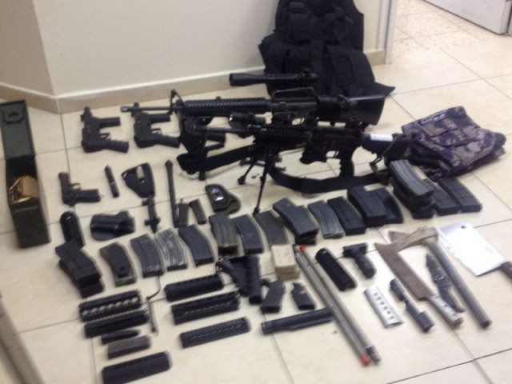
Weapons seized by the IDF in Judea and Samaria
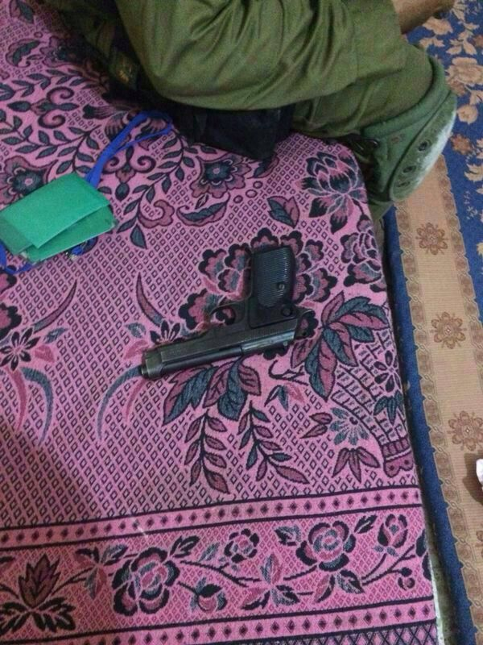
Weapons seized by the IDF in Judea and Samaria
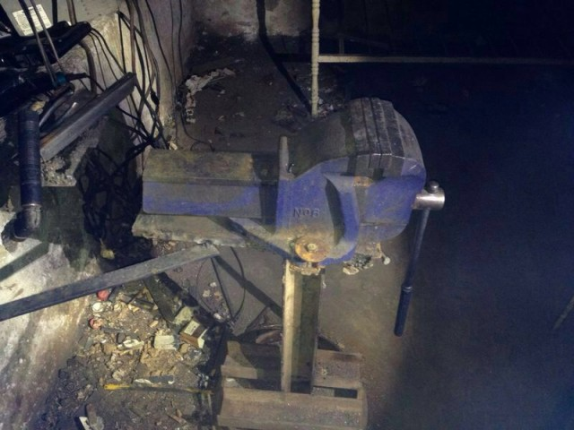
Weapons seized by the IDF in Judea and Samaria
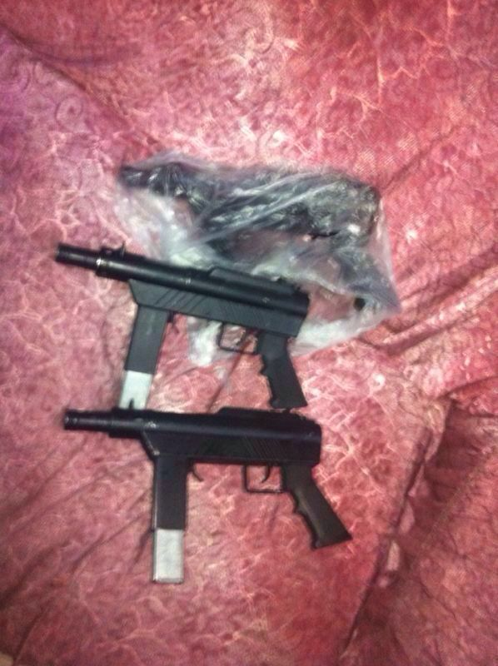
Weapons seized by the IDF in Judea and Samaria
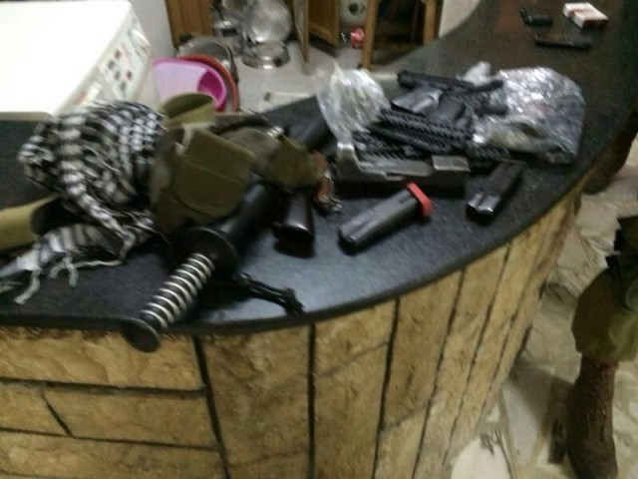
Weapons seized by the IDF in Judea and Samaria
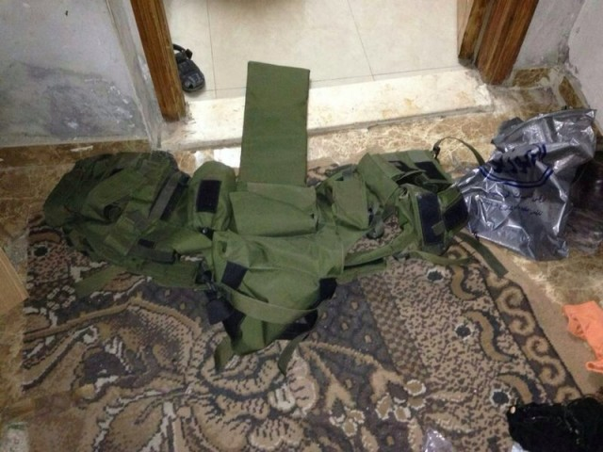
Weapons seized by the IDF in Judea and Samaria
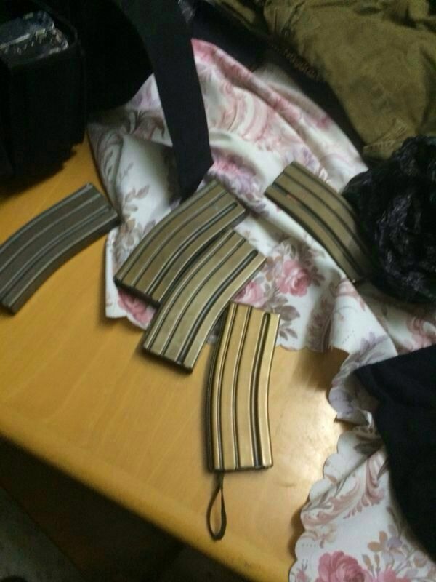
Weapons seized by the IDF in Judea and Samaria
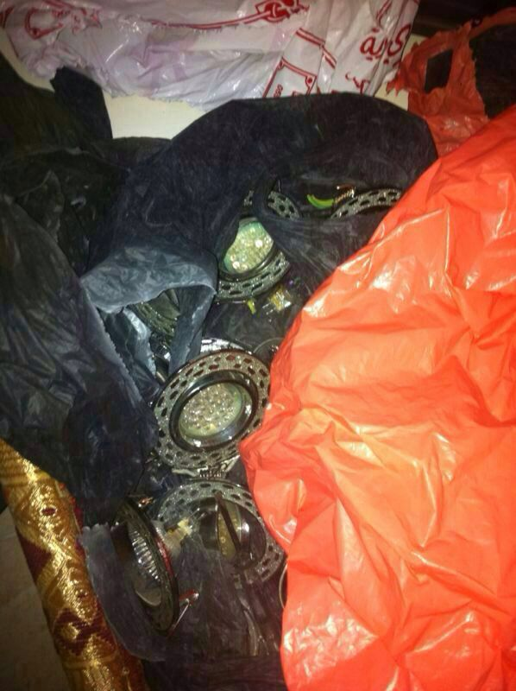
Weapons seized by the IDF in Judea and Samaria
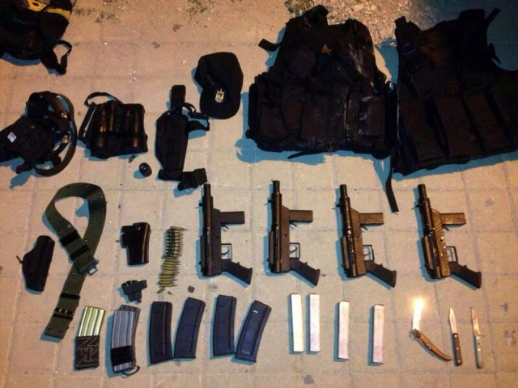
Weapons seized by the IDF in Judea and Samaria
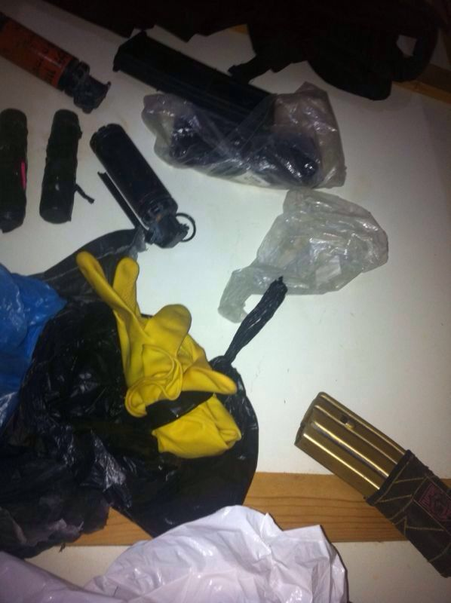
Weapons seized by the IDF in Judea and Samaria
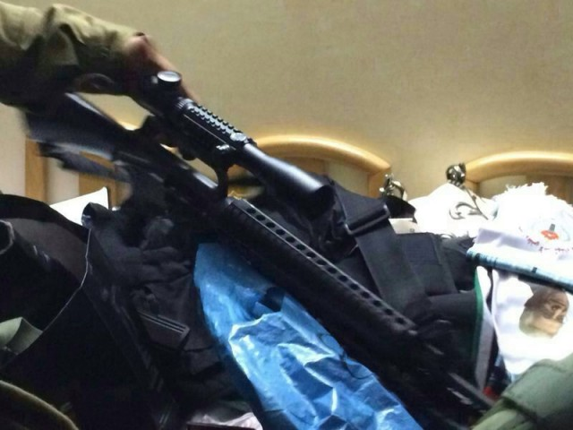
Weapons seized by the IDF in Judea and Samaria
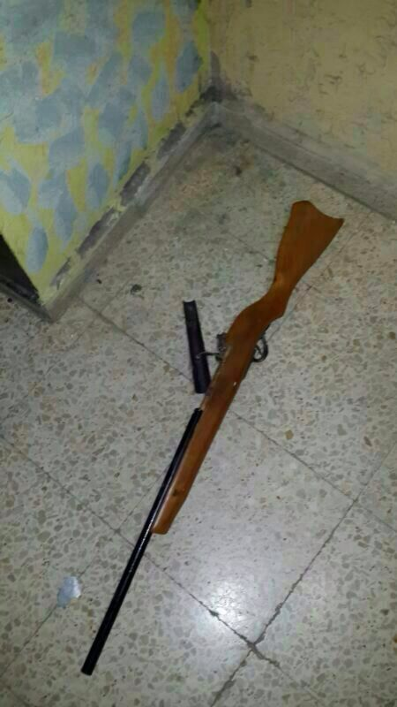
Weapons seized by the IDF in Judea and Samaria
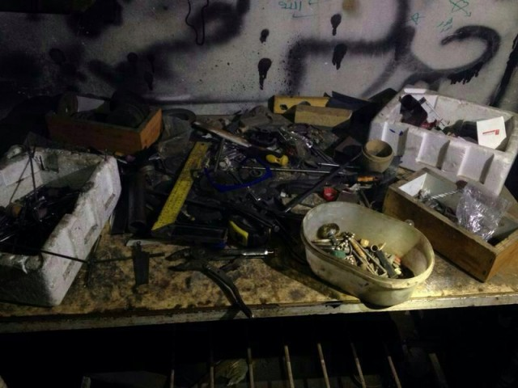
Weapons seized by the IDF in Judea and Samaria
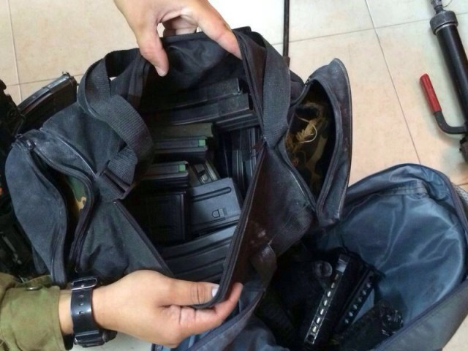
Weapons seized by the IDF in Judea and Samaria
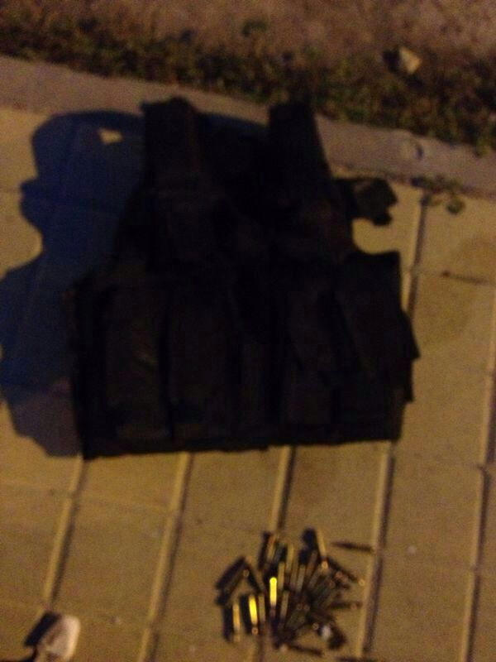
Weapons seized by the IDF in Judea and Samaria
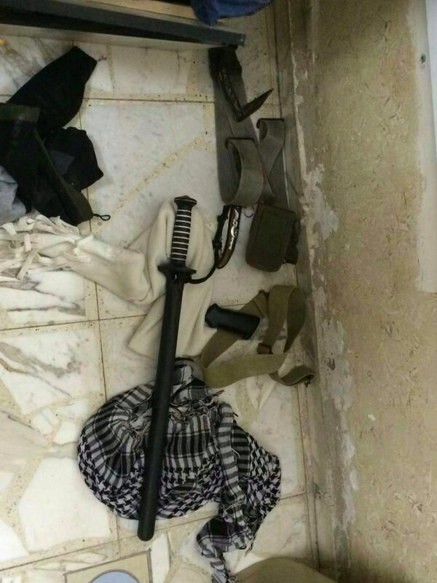
Weapons seized by the IDF in Judea and Samaria
Weapons seized by the IDF in Judea and Samaria
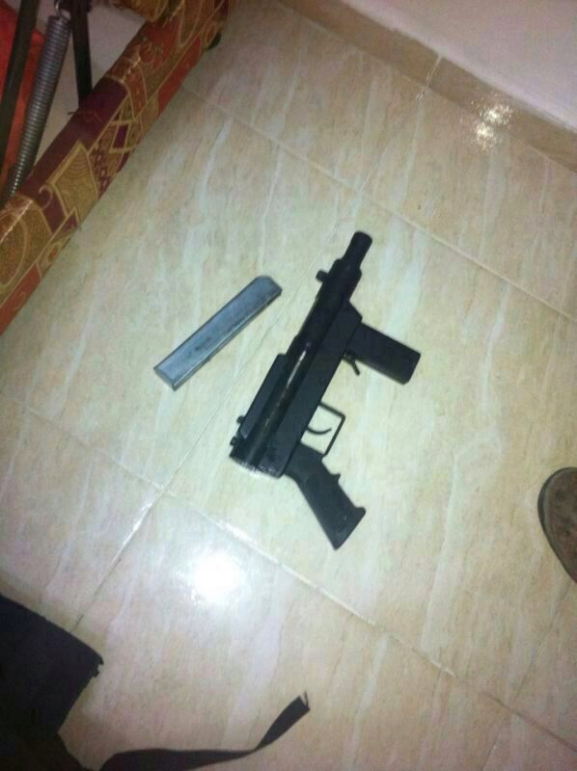
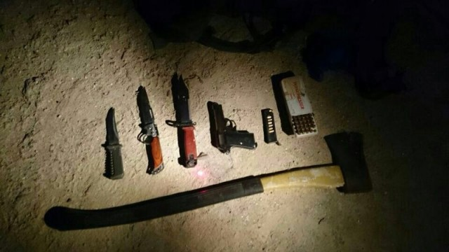
Weapons seized by the IDF in Judea and Samaria
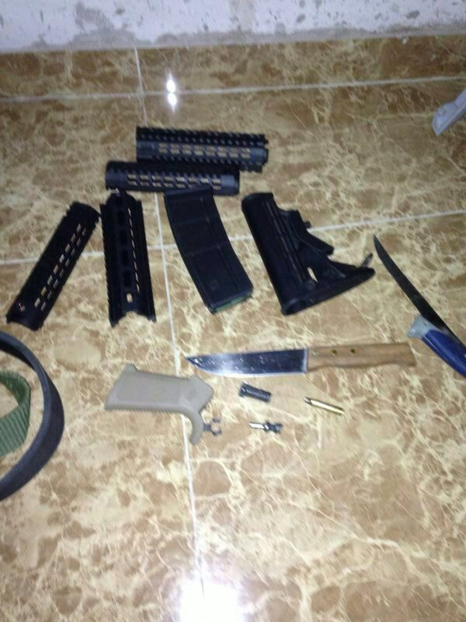
Weapons seized by the IDF in Judea and Samaria
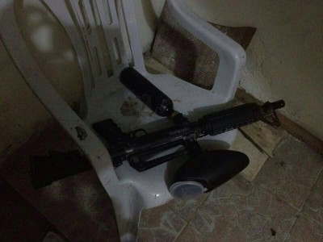
Weapons seized by the IDF in Judea and Samaria

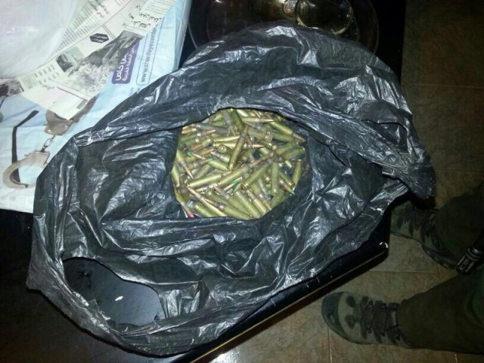
Weapons seized by the IDF in Judea and Samaria

[EMBEDDED VIDEO: https://youtu.be/qQihFdS1SKM]

