PHOTOS: IDF Finds Weapons throughout Gaza
IDF Blog
July 26, 2014
http://web.archive.org/web/20140806022111/http://www.idfblog.com/blog/2014/07/26/photos-idf-finds-weapons-throughout-gaza/

Since launching the ground phase of Operation Protective Edge, the IDF has found an enormous amount of weapons in the Gaza Strip. Hamas is known to keep munitions in homes, schools, mosques and hospitals. In many cases, IDF forces have found Hamas weapons caches in underground tunnels.
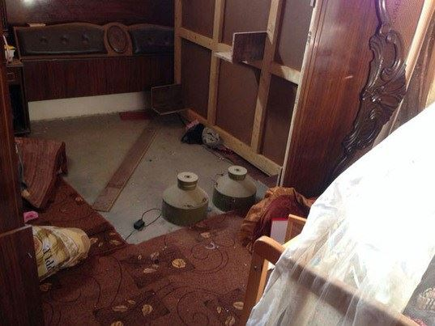
The Maglan special forces unit found explosives two steps away from a baby’s bed.
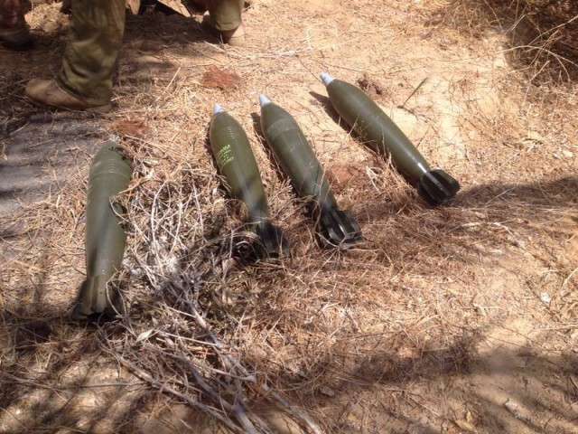
June 24: Four rockets found inside a terror tunnel by paratroopers

[EMBEDDED VIDEO: https://youtu.be/Pywx1rRXbHU]

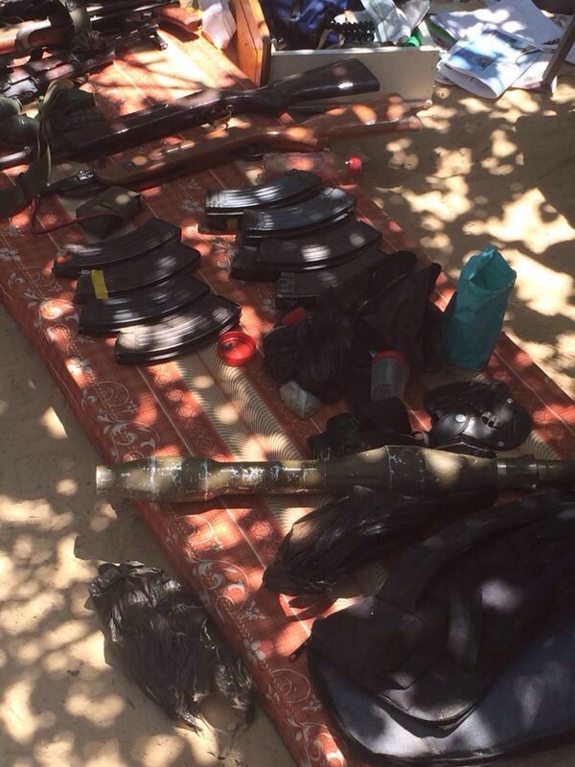
July 25: Weapons and ammunition found in Gaza by the Maglan special forces unit.
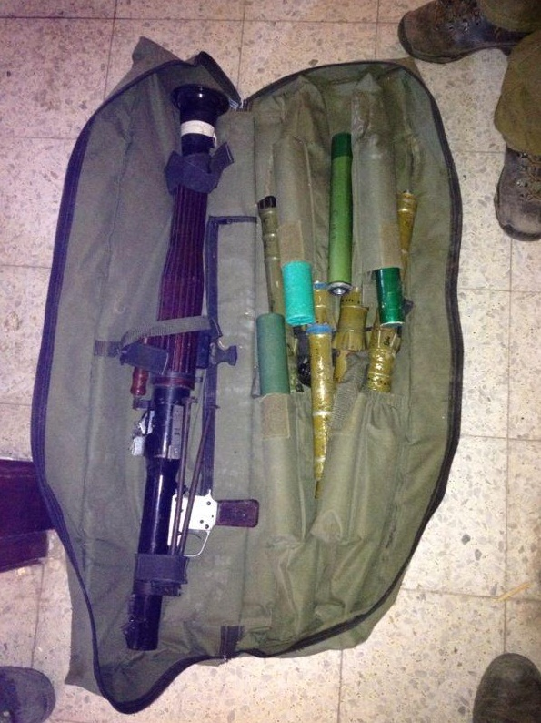
June 24: Golani Brigade special forces found these automatic rifles, RPGs and ammunition hidden in Shuja’iya.
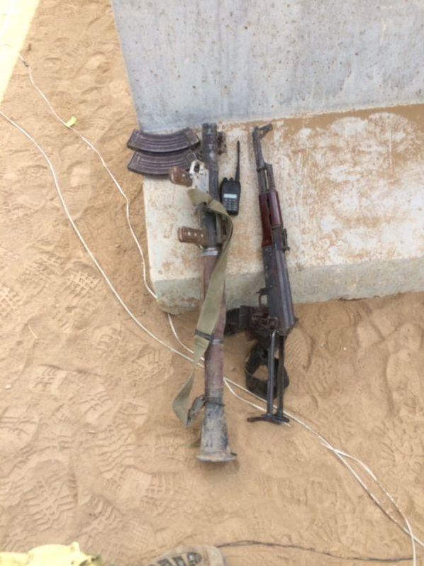
June 24: Golani Brigade special found these automatic rifles, RPGs and ammunition hidden in Shuja’iya.
On June 25, IDF Paratroopers uncovered a massive weapons cache belonging to Hamas terrorists. Among the many weapons found were RPGs, hand grenades and suicide vests ready for use and material to make more.
Hamas terrorists attempted to infiltrate Israel through an underground tunnel on July 19. IDF forces opened fire at the infiltrators, killing one terrorist and preventing a massacre in Israel. This is what the terrorists left behind.
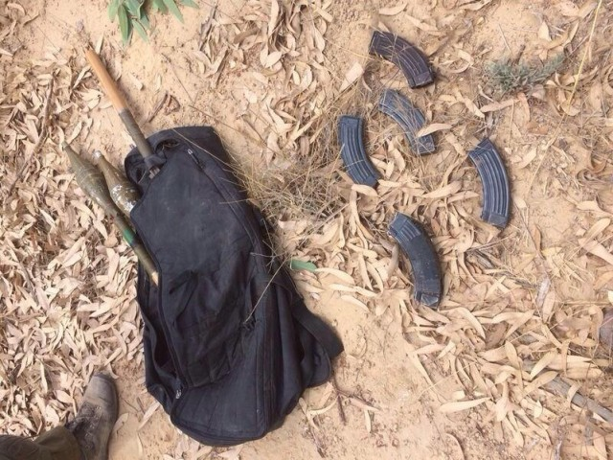
Weapons left behind from terrorists who infiltrated Israel through a tunnel on July 19.
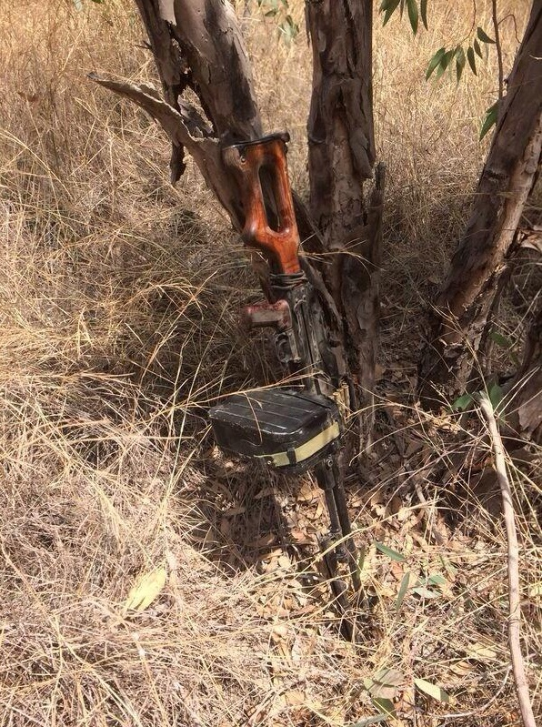
Weapons left behind from terrorists who infiltrated Israel through a tunnel on July 19.
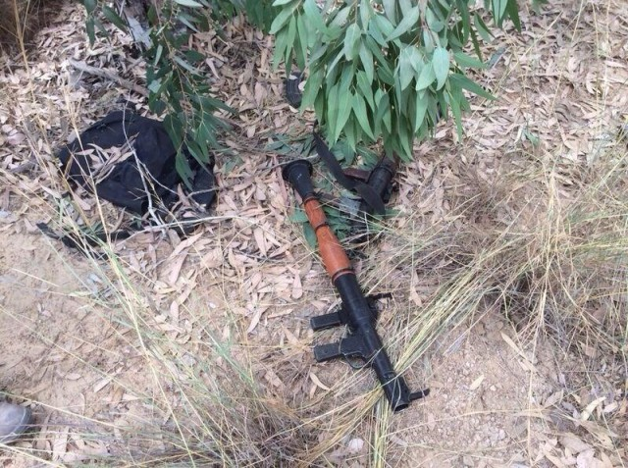
Weapons left behind from terrorists who infiltrated Israel through a tunnel on July 19.
Soldiers found grenades, ammunition and other weapons in a tunnel on July 24.
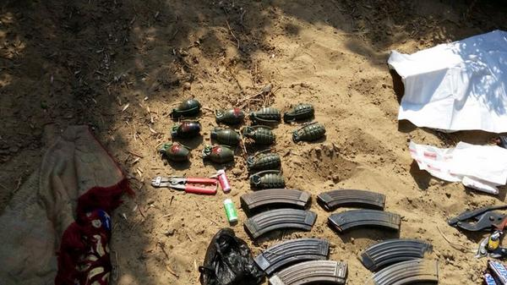
On the same day, Paratroopers found mortars, ammunition vests, combat gear and other weapons in a building in Khan Yunis.

[EMBEDDED VIDEO: https://youtu.be/tAkBy8BfS6A]

On July 21, The IDF Nahal Brigade inspected the grounds of an agricultural school in Beit Hanoun, Gaza, and discovered Grad rocket launchers. Some of the launchers still had rockets in them and were ready to be be fired. Hamas has shot many rockets at Israel from this location.
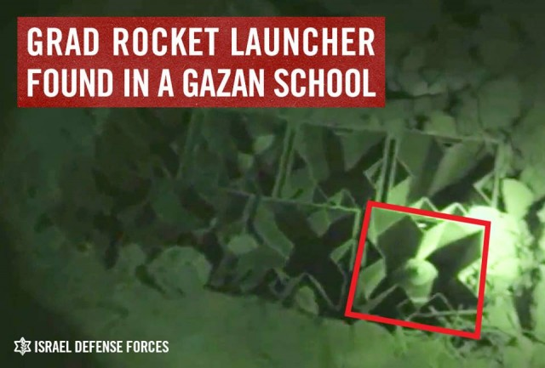
Other weapons found during Operation Protective Edge:
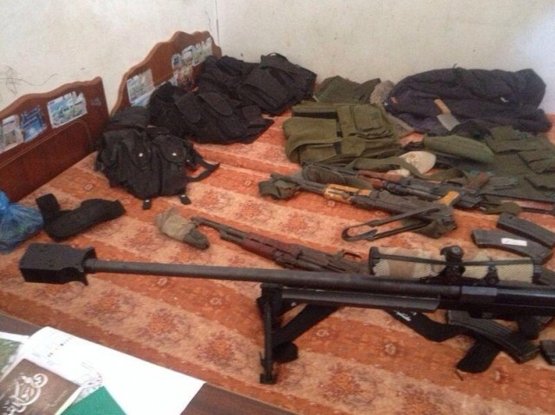
These weapons were found in Khan Yunis.
Soldiers found these weapons in a number of operations throughout Gaza.
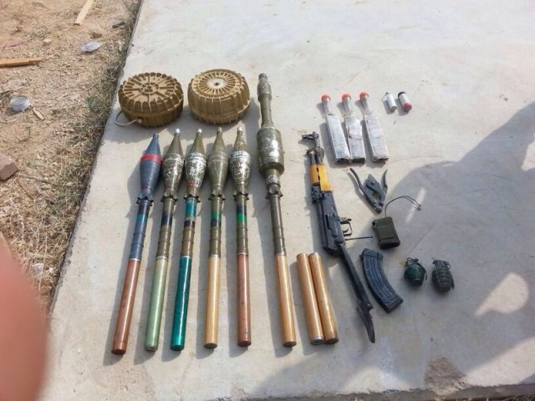
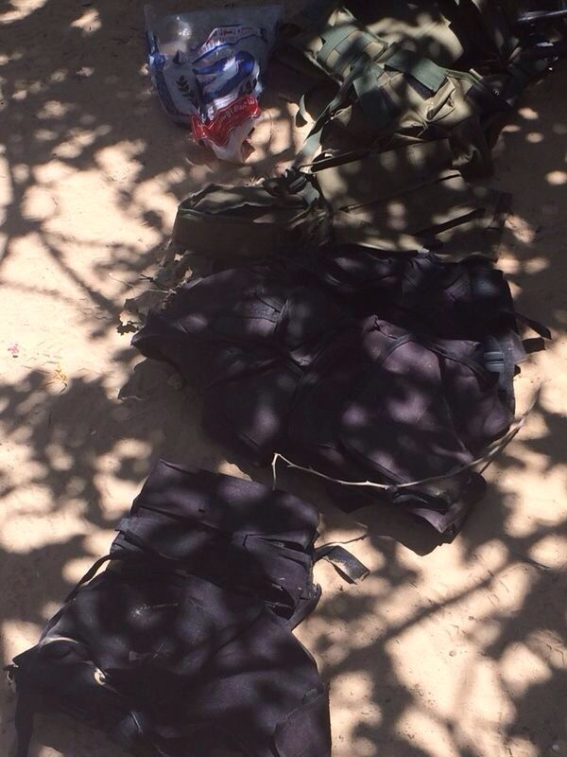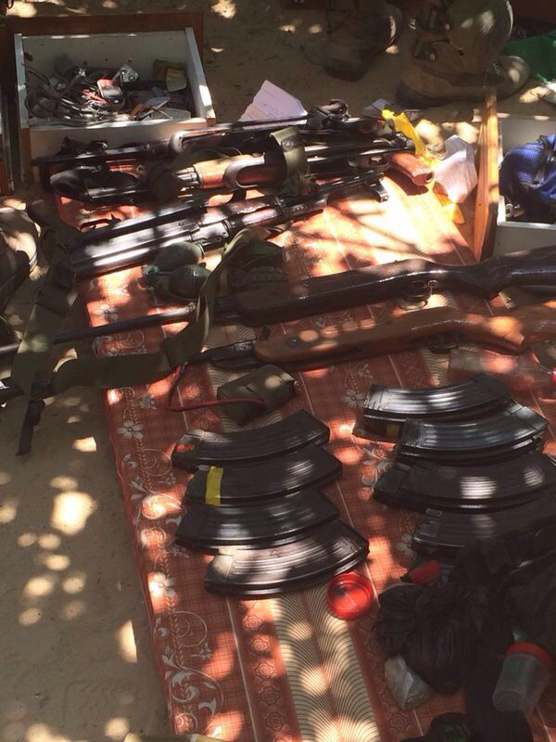
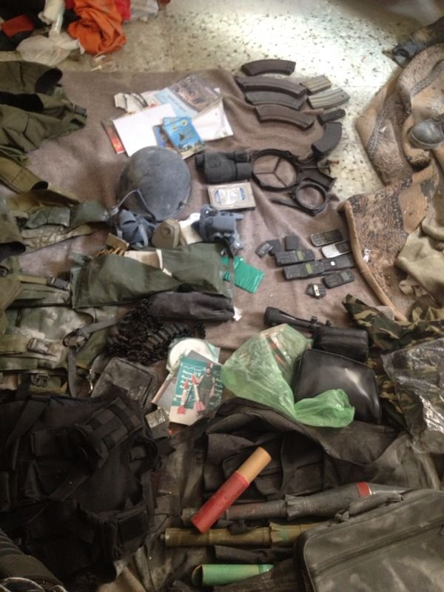
Weapons found in civilian building throughout Gaza

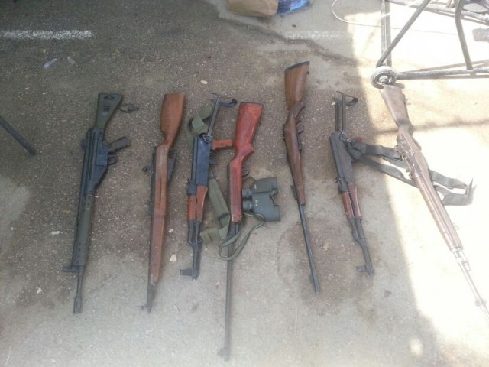

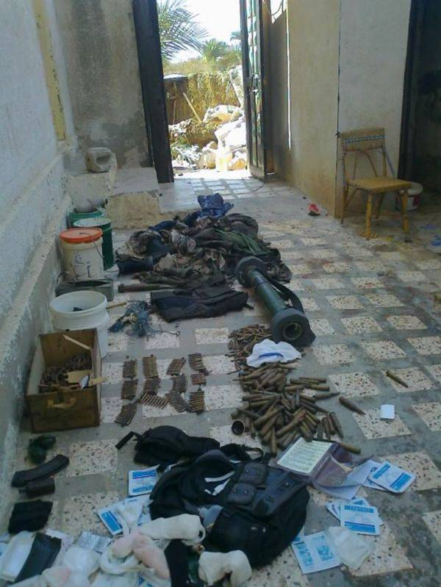

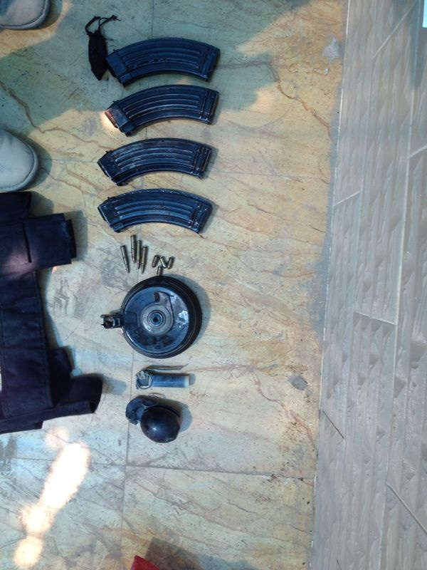
Ammunition found by 7th Brigade in a house in Gaza

Vidoes of seized weapons caches:
July 17: IDF forces identified approximately 13 terrorists attempting to infiltrate Israel through a terror tunnel constructed by Hamas. The IDF stopped the terrorists and took video of the weapons they left behind.
[EMBEDDED VIDEO: https://youtu.be/xjkwIMRZI8o]

During an overnight operation on July 25, soldiers from the Nahal Brigade uncovered a large weapons cache inside a civilian house in Gaza.

[EMBEDDED VIDEO: https://youtu.be/OsL0kkcFB9w]

In the southern Gaza Strip, the IDF Givati Brigade found explosives on doors of homes and mines on streets.

[EMBEDDED VIDEO: https://youtu.be/0fze6qHvzgQ]

[EMBEDDED VIDEO: https://youtu.be/QiclM2pM29k]

