Palestinians Praise Kidnapping of 3 Israeli Teenagers
IDF Blog
June 15, 2014
https://web.archive.org/web/20140806025013/http://www.idfblog.com/blog/2014/06/15/palestinians-praise-kidnapping-3-israeli-teenagers/

On the streets and over the internet, Palestinians are voicing their support for the terrorists who kidnapped three young Israelis.
On Thursday night, Hamas terrorists kidnapped three Israeli teenagers in Judea and Samaria. For more than two days, IDF forces have conducted a widespread operation in order to locate the teens. Meanwhile, Palestinians have been voicing their support for the kidnapping and calling for further abductions.
Soon after Thursday’s kidnapping, terrorist organizations praised the attack and urged Palestinians in Judea and Samaria to hamper the IDF’s efforts to locate the boys. Senior Hamas [EDITOR’S NOTE: LINK GOES TO AN APRIL 2, 2014 IDF BLOG ARTICLE ENTITLED “Meet the Man Standing Between Israel and Hamas’ Terror Tunnels”] and Palestinian Islamic Jihad officials have called for the kidnapping of more Israelis, with the insidious intention of trading them for convicted terrorists.
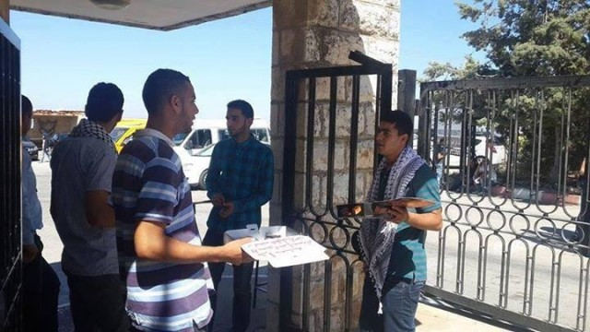
University students in Birzeit University distribute sweets in celebration of the kidnapping of the three Israeli teenagers.
Upon hearing of the abduction, Palestinians handed out candy in the streets and posted messages lauding the incident on social media sites. On Friday, Palestinians initiated a Facebook campaign expressing support for the terrorist kidnapping. Dozens changed their Facebook profiles, posting pictures of three fingers meant to represent the abducted teens. Meanwhile, comics featuring slogans such as #Three_”GiladShalits” and “Hebron_Uprising” began spreading over the internet.
The kidnapping Mondial: Gaza 1, Judea and Samaria 3
”That moment when you hear that three Israelis abducted in Hebron are settlers.”
#Three_GiladShalits

Three settlers abducted in one kidnapping. 3 settlers x 1

Since 2013, the IDF and ISA have foiled over 64 kidnapping attempts, [EDITOR’S NOTE: LINK GOES TO A DECEMBER 4, 2013 IDF BLOG ARTICLE ENTITLED “Palestinian Terrorists Determined to Kidnap Israeli Soldiers”] but terrorists remain motivated to abduct Israelis. Hamas has put considerable effort into kidnapping attempts through its large network.
The kidnappings are part of a broad terrorist strategy. Terrorist organizations use the victims as bargaining chips to force decision makers in Israel to accede to their demands.
Last September, a Palestinian terrorist lured Sgt. Tomer Hazan [EDITOR’S NOTE: LINK GOES TO A SEPTEMBER 21, 2013 ARTICLE ENTITLED “Joint IDF and ISA Operation Exposes Murder of an IDF Soldier”] to a Palestinian village in central Judea and Samaria and murdered him. During an interrogation, the terrorist admitted his plans to trade Sgt. Hazan’s body for the release of his brother – a convicted terrorist imprisoned in Israel for involvement in multiple terror attacks.
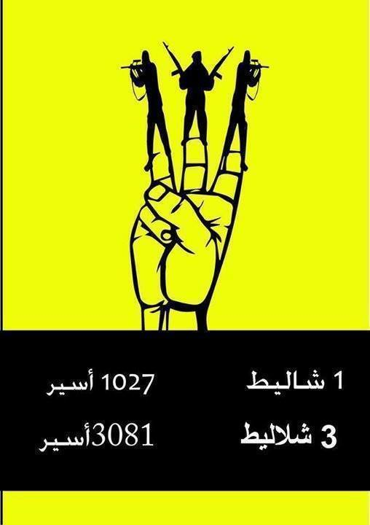
1 Shalit=1027 prisoners, 3 Shalits= 3081 prisoners
Until today, Palestinian terrorists have viewed the capture of 1st Sgt. Gilad Shalit [EDITOR’S NOTE: LINK GOES TO A OCTOBER 18, 2012 IDF BLOG ARTICLE ENTITLED “Reliving History: The Day Gilad Shalit Returned Home”] in 2006 as a key accomplishment, increasing their determination to kidnap Israelis and trade them for Palestinian prisoners. In 2011, as part of the deal to secure Shalit’s freedom, Israel released 1,027 convicted terrorists and Hamas operatives. Among the released were those serving life sentences for perpetrating some of the most severe terror attacks [EDITOR’S NOTE: LINK GOES TO A MAY 8, 2013 IDF BLOG ARTICLE ENTITLED “Infographic: Palestinians Committed Hundreds of Terror Attacks in April”] in Israel’s history.
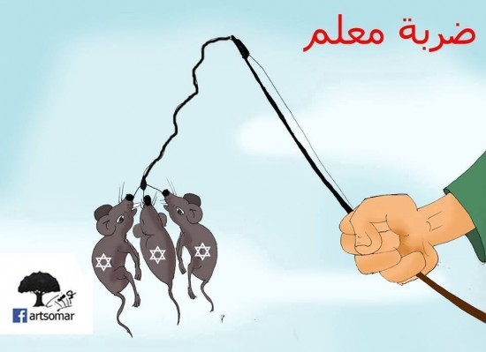
A hard strike [A blow that teaches a lesson]
Palestinians have shown concerning levels of support for Thursday’s kidnapping. Israeli civilians are under a significant threat, and the IDF will respond as necessary to protect Israel from abductions and other acts of terror.
More from the web:
The Palestinian public continues to celebrate the kidnapping of the three Israeli teens with the “3″ social media campaign.
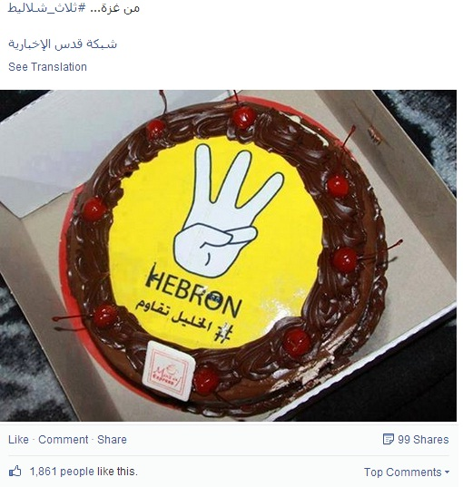
Palestinians in Gaza celebrate kidnapping with cake
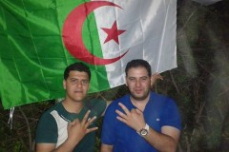

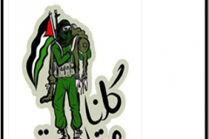
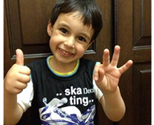

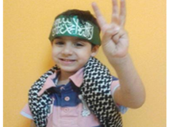
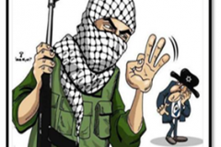

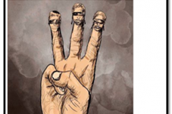
Woman participating in the “3″ social media campaign

