Photo: A parking lot in Ashdod, Israel, destroyed by Gaza rocket attacks
IDF Blog
July 9, 2014
http://web.archive.org/web/20151118135530/https://www.idfblog.com/blog/2014/07/09/israel-fire-life-comes-halt/%D7%A4%D7%92%D7%99%D7%A2%D7%AA-%D7%98%D7%99%D7%9C-%D7%92%D7%A8%D7%90%D7%93-%D7%91%D7%90%D7%A9%D7%93%D7%95%D7%93/

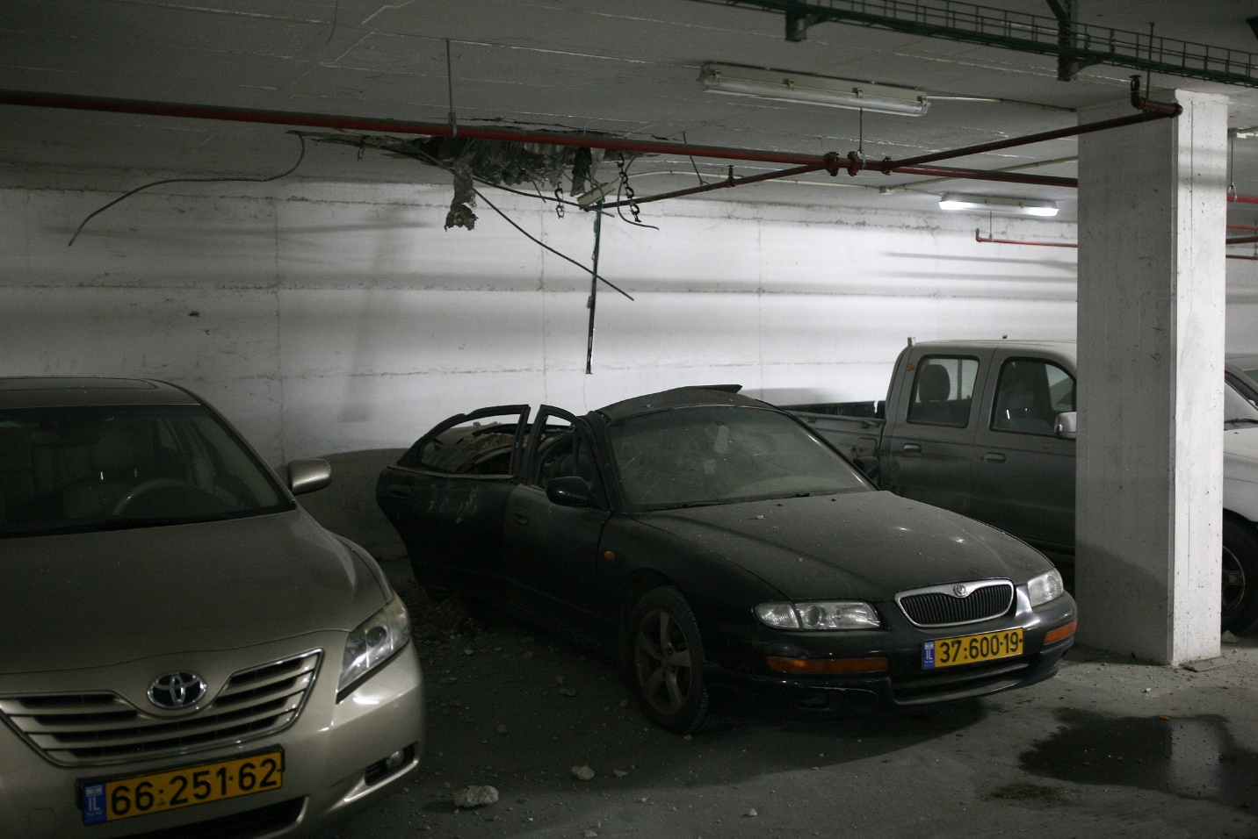A parking lot in Ashdod, Israel, destroyed by Gaza rocket attacks.

