Photo: Civilians in Tel-Aviv lay on the ground in refuge of Gaza rocket attack
IDF Blog
July 9, 2014
http://web.archive.org/web/20151119023640/https://www.idfblog.com/blog/2014/07/09/israel-fire-life-comes-halt/14425451027_2f821e9c16_o-1/

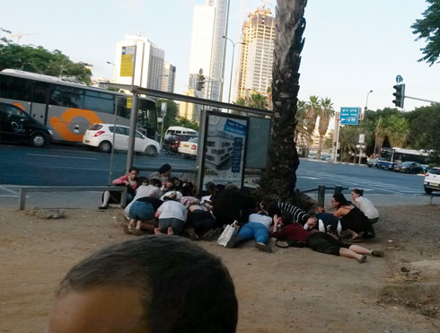
Civilians in Tel-Aviv lay on the ground in refuge of Gaza rocket attack

