Pinpoint Strikes: Targeting Terrorists, Avoiding Civilians
IDF Blog
July 11, 2014
http://web.archive.org/web/20140812201906/http://www.idfblog.com/blog/2014/07/11/pinpoint-strikes-targeting-terrorists-avoiding-civilians/

Hamas has intentionally embedded its military infrastructure within the densely packed civilian areas of the Gaza Strip, with the full knowledge that it endangers Palestinian lives. The IDF works to the best of its ability to limit civilian casualties by using precision attacks on Hamas’ terror sites and providing warnings of strikes in advance.
Throughout Operation Protective Edge, the IDF has made extensive use of tactics to avoid civilian casualties in the Gaza Strip. As the operation progresses, the IDF is gathering more evidence that Hamas takes advantage of the densely populated Gaza Strip and civilian population to protect themselves.
In a prime example of the IDF’s precision capabilities, an airstrike was carried out on a car carrying three senior terrorists of Palestinian Islamic Jihad. The car was targeted perfectly, but the surrounding area and individuals were left unharmed.

[EMBEDDED VIDEO: www.youtube.com/watch?v=pGS0A6zxgoc]

In another video, the IDF uses guided missiles to carry out strikes on targets with the utmost precision.

[EMBEDDED VIDEO: https://youtu.be/mBkTmfr4oHw]

Hamas Exploits Civilians
As Hamas fires rockets on Israel, it systematically exploits Palestinian civilians as human shields for military targets in Gaza. Hamas stores explosives and weapons in and around schools, mosques, residential homes and other civilian infrastructures.
These images, taken by the Israel Air Force, show how Hamas positions its rocket launching sites, weapons caches, and command centers in areas surrounded by civilian buildings.
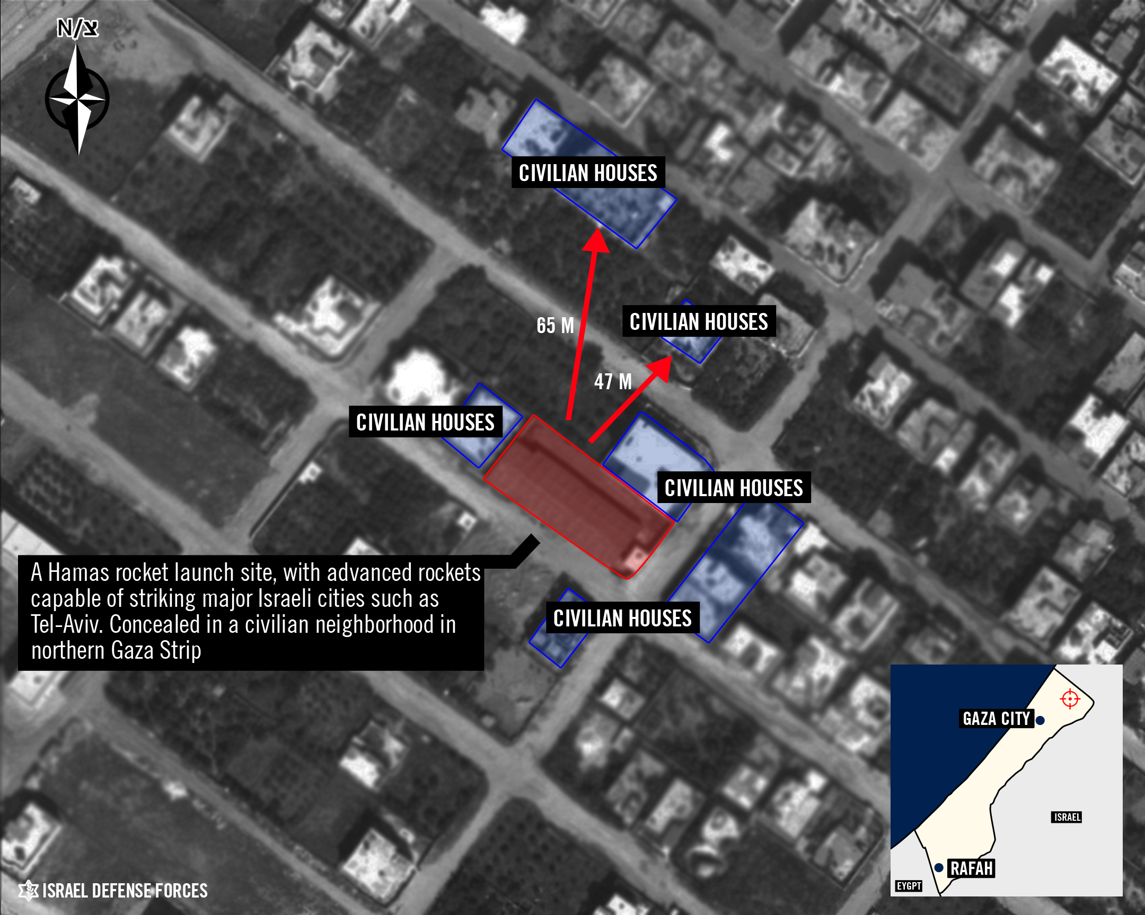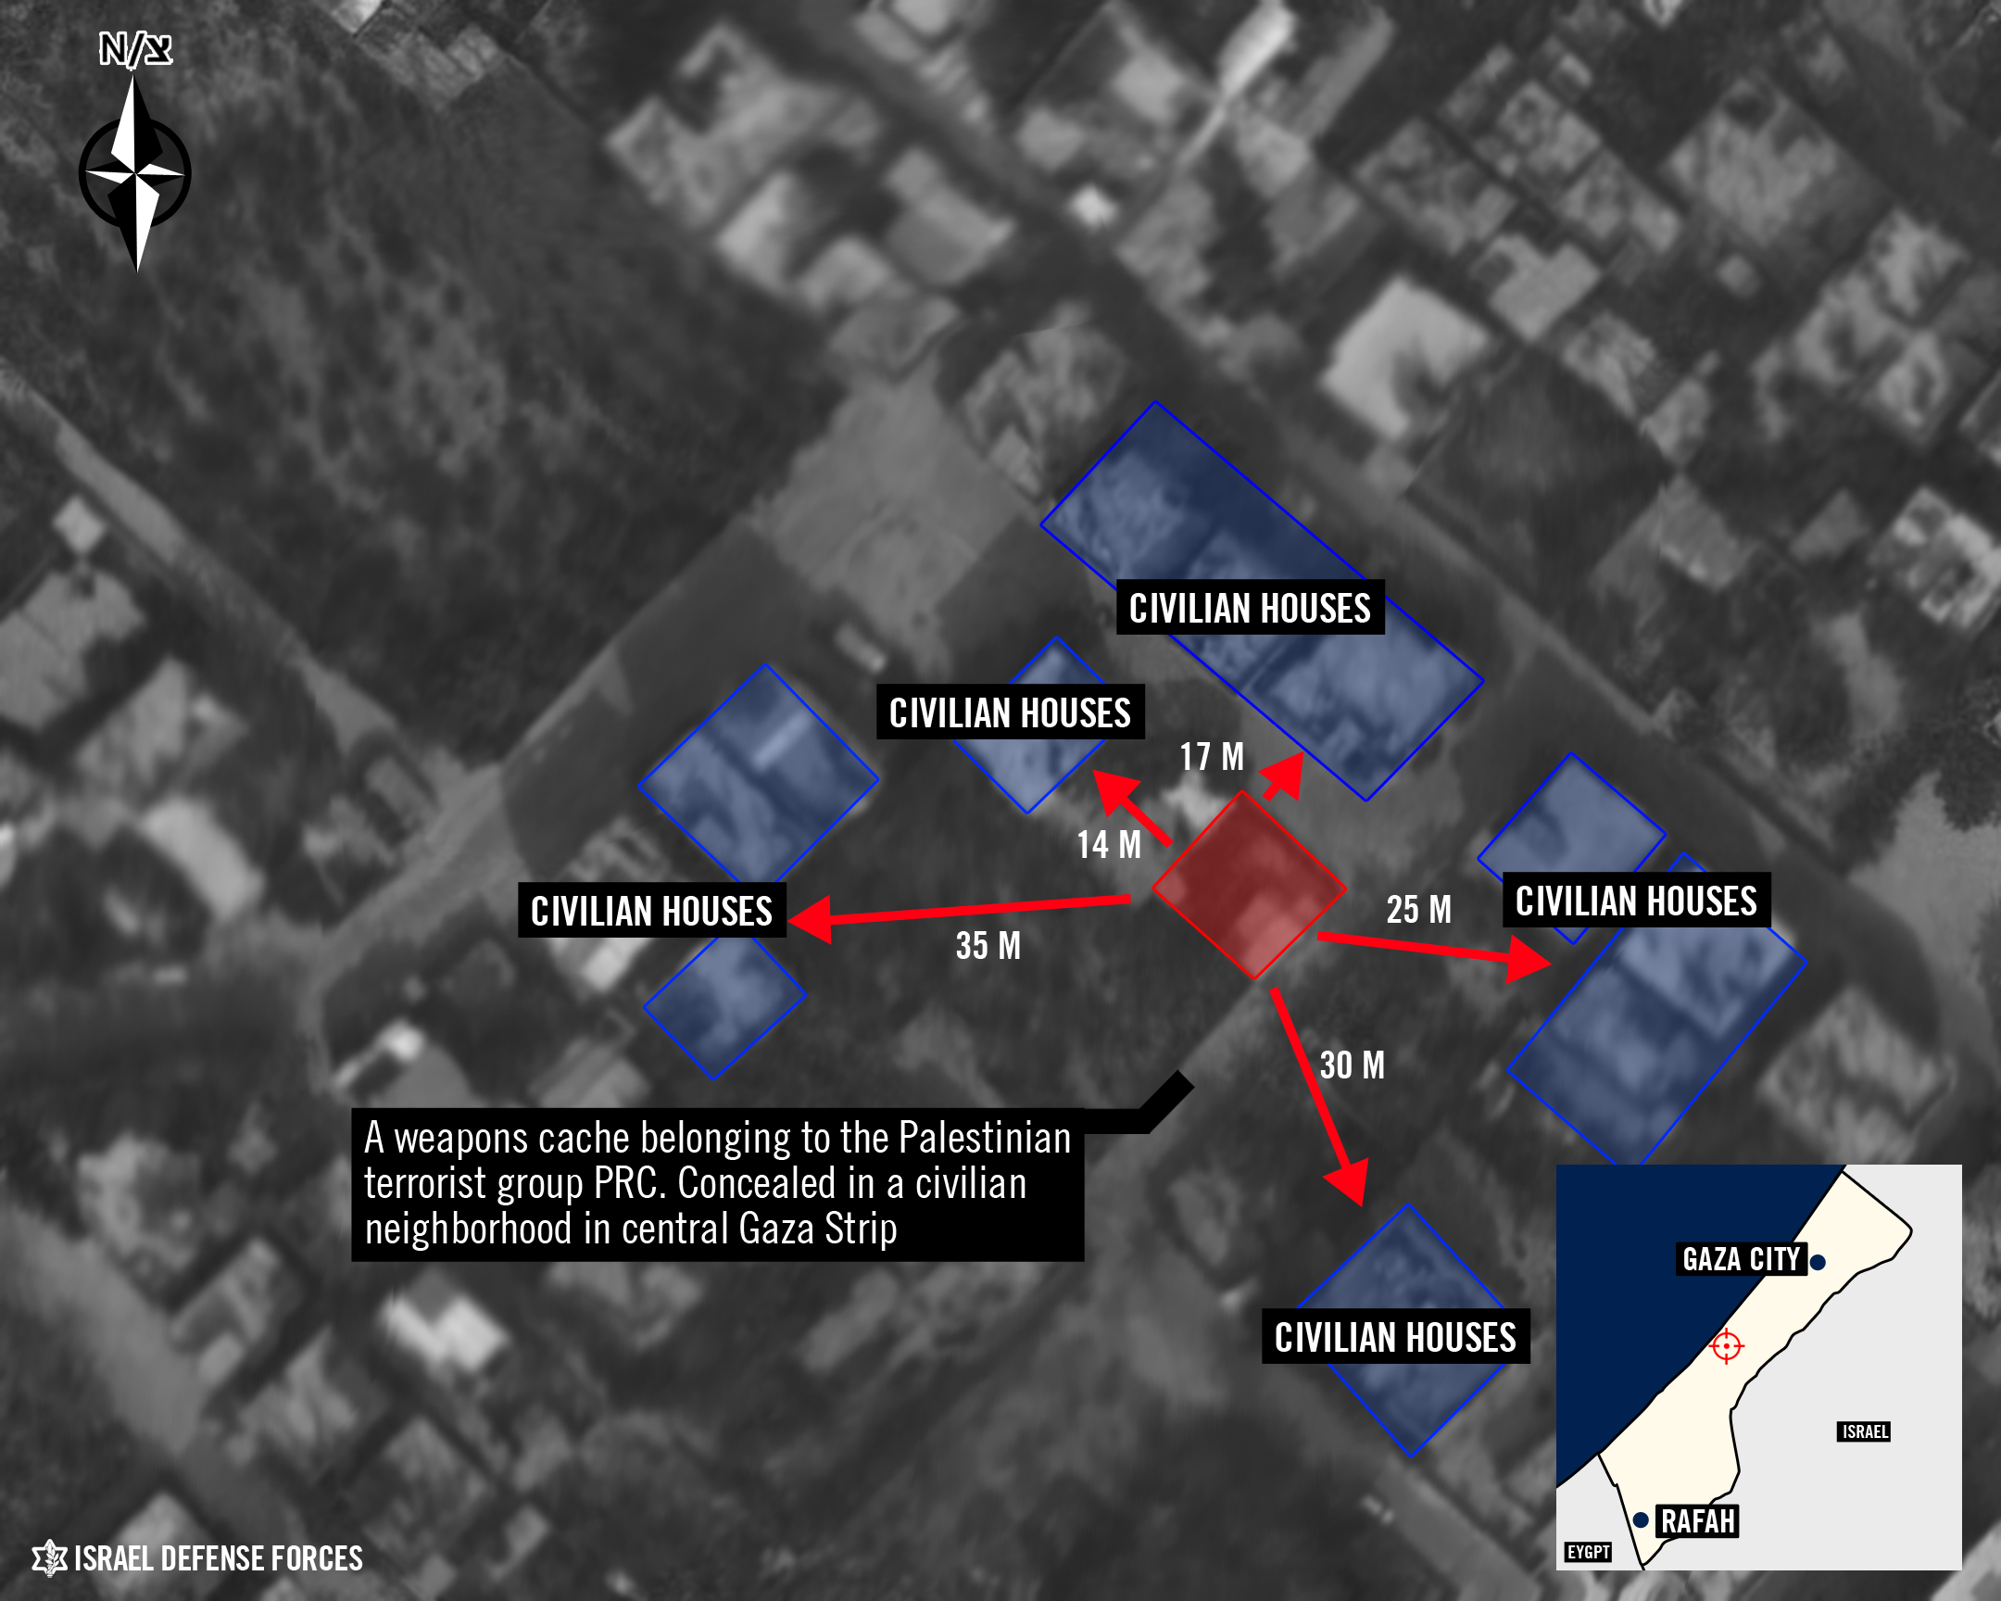
In order to limit the casualties to innocent bystanders, the IDF uses a number of tactics including precision airstrikes on weapons caches, tunnels, and other terror targets.

[EMBEDDED VIDEO: https://youtu.be/0e3xv7pI93M]

The following videos show recent precision strikes on terror sites that were located next to schools, which were left unharmed.

[EMBEDDED VIDEO: https://youtu.be/a5kosi4elOE]

[EMBEDDED VIDEO: https://youtu.be/8s_Bv9wKdw0]

On July 9, the IDF targeted terror tunnels in the Gaza Strip. The precision attacks caused secondary explosions inside the tunnels, destroying the explosives stored inside and proving that the tunnels contained weapons caches near Palestinian homes.

The IDF Warns Before Striking
As a warning tactic, the IDF targets buildings with loud but non-lethal bombs, meant to warn civilians that they are in the vicinity of a weapons cache or other target. This method is used to allow the residents to leave the area before the IDF targets the site with live ammunition.
The following video shows how Hamas exploits the IDF’s efforts to avoid civilian casualties. On July 9, Palestinians fled a Hamas target after the IDF fired a warning shot. Moments later, other residents flocked to the roof to act as human shields. The Israeli aircraft called off the strike in order to avoid casualties.

Despite these challenges, the IDF will continue to act against Hamas terror in order to defend its citizens.

