FOR IMMEDIATE RELEASE

Former Slave’s Hunger Strike Reaches Day 33
Human Rights Activist Simon Deng Protesting at White House & United Nations
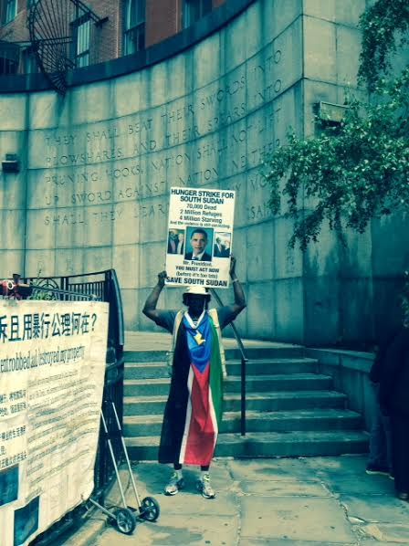

Simon Deng outside the United Nations at the Sharansky Steps in New York City
(photo credit: Heather Robinson)

New York, NY (Monday, June 15, 2015) - Today marks the 32nd day of Simon Aban Deng’s hunger strike for South Sudan. Though Mr. Deng—a former child-slave turned competitive swimming champion in Sudan, now a human rights activist & New York City lifeguard supervisor—is growing weaker by the day, he remains resolute. Until President Obama and his administration signal an immediate shift in U.S. policy toward South Sudan, Simon will continue his fast.

WHAT: Hunger strike for South Sudan
WHO: Simon Deng, activist and former child-slave
WHERE: Sharansky Steps, E. 43rd St at 1st Avenue, by the United Nations
WHEN: 9am to 12 noon, TODAY (and for the forseeable future)

“If I must die on the steps of the White House, then so be it,” Mr. Deng said last month in Washington, D.C. In order to be closer to his family at this stage of his prolonged fast, he is now protesting mainly in New York City. Supporters & members of the media can find him each day between 9am and 12pm outside the UN, near the Sharansky Steps at 43rd Street & 1st Avenue.

“The world is a better place today thanks to people throughout history standing up for what they believe,” says Mr. Deng. “The war and destruction in South Sudan has become a slow-motion genocide, and we people of conscience must stand up if we are ever going to stop it. My hunger strike must be just one part of a larger movement. Together we must pursue all possible avenues to achieve peace. We must never stop working toward peace.”

BACKGROUND:

Over the past year of violence in South Sudan—which became independent from Sudan in July 2011—some 70,000 people have been killed, some 2 million have been driven from their homes, and over 4 million are currently at risk of starvation, all due to the internecine conflict between South Sudanese rulers (and former allies) President Salva Kiir and former Vice President Riek Machar.

In an open letter to President Obama sent on May 15th, the first day of the fast, Mr. Deng likened South Sudan to an infant, brought into existence with the U.S. as midwife, but then abandoned to fend for itself. “We brought freedom to South Sudan,” Mr. Deng writes. “It is our baby. We cannot allow it the freedom to fail.”

Mr. Deng addressed President Obama directly: “I call on you today to prove your commitment to the people of South Sudan. You alone can force a peaceful end to this insanity. It will not require ‘US boots on the ground,’ but it will require consistent engagement, seriousness of purpose, and a willingness to both make threats and follow through on them. In short, it will require your leadership.”

Mr. Deng’s hunger strike has made news in Juba and across South Sudan, but has been largely ignored by U.S. media. High-profile supporters—including comedian/activist Dick Gregory, radio host Joe Madison, and Enough Project Co-Founder John Prendergast—were frequent visitors while Mr. Deng was in Washington, DC, yet few in the public even know that South Sudan exists—let alone that it is being destroyed by a senseless civil war. Mr. Deng remains optimistic that his action will bring much-needed public attention to the plight of his people, and that US policy could completely change the situation on the ground.
“I will be starving myself until the U.S. makes perfectly clear that the war in South Sudan is unacceptable—and we will not stand for it.” -Simon Deng

South Sudanese-Americans join Simon outside the White House

SIMON DENG BIOGRAPHY:

Simon Aban Deng grew up in Malakal, South Sudan, then a part of Sudan. At the age of nine he was captured into slavery and taken to northern Sudan. After fortuitously escaping his life as a slave at the age of 12, he returned home a free person and was reunited with his family, but eventually returned to the north where he overcame intense discrimination and persecution to become long-distance swimming champion of Sudan.

In 1990, he moved as a refugee to the United States. For many years, he didn’t discuss his former life, but after reading an article detailing how slaves could still be bought for $10, Simon committed himself to telling his story and advocating for justice in his homeland. In March 2006, he launched the Sudan Freedom Walk, a 300-mile trek from United Nations headquarters in New York City to the U.S. Capitol in Washington, DC, calling for an end to slavery and genocide in Sudan. The walk culminated with a rally featuring speeches from a bipartisan group of lawmakers including then-Senators Hillary Clinton (D-NY) and Sam Brownback (R-KS), and was followed up with meetings at the White House with President George W. Bush, on Capitol Hill with then-Senator Barack Obama, and in Geneva with the UN Human Rights Commission.

Simon has led subsequent Sudan Freedom Walks, including one from Brussels to The Hague, and has returned many times to the land of his birth. He is a well-known and revered figure in South Sudan, and is personally acquainted with the leaders of both of the warring parties (President Salva Kiir and former Vice President Riek Machar), whom he has repeatedly called on to end the senseless cycle of violence. When he’s not working to save his people, Simon helps to save New York residents and visitors as a lifeguard working for the city. He lives in the Bronx with his wife Monica and their beautiful baby girl Hope.

CONTACT INFORMATION: Simon can be found by the Sharansky Steps (43rd St & 1st Avenue) between 9am and noon on most days. Interview scheduling and other inquiries should be made to (215) 264-0446 or by email to southsudanfast@gmail.com. Full-size photos available on request.

