Rocket Attacks on Israel From Gaza
IDF Blog
https://web.archive.org/web/20140806022005/http://www.idfblog.com/facts-figures/rocket-attacks-toward-israel/

Israel’s citizens are regularly threatened by rocket fire from the Gaza Strip. Hamas and other terrorist organizations launch mortars, rockets and missiles towards Israelis cities. Here is everything you need to know about the constant threat Hamas poses to Israel’s civilians.
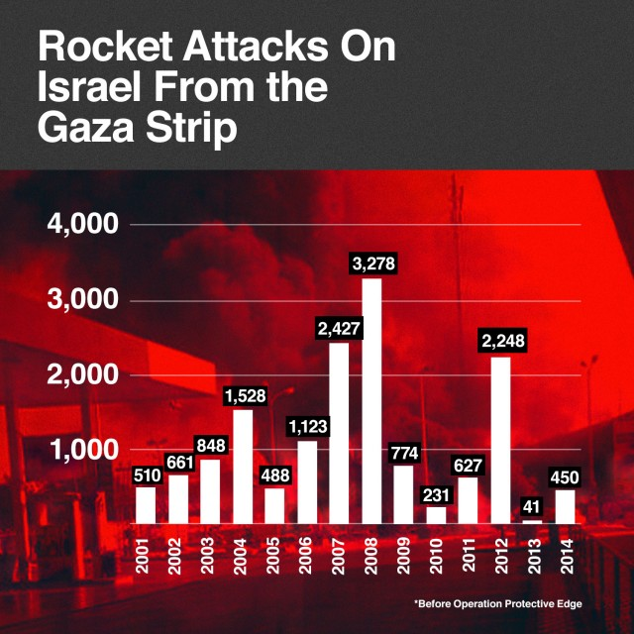
Since Israel withdrew from the Gaza Strip in 2005, terrorists have fired more than 11,000 rockets into Israel. Over 5 million Israelis are currently living under threat of rocket attacks.
More than half a million Israelis have less than 60 seconds to find shelter after a rocket is launched from Gaza into Israel. Most rockets launched from Gaza into Israel are capable of reaching Israel’s biggest cities, including Tel Aviv and Jerusalem.
Rocket fire from Gaza is a constant threat facing Israel’s civilians. In 2011 alone, 630 rockets from Gaza hit Israeli towns. That’s an even higher number than in 2010, when 231 rockets hit Israel.
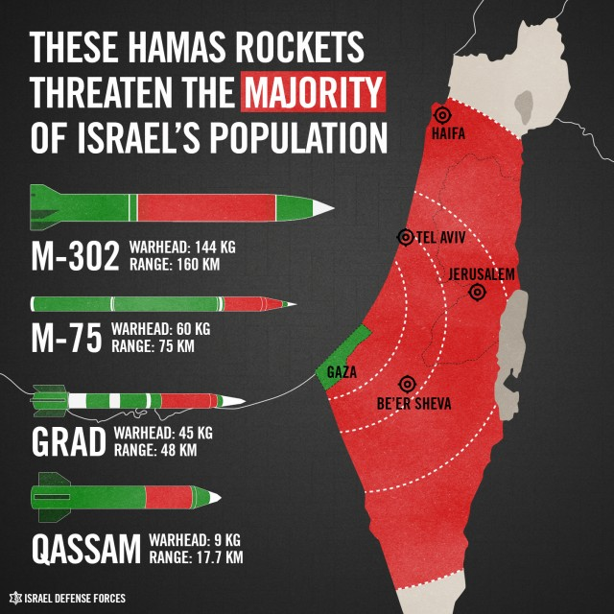
Since 2001, more than 15,200 rockets and mortars, an average of over 3 rocket attacks every single day, have targeted Israel.
Hamas [EDITOR’S NOTE: LINK GOES TO AN IDF BLOG WEBSITE ENTITLED “HAMAS TERRORISM 101], the ruling entity of the Gaza Strip, is responsible for most of the rocket fire on Israeli population centers. The organization – which is recognized by the US, UK, EU and Israel as a terrorist group – has been increasing the size and capabilities of its rocket arsenal. In addition, Hamas has turned a blind eye as other terrorist organizations have launched rocket attacks.
Twice since 2005, the IDF has been forced to launch major operations in response to heavy rocket fire on Israel’s civilians. The most recent, Operation Protective Edge, began after continual and relentless rocket attacks on Israeli cities since the beginning of 2014.
Operation Protective Edge – 2014
On July 7, 2014, the IDF launched Operation Protective Edge in order to restore quiet to the region and stop Hamas terrorism. The single goal of the operation is to stop Hamas’ incessant rocket attacks against Israel’s civilians.
The operation is ongoing, and since the start of the operation over 1000 rockets have been launched at Israel. Of those, 754 have hit Israel and approximately 201 were intercepted by the Iron Dome Missile defense system [EDITOR’S NOTE: LINK GOES TO A SEPTEMBER 27, 2013 IDF BLOG ARTICLE ENTITLED “From iPods to Iron Dome: Israel’s Air Defense Command Part II”].
Hamas has fired long range rockets at cities across Israel, including Tel Aviv and Jerusalem. Rockets such as the M-302 – the same missiles confiscated from the KLOS-C weapons seizure [EDITOR’S NOTE: LINK GOES TO A MARCH 11, 2014 IDF BLOG ARTICLE ENTITLED “Iran’s Weapons Shipment: The Full Disclosure”]– have long range capabilities and endanger the majority if Israel’s population. Rocket sirens have sounded non-stop across Israel, sending civilians running for shelter.
In response to these rocket attacks, the IDF has targeted over 1,474 terror targets using precision attacks to pinpoint terrorists and terror infrastructure while limiting civilian casualties.
Operation Pillar of Defense – 2012
On November 14, 2012, in response to incessant rocket attacks in the Gaza Strip, the IDF launched Operation Pillar of Defense [EDITOR’S NOTE: LINK GOES TO AN IDF BLOG ARTICLE ENTITLED “2012 Operation Pillar of Defense”], a widespread campaign against terror targets in Gaza.
During the eight days of the operation — and in the weeks leading up to it — life was unbearable for more than 3.5 million Israelis. From November 14 to November 21, Palestinian terrorist groups fired more than 1,506 rockets at Israel. The majority of those rockets struck Israel, damaging homes, schools and other civilian areas.
During the operation, Hamas and other Palestinian terrorist groups fired long-range rockets, such as the Fajr-5 [EDITOR’S NOTE: LINK GOES TO A NOVEMBER 17, 2012 IDF BLOG ARTICLE ENTITLED “Hamas Fajr-5 Missiles and UAV Targets Severely Damaged”], toward Tel Aviv and Jerusalem. Though the IDF severely damaged the terrorist organizations’ long-range rocket arsenal, more than 3.5 million Israelis are still under the threat of Hamas’ rocket fire.
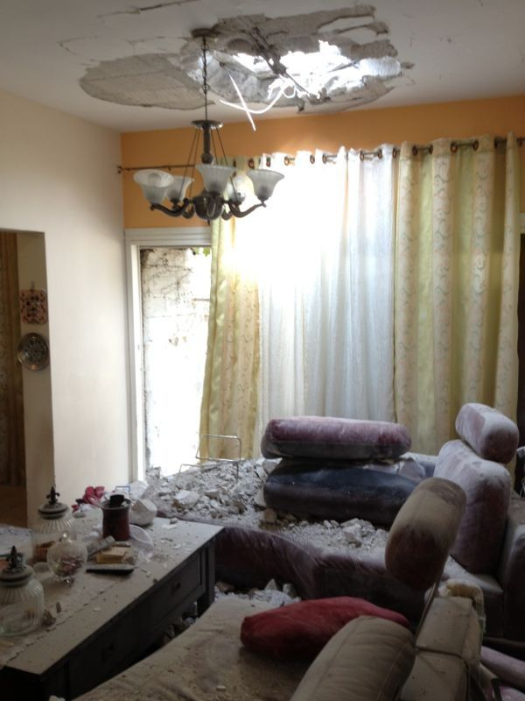
Rocket fire from Gaza causes severe damage
Operation Cast Lead – 2008
In December 2008, after exhausting non-military moves and diplomatic overtures [EDITOR’S NOTE: LINK GOES TO A DECEMBER 27, 2011 ARTICLE ENTITLED “Three Years since Operation Cast Lead”] to hinder Hamas’ rocket attacks, Israel launched Operation Cast Lead. The military operation was successful in destroying Hamas’ rocket launchers and terror infrastructure [EDITOR’S NOTE: LINK GOES TO A DECEMBER 28, 2011 ARTICLE ENTITLED “Since Operation Cast Lead, Hamas has reinforced itself in an effort to hurt Israeli civilians”].
Almost immediately after the operation, Hamas focused on rearming itself and increasing its military capabilities. The terroirst organization extended the range and quality of weapons that threaten Israel’s civilian population. Thousands of rockets were smuggled into Gaza, and many of the terror cells which Israel neutralized in 2008 have been revived.

