Share Their Names, Share Their Faces #EyalGiladNaftali
IDF Blog
June 18, 2014
https://web.archive.org/web/20140806025013/http://www.idfblog.com/blog/2014/06/18/speak-voice-share-story-eyal-gilad-naftali/

Ten days have passed since Hamas terrorists kidnapped Eyal, Gilad and Naftali. Help us share their story with the world.
Eyal Yifrach, Gilad Shaar, and Naftali Frenkel were last seen on June 12 near Gush Etzion before being kidnapped by Hamas terrorists. The three teenagers were on their way home to their families at the time of the attack. After the abduction, the IDF launched Operation Brother’s Keeper, a relentless search for the teens and their kidnappers.
Hamas’ attack followed dozens of attempts to kidnap innocent Israelis. The international community must know about Hamas’ recent violence and its determination to terrorize Israel. Share the stories of Eyal, Gilad and Naftali, and help us show the truth to the world.
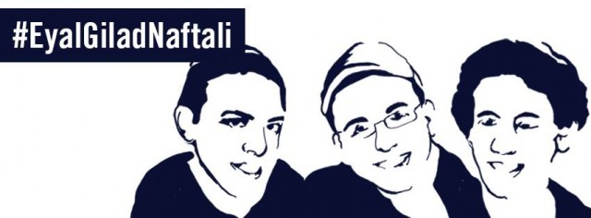
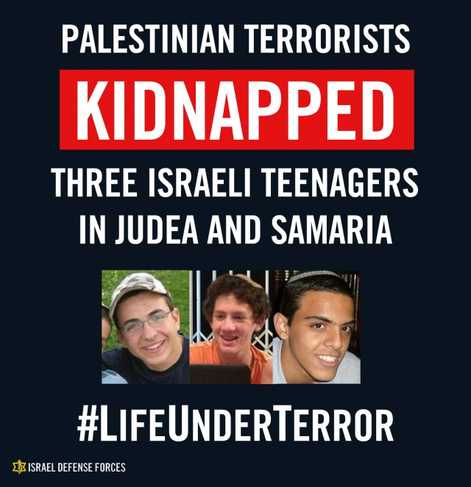

Operation Brother’s Keeper aims to find the three Israeli teenagers and weaken Hamas terrorism in Judea and Samaria. So far, IDF forces have arrested 240 terror suspects connected to the kidnapping.
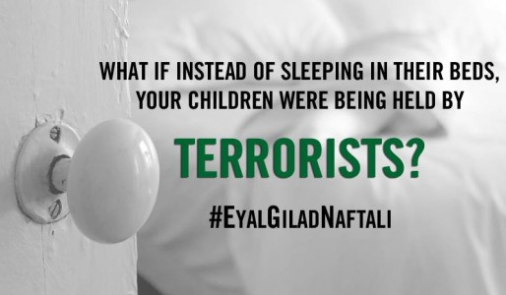

The parents of Eyal, Gilad and Naftali are still waiting for them to come home.

[MISSING VIDEO LINK]

Eyal, Gilad and Naftali are just regular boys. Share their stories, share their faces and share the truth.
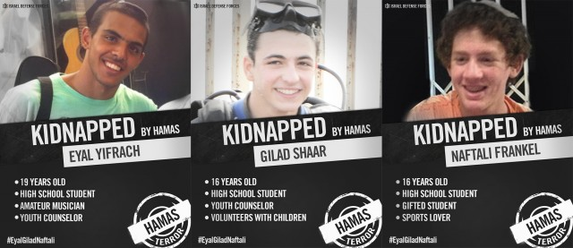

Hamas’ abduction followed dozens of attempts to kidnap innocent Israelis. Since the beginning of 2013, Israel has foiled 64 planned abductions, many of them at the hands of Hamas terrorists.
