Shuja’iya: Hamas’ Terror Fortress in Gaza
IDF Blog
July 20, 2014
https://web.archive.org/web/20150519184530/https://www.idfblog.com/blog/2014/07/20/shujaiya-hamas-terror-fortress-gaza/

Hamas uses the residential neighborhood of Shuja’iya as a fortress for its weapons, rockets, tunnels and command centers. Hamas exploits the neighborhood’s residents as human shields for its terrorist activity.
This residential neighborhood in Gaza City lies just over the border fence from Israel. Since Hamas’ ruthless takeover of the Gaza Strip in 2007, the organization has developed extensive terrorist infrastructure throughout the neighborhood. In just 13 days, Hamas has fired over 140 rockets from Shuja’iya into Israel.
Since the beginning of the ground phase of Operation Protective Edge, IDF soldiers have found 10 openings to terror tunnels in Shuja’iya. These tunnels are used for infiltrating Israel, smuggling weapons, and launching rockets at Israeli civilians.
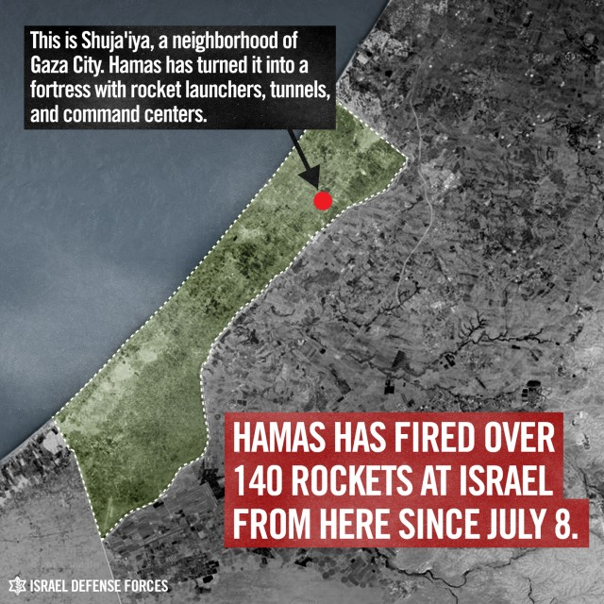
The IDF warned civilians in Shuja’iya to evacuate the area many days before striking the terror infrastructure within it. Dropping leaflets, making phone calls and sending text messages are just some of the many actions the IDF has been taking to minimize civilian casualties in Gaza.
Hamas knows that Israel is reluctant to attack areas with many civilians. The terrorist organization fights from within the civilian population and uses them as human shields.
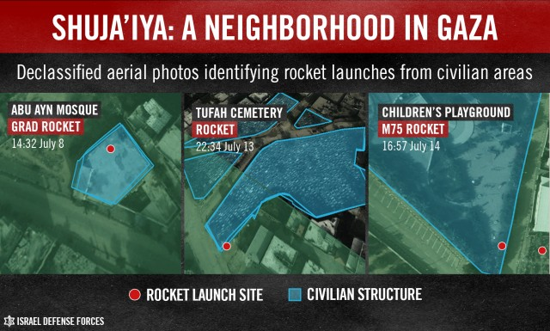
Hamas commanded the residents of Shuja’iya to ignore the IDF’s warning and stay in the neighborhood. By doing so, Hamas ordered them directly in the line of fire.
Many days ago, we dropped this Arabic flyer warning residents of Shuja’iya to evacuate. Read the English translation. pic.twitter.com/14REpZqhB3
— IDF (@IDFSpokesperson) July 20, 2014

Despite the fact that many of the residents ignored warnings and didn’t leave the neighborhood, the IDF continued to operate in the most precise and surgical way possible, targeting only terrorists and their infrastructure.
The IDF agreed to the Red Cross’ request for a two-hour humanitarian window in Shuja’iya. This humanitarian window was opened despite the threats emanating from the neighborhood, including continuous Hamas rocket fire at Israel.
IDF Chief of Staff: “We have a moral obligation to avoid civilian casualties. We also have a moral obligation to defend our people.”
— IDF (@IDFSpokesperson) July 20, 2014

Hamas broke the humanitarian window when firing at Israel during the two-hour period. Still, the IDF agreed to the Red Cross appeal to extend the humanitarian window by another hour.

Background
Shuja’iya is a densely populated neighborhood, close to the Karni Crossing and just over the border fence from the Israeli community of Kibbutz Nahal Oz. Since Hamas’ takeover of the Gaza Strip in 2007, it has become a stronghold for Hamas terrorist activity. Shuja’iya is saturated with Hamas observations points and is home to a vast network of tunnels used for attacking Israel. Hamas exploits many of the neighborhood’s mosques as weapons caches as well as launching pits which are used to fire rockets at Israel.
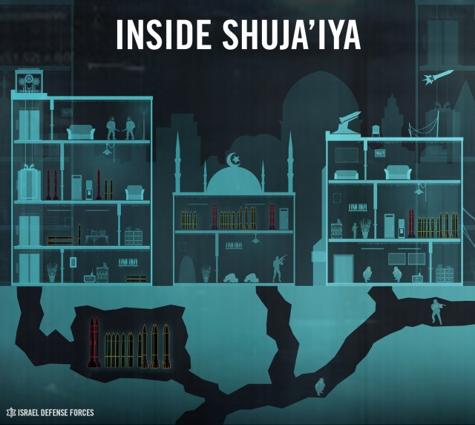
A vicious rivalry between Hamas and the Palestinian Islamic Jihad (PIJ) has developed in Shuja’iya since the internal turmoil in Gaza of 2007. Both terrorist organizations have spent the past seven years actively trying to increase their influence in the neighborhood. The rivalry has created an arena in which each organization strives to be regarded as the leaders in the fight against Israel. This has resulted in the neighborhood’s deterioration from a civilian residential area into a terrorist fortress.

