Testimonies from Gaza and Hamas intimidation of foreign journalists
Israel Ministry of Foreign Affairs
August 11, 2014
https://mfa.gov.il/MFA/ForeignPolicy/Issues/Pages/Testimonies-from-Gaza-and-Hamas-intimidation-of-foreign-journalists.aspx

What explains the absence of investigative reporting into Hamas crimes in the Western media? Part of the answer seems to be fear.
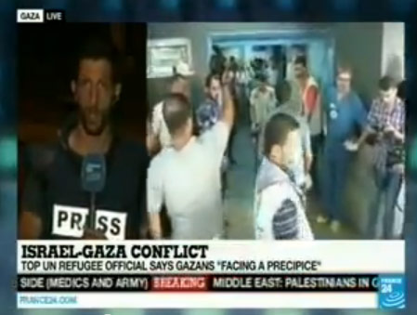
France 24 reporter live from Gaza
Copyright: Webshot
Several Western journalists working in Gaza during Operation Protective Edge have been harassed and threatened by Hamas for reporting cases of the involvement of civilians in warfare against Israel.
The Times of Israel has confirmed several incidents in which journalists were questioned and threatened, among them photographers who had filmed Hamas terrorists preparing to shoot rockets from within civilian structures, and/or fighting in civilian clothing. The photographers were then harassed by Hamas operatives who seized their equipment. Several Western journalists have posted and then removed tweets critical of Hamas, while others have been prevented by Hamas from leaving Gaza.
Are foreign journalists, under constant threat from Hamas, in effect censoring themselves? Is this why we don’t see coverage of Hamas terrorists firing rockets from civilian areas, the use of human shields and other war crimes?
The Washington Post reprinted a list of 40 questions that are worth posing to foreign correspondents in Gaza, originally published on 31 July in the well-known British blog Harry's Place. Among the questions asked:
- Have you or any of your colleagues been intimidated by Hamas?
- Do you feel restricted in your ability to 'say what you see' in Gaza?
- Are you scared to publish photos of Hamas operatives on your Twitter page, or broadcast images of Hamas fighting and aggression on your news channel?
- Is international media reporting from Gaza free from pressure and intimidation, or is there a real problem?
- Can live journalism by reporters who are scared of retaliation from the authorities they are reporting about really count as pure journalism, or is journalism in that context fundamentally compromised?
Israeli filmmaker Michael Grynszpan described on Facebook an exchange he had had with a Spanish journalist on 30 July:
"I met today with a Spanish journalist who just came back from Gaza. We talked about the situation there. He was very friendly. I asked him how come we never see on television channels reporting from Gaza any Hamas people, no gunmen, no rocket launcher, no policemen. We only see civilians on these reports, mostly women and children. He answered me frankly : "It's very simple, we did see Hamas people there launching rockets, they were close to our hotel, but if ever we dare pointing our camera on them they would simply shoot at us and kill us."
In spite of widespread intimidation and even forced censorship, some foreign correspondents reporting from Gaza have nevertheless given eye-witness testimonies about Hamas' exploitation of Gaza civilian population as human shields.
Finnish journalist Aishi Zidan, representing Helsingin Sanomat , reported on 1 August about rockets fired from the parking lot of the Shifa hospital, Gaza's main medical center.

[EMBEDDED VIDEO: https://youtu.be/Nu-e5qWXx-k]

During live broadcasts, two other correspondents - from Al-Jazeera and France 24 - inadvertently caught Hamas missiles being fired nearby, in the midst of a populated area:

[EMBEDDED VIDEO: https://youtu.be/L8Qbt4xoYUk]

The Gaza correspondent of France24 says: "This right here (points) is a launching pad for rockets...The Israeli army has repeatedly accused Palestinian militants of shooting from within densely populated civilian areas, and that is precisely the type of set-up we have right here. Rockets set up right next to buildings, with a lot of residents in them…This rocket-launching site is right next to a UN facility."

[EMBEDDED VIDEO: https://youtu.be/0Zf8YUOpfKI]

A correspondent of New Delhi Television (NDTV) documented the preparation and the firing of rockets by terrorists from within a populated area in Gaza. According to NDTV: "This report is being aired after our team left the Gaza Strip - Hamas has not taken very kindly to any reporting of its rockets being fired. But just as we reported the devastating consequences of Israel's offensive on Gaza's civilians, it is equally important to report on how Hamas places those very civilians at risk by firing rockets deep from the heart of civilian zones."
On August 7, the correspondent published a follow-up article entitled "Three Men, A Tent and Some Shrubs: The Backstory of Our Hamas Report":
"We had all of it on tape, but wrestled with the dilemma of what to do with it. Two considerations weighed on our mind. One, the fear which hobbles the reporting such material: fear of reprisals from Hamas against us and those who worked with us, fear of inviting an Israeli response on the spot (these have been known to miss). Two, we needed to be 100 % sure that this was a rocket launch site...
The next morning... with minutes left for the ceasefire to kick in, flurries of Hamas rockets were fired. At about 7:52 am, this patch of earth was activated; the rockets took off with a bang and a plume of smoke. We managed to catch it on video just seconds after...
We knew then we had to air the story. For us to have filmed how a rocket was assembled next to us, on a site used twice to launch a rocket, endangering the lives of all those around us on two occasions - to not have reported it would have been simply wrong."

[EMBEDDED VIDEO: https://youtu.be/A_fP6mlNSK8]

On August 10, Norway TV 2 Reporter Pål T. Jørgensen reported from Gaza that members of the press there have received strict restrictions and threats:
"There are decent working conditions here, however several foreign journalists have been kicked out from Gaza because Hamas does not like what they have said or written. We have received clear directions that if we see Hamas launching or shooting rockets, we cannot record them. If we do then there will be serious consequences which can lead to expulsion from Gaza. Our fixers, the person that is translating and is helping us around with everything, will also be in grave trouble if we film soldiers from Hamas, especially if they are firing rockets. Apart from that it is fairly ok to work here."
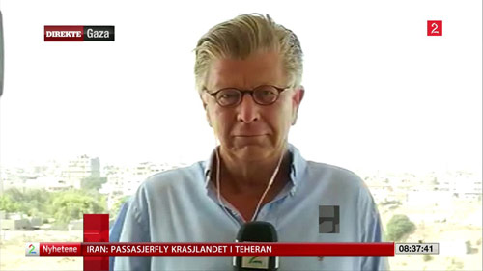
On August 11, Dutch journalist Monique van Hoogstraten reported in the Trouw: 'Hamas in the city: invisible, but not gone'
"Since the war started, one population group in Gaza has disappeared from the streets: people in uniform...They work for Hamas and are targets of Israel... Only at the Shifa Hospital, the big hospital in Gaza City, are a few sitting in uniform. There, they feel protected from the Israeli bombings. In addition, that is where they monitor the international press to prevent it from doing 'wrong' things. Local camera crews know this, but foreigners do not: Hamas does not want that killed or wounded fighters appear on camera footage.
Yes, there are many civilian casualties and most of the inhabitants of Gaza live in fear, but Hamas likes to exploit this for its PR. 'He does not dare to talk to you,' says the wife of someone who has been placed under house arrest because he is known for criticizing Hamas. She too does not dare to tell his story, because 'we are being watched'."
A CBN News correspondent in Gaza reported on 6 August about Hamas' use of a church to fire rockets at Israel. The church's bishop took the CBN reporter to the roof terrace outside his office to show how Islamists used the church compound to launch rockets into Israel. He refused to discuss details on camera for security reasons, but days after the war started, Israeli missiles targeted an area close to the church sanctuary.
CNN correspondent Martin Savidge described in clear terms Hamas' tactic of operating from within the civilian population of Gaza. When asked by the anchor whether residents of the houses nearby were aware of this fact, Savidge replied:
"It would be impossible for them not to be aware, I mean, when rockets are launched, and we've witnessed at least the firing of rockets from this vantage point. We haven't seen the actual launcher per-ce, but you could see the flash you could see that it was in between buildings, and you can the thunder as the rockets roar into the air, so clearly you can tell that this is being launched from a populated area.
The difficulty for people here is that these are armed men setting up a weapon… there is a level of fear that could keep some people from reporting what they are seeing."
Other journalists were able to testify that rockets were fired by Palestinian terrorist organizations on 28 July, but misfired and hit populated areas in Gaza.
Such was the case of Italian journalist Gabriele Barbati who sent out the following tweet: “Out of #Gaza far from #Hamas retaliation: misfired rocket killed children yday in Shati. Witness: militants rushed and cleared debris.”
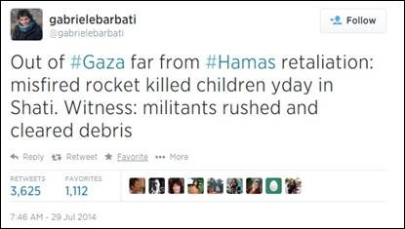
- thus corroborating the IDF account that it was rockets fired by Gaza terrorists which ended up killing Palestinian civilians.
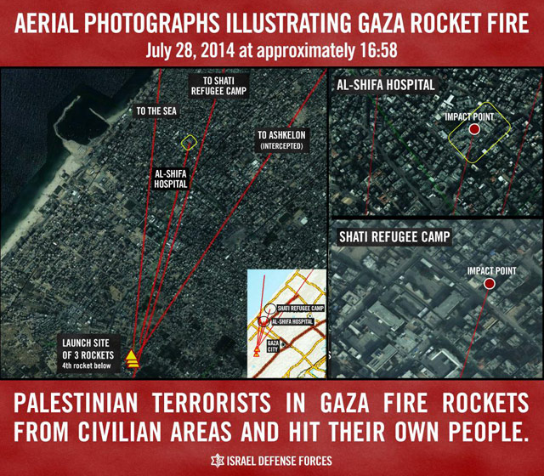
Globe and Mail correspondent in Gaza, Patrick Martin, wrote in his article from 20 July:
"The presence of militant fighters in Shejaia became clear Sunday afternoon when, under the cover of a humanitarian truce intended to allow both sides to remove the dead and wounded, several armed Palestinians scurried from the scene. Some bore their weapons openly, slung over their shoulder, but at least two, disguised as women, were seen walking off with weapons partly concealed under their robes. Another had his weapon wrapped in a baby blanket and held on his chest as if it were an infant."
Canadian TV correspondent Janis Mackey Frayer tweeted the following on 20 July:
"Inside Shejaiyya we also saw several #Hamas gunmen. One passed dressedin a woman's headscarf... tip of a gun poked out fromunder cloak."
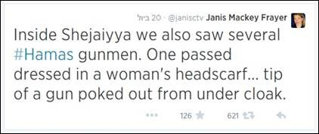
A report by Washington Post correspondents from 17 July recounts: "During the lull, a group of men at a mosque in northern Gaza said they had returned to clean up the green glass from windows shattered in the previous day’s bombardment. But they could be seen moving small rockets into the mosque."
- Still, such accounts remain few and far between. As Daniel Schwammenthal, Director of the AJC Transatlantic Institute in Brussels, wrote in The Commentator on 1 August: "Whatever the reason is for today’s miscoverage - fear, ignorance or bias - we are not getting the true picture from Gaza."

