The Invisible Face of Hamas
IDF Blog
August 7, 2014
http://web.archive.org/web/20140828094525/http://www.idfblog.com/blog/2014/08/07/invisible-face-hamas/

Hamas hides its actions from the world by threatening journalists, pressuring civilians over social media, and disguising its fighters in civilian clothing.
Despite the large number of international journalists reporting from Gaza during Operation Protective Edge, images of Hamas terrorists have scarcely appeared in Western media outlets. This is primarily because Hamas threatens journalists who don’t tell the story the way Hamas wants it to be told.
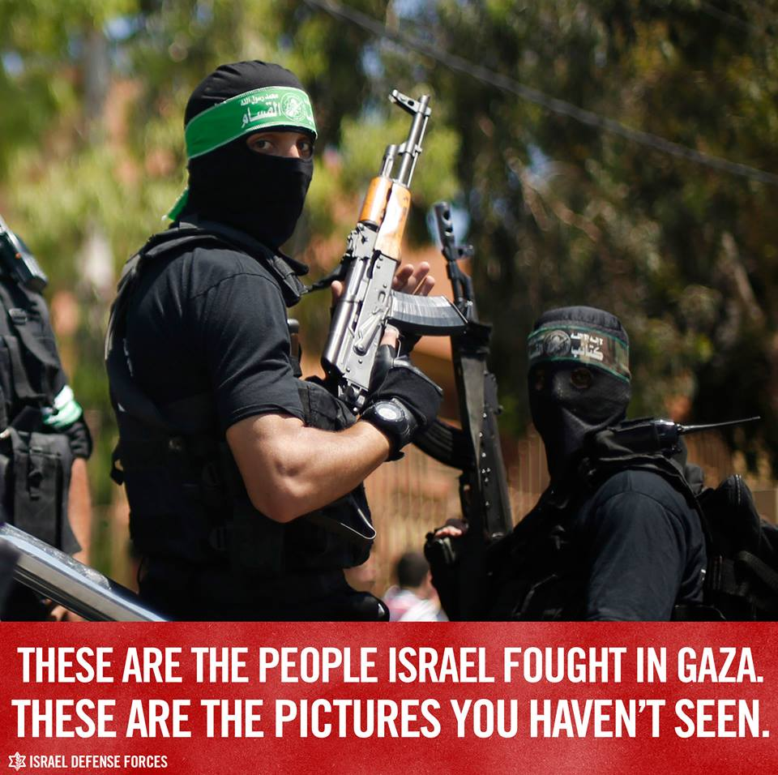
In addition, Hamas terrorists are often difficult to identify because they wear civilian clothing. By doing so, Hamas terrorists are not only trying to avoid being targeted by the IDF, but the are also causing international organizations to incorrectly label the death of many terrorists as civilians. It should come as no surprise that Hamas has ordered Gaza’s social media users not to post images of terrorists online and to refer to all terrorists killed in IDF strikes as “innocent civilians.”
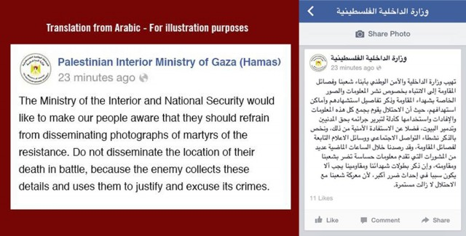
Hamas Facebook message to Palestinians asking them to hide information about terrorist casualties.
Hamas knows that it benefits in the international arena from images of civilian casualties in Gaza. It is for this reason that Hamas embeds its military infrastructure in, and fires rockets from, residential areas and civilian structures. Hamas knows that if it can make terrorists killed by Israel appear to be civilians, then it will gain points in the media war and win sympathy abroad.

They would simply shoot us and kill us
Filmmaker Michael Grynszpan wrote on Facebook [EDITOR’S NOTE: LINK GOES TO A JULY 30, 2014 FACEBOOK POST BY MICHAEL GRYNSZPAN] that a Spanish journalist had given him a straightforward explanation as to why images of Hamas terrorists were not appearing in the media. “It’s very simple. We did see Hamas people there, launching rockets. They were close to our hotel, but if ever we dared pointing our camera on them, they would simply shoot at us and kill us.”
New York Times executive Eileen Murphy offered another reason [EDITOR’S NOTE: LINK GOES TO A JULY 31, 2014 JEWISH TELEGRAPHIC AGENCY ARTICLE ENTITLED “NYT on why it hasn’t shown photos of Hamas fighters: We don’t have any”] for the lack of images of terrorist operatives appearing in newspapers. “It is very difficult to identify Hamas because they don’t have uniforms or any visible insignia.”
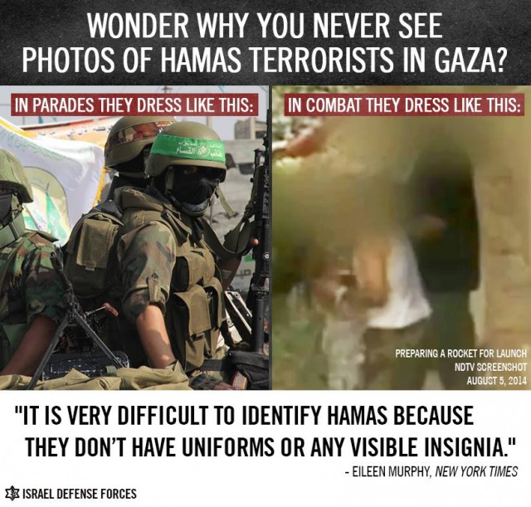
The French newspaper Libération published an article [EDITOR’S NOTE: LINK GOES TO A JULY 24, 2014 ELDER OF ZIYON ARTICLE ENTITLED “Hamas Al Qassam offices are next to the emergency room at Shifa Hospital (UPDATE)”] about French-Palestinian journalist Radjaa Abu Dagga, who was summoned for an interrogation by Hamas terrorists whose office was inside Shifa Hospital. Dagga reported that the terrorists were all well dressed “in civilian clothing with a gun under one’s shirt and some had walkie-talkies.” The terrorists accused Abu Dagga of working for the Palestinian Authority and Israel and then ordered him to leave Gaza immediately without his papers. Abu Dagga later asked Libération to remove the article [EDITOR’S NOTE: LINK GOES TO A JULY 24, 2014 LIBERATION ARTICLE ENTITLED “«Tu dois quitter Gaza au plus vite et arrêter de travailler»“] for reasons unknown.

Violence and intimidation
Abu Dagga is not the only journalist in Gaza who has written about being intimidated and threatened by terrorists unhappy with the content of their reports. Financial Times reporter John Reed was reportedly threatened after tweeting that rockets had been fired from near Shifa Hospital, the same civilian building where Abu Dagga was interrogated.
Watched two rockets fired toward Israel from near al-Shifa hospital, even as more bombing victims were brought in. Not over yet. #Gaza
— John Reed (@JohninJerusalem) July 23, 2014

Shifa Hospital was later hit by a rocket fired by terrorists in Gaza.
Many other instances have been reported of journalists who have attempted to report the truth in Gaza – including by posting about Hamas’ use of Palestinian human shields –and subsequently being forced to remove posts and even having equipment confiscated.
Canadian journalist Janis Mackey Frayer was threatened after tweeting that she had spotted several terrorists in the Hamas stronghold of Shuja’iya disguised in civilian clothing.
Inside Shejaiyya we also saw several #Hamas gunmen. One passed dressed in a woman’s headscarf… tip of a gun poked out from under cloak.
— Janis Mackey Frayer (@janisctv) July 20, 2014
Huffington Post reporter Sophia Jones tweeted on July 20 that Israel had opened the Erez border crossing but that Hamas was denying journalists the right to leave.
The Israeli side of the border with gaza was briefly open today, but Hamas did not let journalists leave Gaza.
— Sophia Jones (@Sophia_MJones) July 20, 2014
Italian reporter Gabriele Barbati pointed to Hamas’ intimidation tactics when he waited until leaving Gaza before issuing the following tweet:
Out of #Gaza far from #Hamas retaliation: misfired rocket killed children yday in Shati. Witness: militants rushed and cleared debris
— gabrielebarbati (@gabrielebarbati) July 29, 2014
Barbati was referring to an event in which a misfired terrorist rocket crashed into the Shati area of Gaza. Terrorists lied by blaming this event on the IDF in order to gain sympathy in the international arena.

Terrorists Dressed in civilian clothes, embedded in civilian areas
Despite Hamas’ violence and intimidation, some reporters have managed to capture footage and images that expose Hamas’ tactics. In the video below published by Indian outlet NDTV, viewers can see Hamas terrorists dressed in civilian clothing assemble a rocket launching site in a residential area of the Gaza Strip.

[EMBEDDED VIDEO: http://humanrightsvoices.org/site/documents/?d=21834]

France 24 reporter Gallagher Fenwick was surprised when Hamas rocket fire interrupted his live broadcast. He later went looking for the location of the rocket launcher. His news team took the following footage, which shows Palestinian children curiously examining a Hamas rocket launching site next to a UN building.

[EMBEDDED VIDEO: http://humanrightsvoices.org/site/documents/?d=22062]

Hamas does everything possible in order to distort the truth about what is happening in Gaza. Hamas fighters hide underground, they wear civilian clothing, and they force journalists to play by Hamas’ rules. [EDITOR’S NOTE: LINK GOES TO AN AUGUST 6, 2014 FOUNDATION FOR DEFENSE OF DEMOCRACIES ARTICLE ENTITLED “HAMAS RULES”]

