The Price of Hamas’ Underground Terror Network
IDF Blog
July 26, 2014
http://web.archive.org/web/20140822084237/http://www.idfblog.com/blog/2014/07/26/price-hamas-underground-terror-network/

Hamas could be investing in the people of Gaza. Instead it invests in terrorism.
Construction materials meant for Palestinians routinely enter Gaza [EDITOR’S NOTE: LINK GOES TO A DECEMBER 12, 2012 IDF BLOG ARTICLE ENTITLED “How Do Goods Get to Gaza? We Asked the Officer in Charge “] from Israel. To be exact, 4,680 trucks carrying 181 thousand tons of gravel, iron, cement, wood and other supplies have passed through the Kerem Shalom crossing since the beginning of 2014.
Imagine what Hamas could build with these resources instead of tunnels. Hundreds of homes and civilian structures for the residents of Gaza go unbuilt while the underground terror network continues to expand.

[EMBEDDED VIDEO: http://humanrightsvoices.org/site/documents/?d=21906]

Hamas’ first priority is killing Israelis. The people of Gaza and the people of Israel suffer because of this.
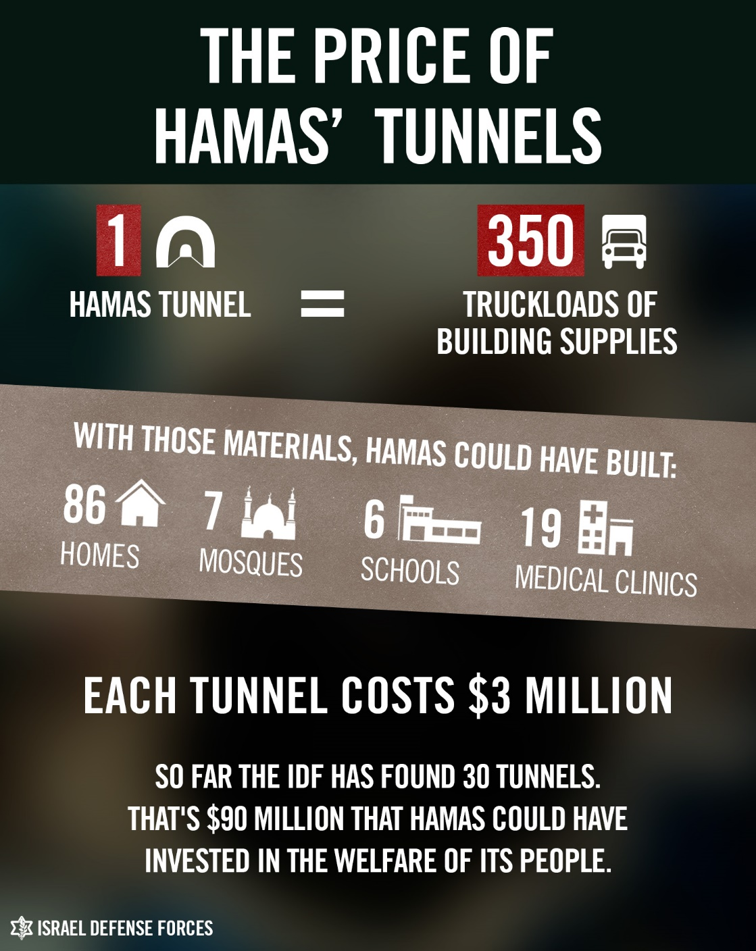
READ: The double crime of Hamas’ underground terror network http://t.co/0XQs1X0AvM [EDITOR’S NOTE: BROKEN LINK]
— IDF (@IDFSpokesperson) July 26, 2014

