What You Can’t See on the UN’s Maps of Gaza
Israel Ministry of Foreign Affairs
August 25, 2014
https://mfa.gov.il/MFA/ForeignPolicy/Terrorism/Pages/What-you-cant-see-on-UN-maps-of-Gaza.aspx

The red dots on the UN’s maps represent more than destruction. They show the many cases in which terrorists attacked Israel from heavily populated areas in Gaza.

(IDF Spokesperson)

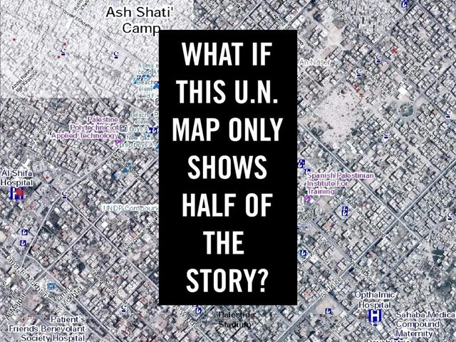
What you can't see on the UN maps of Gaza
Copyright: IDF Spokesperson
Last week, the UN published several maps showing the aftermath of Operation Protective Edge. The maps mark damaged buildings with red dots scattered throughout Gaza. But these maps tell only half the story: Hamas used many of these buildings - including houses, hospitals and schools - as sites to launch rockets and carry out other attacks.
In many cases, the IDF struck buildings in order to stop Hamas’ violence. This means that the red dots on the UN’s maps represent more than destruction. They show the many cases in which terrorists attacked Israel from heavily populated areas in Gaza.

[EMBEDDED VIDEO: http://humanrightsvoices.org/site/documents/?d=21809&id=25093]

Shuja'iya comparison: IDF target map and UN map - The areas damaged in Shuja'iya were used to attack Israel
(August 5, 2014)

