Why Does Israel Target Hamas Infrastructure in Judea and Samaria?
IDF Blog
June 19, 2014
https://web.archive.org/web/20140806022324/http://www.idfblog.com/blog/2014/06/19/israel-target-hamas-infrastructure-judea-samaria/

Hamas uses schools, hospitals and mosques to support violence. After the organization kidnapped three Israelis, our soldiers began targeting the resources that fuel its terrorism.
Hamas uses a vast civilian network to generate support for its violence. Terrorists refer to this system as ‘Dawa’, a term that literally means ‘calling’ or ‘preaching.’
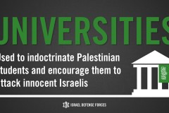
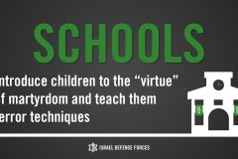
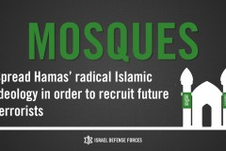

The social apparatus includes mosques, schools and hospitals located in Judea and Samaria. Hamas exploits these institutions to recruit terrorists and implement its radical Islamic ideology. The IDF must weaken the organization’s civilian resources, which serve as a lifeline for its daily terror.
Last week, IDF soldiers embarked on a mission to find three teenagers kidnapped by Hamas terrorists. A key objective of this operation is to weaken the Hamas terrorist infrastructure that enabled the recent abduction. To achieve this goal, Israeli soldiers have targeted institutions within the Dawa network.
During an operation Wednesday night in Ramallah, IDF forces shut down the offices of Hamas’ official television station. Hamas uses the television network to spread its violence throughout Judea and Samaria. The forces also targeted Hamas resources in Birzeit University, a hotbed of incitement and terrorism in Ramallah.
[EMBEDDED VIDEO: http://humanrightsvoices.org/site/documents/?d=22002]

Cycle of terror: How Dawa works
Last month, Palestinian students in the Hamas movement held a massive demonstration at Birzeit. The students marched through campus carrying Hamas-made M-75 rockets, which terrorists fired at major Israeli cities in October 2012.
The university is just one of many institutions in the Dawa network. The system contains a wide range of political and social entities, including charities, mosques, student unions and sports clubs.
Dawa institutions educate thousands of Palestinian children, introducing them to the virtue of martyrdom. The children are easy targets for manipulation, as Hamas easily convinces them to carry out terrorist attacks.
All of these programs serve the interests of the Hamas leadership. As IDF Brigadier General Nizar Ammar said recently, “the difference between the [political, social, and military] wings of Hamas is often a fiction.”
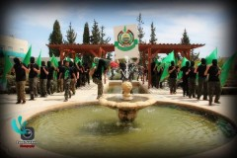
Hamas rally at the Al-Quds University
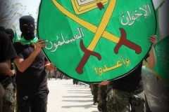
Hamas rally at the Al-Quds University
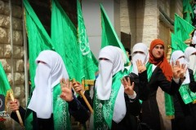
Hamas rally at the Al-Quds University

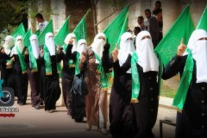
Hamas rally at the Al-Quds University
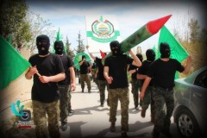

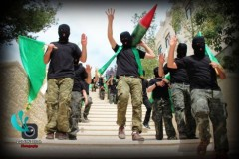

Over the years, Hamas has expanded its fundraising operation. The organization manages student associations at Palestinian universities in Judea and Samaria. The pro-Hamas groups disseminate violent propaganda and hold rallies in support of terrorism against Israel.
Last year, Hamas organized a rally at Najah National University to encourage Jihad and other violence. Students praised abductions like the kidnapping of the three Israeli teenagers last week.
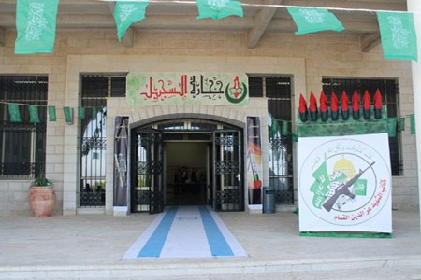
The Dawa network enables Hamas to carry out abductions and other acts of terror. As the terrorist organization intensifies its violence, the IDF will continue its mission to keep Israelis safe.

