Addameer
July 2017
http://www.addameer.org/the_prisoners/human_rights_defenders

ARREST AND PROSECUTION OF HUMAN RIGHTS DEFENDERS
July 2017
The UN Declaration on Human Rights Defenders defines human rights defenders as individuals who play an important role in furthering the cause of human rights through activities such as the documentation of violations, providing support and assistance to victims seeking remedies, combating cultures of impunity and mainstreaming human rights culture and information on an international and domestic level. Human Rights Defenders in the occupied Palestinian territory face various types of harassment and rights violations by the occupation forces, irrespective of the protection afforded to them in international conventions, and particularly the Declaration on the Right and Responsibility of Individuals, Groups and Organs of Society to Promote and Protect Universally Recognized Human Rights and Fundamental Freedoms. Since Oct 2015, the occupation forces intensified prosecution of human rights defenders in the occupied Palestinian territory, aiming to silence them and punish them for their role in exposing violations and crimes perpetrated against the Palestinian people.
Palestinians who organize and participate in protests and demonstrations against the Separation Wall and settlements are widely recognized as human rights defenders, due to their efforts to engage civil society in peaceful methods of resistance aimed at ending Israel’s violations of human rights and international law and its practices of land confiscation, house demolitions and movement restrictions on the Palestinian population. Israel has adopted a policy of arrest, detention, intimidation, threats and, at times, collective punishment against communities who take part in weekly demonstrations and other non-violent actions against the Wall and settlements. Leading Palestinian human rights activists, prominent figures, such as mayors and teachers, and members of the Popular Committees, who are instrumental in coordinating weekly protests and advocacy efforts including legal cases, are often personally targeted and arrested in an attempt to sideline them from organizing the protests, or to discredit them and their efforts. Local cameramen and photographers, as well as members of the press, are also targeted. In 2011, there were at least 295 documented cases of arrest of human rights defenders, 58 of whom were under the age of 18.

Some of the protesters and human rights defenders are prosecuted in the Israeli Military Courts under Military order 101 which was issued by the Israeli military commander in August 1967 and is still in effect in the occupied West Bank despite the Oslo Agreement and the beginning of the Peace Process. Military order 101 criminalizes many civic activities including: organizing and participating in protests; taking part in assemblies or vigils; waving flags and other political symbols; printing and distributing of political material. In addition, the order deems any acts of influencing public opinion as prohibited “political incitement”. Under the heading “support to a hostile organization”, the order further prohibits any activity that demonstrates sympathy for an organization deemed illegal under military orders, be it chanting slogans, waving a flag or other political symbols.

Despite the lack of evidence or independent witnesses, and the vague or empty basis of the charges levied against human rights defenders, the vast majority of activists will be found guilty of committing a “security offense” and sentenced to a term of imprisonment. In the Israeli military courts, the accused’s inalienable right to due process is never upheld. Soldiers’ testimonies and, occasionally, photos of individuals at a demonstration, are very often sufficient for an individual to be found guilty of an offense under the military orders that govern the West Bank. Moreover, if the detainee has been coerced into signing a confession, they will invariably be sentenced and serve time in a military jail.

Israeli occupation forces arrested 11 Palestinian journalists since the beginning of 2017, bringing the number of journalists detained in Israeli jails to 24 journalists. These arrests and prosecutions reached dozens of human rights activists, most of which were detained under administrative detention orders; this includes Addameer colleague and media coordinator Hasan Safadi, who was arrested on 01/05/2016 while crossing Al-Karameh bridge on his way to Palestine.

Human rights defenders who have been arrested and detained include Khalida Jarrar, a Palestinian Legislative Council Member, and Khitam Saafin, chairperson of the Union of Palestinian Women's Committee. They were both arrested on the 2 July 2017, and placed under administrative detention. Human rights defenders face ongoing forms of indiscriminate and arbitrary punishment long after they have been released. Requests from them and their families for permits from the Israeli authorities are consistently denied, they face targeted persecution and intimidation, detention and questioning at checkpoints, defamation, and, in some cases, re-arrest.

Following is a table of journalists arrested by occupation forces until 31 July 2017:
Name | Place of Residence | Place of Work | Type of Arrest | Date of Arrest
Ahmad Qatamish | Ramallah | Freelancer | Administrative Detention | 07/05/2017
Hammam Atili | Tulkarem | Media Student in Najah National University | Charges | 12/08/2014
Omar Al-Amor | Bethlehem | - | Detained | 26/07/2017
Mohammed Mahmoud Issa | Jerusalem | Correspondent for Sawt Al-Haq Wal Hurriya | Life sentence | 1993
Salah Addin Awwad | Nablus | Director of the media department at Prisoners’ Club | 7 years | 2011
Ahmad Al Darawesh | Hebron | Sanabel Radio Station | Detained | 31/08/2016
Ahmad Al-Saifi | Ramallah | Media Student at Birzeit University | 19 years | 19/08/2009
Mohammad Omran | Hebron | Sanabel Radio Station | Detained | 31/08/2016
Nidal Amro | Hebron | Sanabel Radio Station | Detained | 31/08/2016
Muntaser Nassar | Hebron | Sanabel Radio Station | Detained | 31/08/2016
Hamed Al Nammora | Hebron | Sanabel Radio Station | Detained | 31/08/2016
Nidal Abu Aker | Bethlehem | Correspondent for Sawt Al Wehda | Administrative Detention | 09/08/2016
Mohammad Al Batroukh | Jerusalem | Correspondent for Minbar Al-Quds | 10 months | 07/03/2017
Hammam Hantash | Hebron | Freelancer | Administrative Detention | 15/02/2017
Osama Shahen | Hebron | Freelancer | Administrative Detention | 01/09/2016
Hasan Safadi | Jerusalem | Addameer Media Coordinator | Administrative Detention | 01/05/2016
Bassam Al-Sayeh | Nablus |  | Detained | 08/10/2015
Mahmoud Aseda | Nablus | - | Detained | 20/02/2017
Abdullah Nkheli | Jenin | - | Detained | 14/02/2017
Musab Saed | Ramallah | Khalil News Network | Detained | 12/03/2017
Ayyoub Sowan | Qalqilya | Khalil News Network | Detained | 26/03/2017
Asem Mustafa | Nablus | Freelancer | Detained | 14/03/2017
Saleh Azghari | Jerusalem | Freelancer | 8 months | 17/02/2017
Radwan Qatanani | Nablus | - | Detained | 18/07/2017

The Case of Hasan Safadi 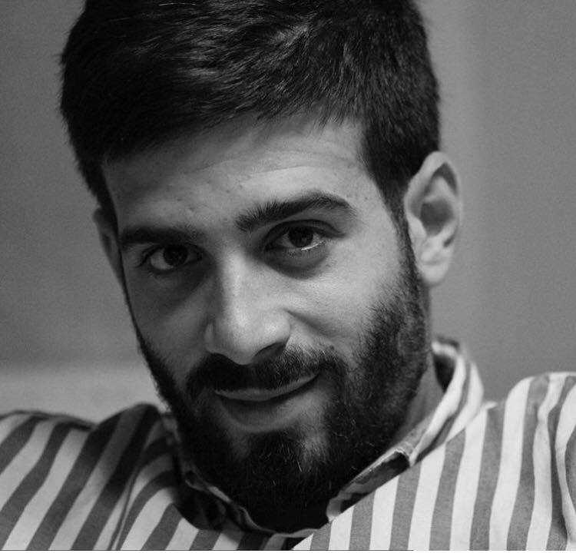
Occupation forces arrested Journalist and Addameer Media Coordinator Hasan Safadi while he was crossing Al Karameh Bridge on 01/05/2016, where he was detained at around 4.00 PM. Safadi was stopped at the bridge after being identified by a soldier. He was searched in a surveillance room on the bridge and then was transferred to Al Moskobiyyeh Interrogation Center. Safadi was on his way home back from an Arab Youth Conference in Tunisia, which tackled various human rights and social issues in the region.
Under the forty-day interrogation, Hasan Safadi was subjected to sleep deprivation, long interrogation sessions, being placed into stress positions with hands tied throughout the interrogation, threats, shouting, and lack of adequate food. Additionally, he was denied access to an attorney for 10 days (12 – 22 May 2016) as well as family visitation. As a result, his family was unable to see him until 07 June 2016 during a court hearing.
During interrogation, occupation authorities issued a gag order against the case of Safadi and conducted closed hearing sessions. The prosecution inflated accusations against Safadi, despite the fact that it was evident there was no adequate evidence to keep him detained.
Safadi was set to be released on 10 June 2016 based on a decision from the Magistrate Court in Jerusalem, on a bail of 2500 NIS and third party guarantees, which had already been paid. Later on the same day, Israeli Minister Avigdor Lieberman signed a six-months administrative detention order against Safadi, which effectively overrode the court’s decision for his release.
Safadi's administrative detention has been renewed twice, the last renewal was on 08 June 2017.

