Sixtieth session

* A/60/150.
** This document is submitted late so as to include the most up-to-date information possible.
Item 73 (a) of the provisional agenda*

Human rights questions: implementation of human
rights instruments

Equitable geographical distribution in the membership
of the human rights treaty bodies

Analysis of the membership of the human rights treaty bodies since 1970

Report of the United Nations High Commissioner for
Human Rights**

Summary
The General Assembly, in its resolution 59/181, requested the United Nations High Commissioner for Human Rights to submit to the General Assembly at its sixtieth session concrete recommendations on the implementation of the resolution, including the possible establishment of quota distribution systems by geographical region for the election of the members of the treaty bodies. This report, submitted in accordance with that request, provides information on the system for the election of treaty body members, along with an analysis of the past and present membership of each treaty body by geographical region.

Contents
 |  | Paragraphs |  | Page
- Introduction |  | 1–4 |  | 3
- The provisions of the treaties relating to election of members of the treaty bodies |  | 5–12 |  | 4
- The five informal regional groups |  | 13–14 |  | 6
- Past and present membership of the treaty bodies |  | 15–35 |  | 6
- Election of members of the Committee on Economic, Social and Cultural Rights and the quota system |  | 36–38 |  | 14
- Conclusion |  | 39 |  | 16
Annexes
I. Regional groups |  |  |  |  | 17
II. Number of four-year terms served, by nationality |  |  |  |  | 21
III. Number of members elected to serve on the human rights treaty bodies and number of States parties eligible to vote at meetings of States parties, by regional group |  |  |  |  | 24

I. Introduction

1. In resolution 59/181, the General Assembly recommended that, in considering whether a quota system for the election of the treaty body members should be adopted, each regional group should be assigned “a quota of membership of each treaty body in equivalent proportion to the number of States parties to the instrument that it represents”. The following analysis presents a statistical comparison of the composition of each treaty body following each election of members and the number of States parties to each treaty by regional group since 1970. It does not examine other factors, such as the number of nominations received per regional group and the number of State party representatives voting in elections, which influence the outcome of the elections.
2. Six of the seven core international human rights treaties create a committee of independent experts to monitor implementation of the treaty by States parties:
• The Committee on the Elimination of Racial Discrimination (CERD) has monitored implementation of the International Convention on the Elimination of All Forms of Racial Discrimination since 1970.
• The Human Rights Committee (HRC), has monitored implementation of the International Covenant on Civil and Political Rights since 1977.
• The Committee on the Elimination of Discrimination against Women (CEDAW) has monitored implementation of the Convention on the Elimination of All Forms of Discrimination against Women since 1982.
• The Committee against Torture (CAT) has monitored implementation of the Convention against Torture and other Cruel, Inhuman or Degrading Treatment or Punishment (Convention against Torture) since 1987.
• The Committee on the Rights of the Child (CRC) has, since 1991, monitored implementation of the Convention on the Rights of the Child and, since 2002, its two Optional Protocols.
• The Committee on the Protection of the Rights of All Migrant Workers and Members of Their Families (CMW), which held its first session in March 2004, monitors implementation of the International Convention on the Protection of the Rights of All Migrant Workers and Members of Their Families.
3. The International Covenant on Economic, Social and Cultural Rights does not create a treaty body, but gives the Economic and Social Council a general mandate to monitor implementation of the Covenant by States parties and United Nations specialized agencies through consideration of regular reports. In 1978, the Council established a Sessional Working Group of Governmental Experts on the Implementation of the International Covenant on Economic, Social and Cultural Rights, to assist it in considering the reports submitted by States parties (decision 1978/10). The composition of the Sessional Working Group was altered in 1982 (resolution 1982/33) and, in 1987, it was reconstituted according to the treaty body model and renamed the “Committee on Economic, Social and Cultural Rights” (CESCR) (resolution 1985/17). The Committee, which first met in 1987, is treated as a treaty body.
4. The Optional Protocol to the Convention against Torture, which is not yet in force, envisages the creation of an additional body, the “Subcommittee on Prevention”, to undertake visits to places of detention in States parties.

II. The provisions of the treaties relating to election of members of the treaty bodies

5. The provisions of the treaties relating to the election of treaty body members are: article 8, International Convention on the Elimination of All Forms of Racial Discrimination; articles 28-34, International Covenant on Civil and Political Rights; article 17, Convention on the Elimination of All Forms of Discrimination against Women; article 17, Convention against Torture; article 43, Convention on the Rights of the Child; and article 72, International Convention on the Protection of the Rights of All Migrant Workers and Members of Their Families. Elections of members of CESCR are governed by the terms of resolution 1985/17.
6. In accordance with the provisions of the relevant treaty, each committee is composed of independent experts, ranging in number from 10 to 23 (see table 1), who are nominated and elected for fixed, renewable terms of four years by States parties from among their nationals. In order to avoid the entire membership changing at any one election, the terms of half of the members elected at the first elections are limited to two years. Subsequent elections occur every two years. The treaties impose no limit on the number of times a member’s term may be renewed.

Table 1
Composition of the human rights treaty bodies

Treaty body | Original number  of members | Increased to | Number of States parties required for increase
CERD | 18 | — | —
HRC | 18 | — | —
CESCR | 18 | — | —
CEDAW | 18 | 23 | 35ª
CAT | 10 | — | —
CRC | 10 | 18^{b} | —
CMW | 10 | 14 | 41

ª Since, at the time of the first meeting of States parties to the Convention on the Elimination of Discrimination against Women, there were already 35 States parties, the meeting elected 23 members to the Committee for its first session.
^{b} Amendment to article 43 (2) of the Convention, approved by the General Assembly in resolution 50/155, which entered into force on 18 November 2002 upon acceptance by two thirds of the States parties.

A. Qualifications for nomination as members

7. The provisions of the treaties (or, in the case of CESCR, the relevant Council resolution) vary with regard to the qualifications expected of nominees. Members are generally required to be of recognized competence (in the field of human rights) and of high moral standing and acknowledged impartiality (although this is not explicitly stated in the case of CESCR). Nominees must be nationals of a State party to the relevant treaty, but members of all treaty bodies serve in their personal capacity.

B. Criteria for election of members

8. The treaties set out criteria to guide States parties when voting for members. In all cases, consideration must be given to equitable geographical distribution. All treaties restrict nominations to one nominee per State party, except the International Covenant on Civil and Political Rights which allows two nominations per State but states that the Committee may not include more than one national of the same State (art. 31 (1)).
9. The treaties also set out additional considerations to be taken into account in electing treaty body members, including representation of the “principal legal systems” (CERD, CEDAW, CRC), “the different forms of social and legal systems” (CESCR), “the different forms of civilization” (CERD, CEDAW), “different forms of civilization and legal systems of States parties”, or the “usefulness of legal experience” (HRC, CAT). The Optional Protocol to the Convention against Torture contains very specific requirements for members of the Subcommittee on Prevention, including “proven professional experience in the field of the administration of justice, in particular criminal law, prison or police administration, or in the various fields relevant to the treatment of persons deprived of their liberty” (art. 5 (2)).
10. No treaty in force explicitly requires “gender balance” with regard to the election of experts and no quota system is in operation for any of the treaty bodies to address gender balance. In the composition of the Subcommittee on Prevention, due consideration will have to be given to “balanced gender representation on the basis of the principles of equality and non-discrimination” (art. 5 (4)).

C. Conduct of elections

11. The election of members of all treaty bodies, except CESCR, takes place at a biennial meeting of States parties to the treaty concerned. Election is by secret ballot.

D. Replacement of members

12. All treaties contain provision for the replacement of any members who resign or die before the end of their term. In most cases, the State party that nominated the former member appoints another expert from among its nationals to fill the vacancy for the remainder of the term, subject in certain cases to the approval of the relevant committee (CERD, CEDAW, CRC and CMW) or other States parties (CAT). This procedure has no impact on the existing geographical distribution of the committee concerned. Article 34 of the International Covenant on Civil and Political Rights requires vacancies on the Human Rights Committee to result in a new round of nominations and elections, provided the term still has at least six months to run. This may result in a change in the geographical composition of the Committee. In practice, on the nine occasions that members of the Human Rights Committee have been replaced, the nationality of the member changed once, although the replacement member was from the same regional group.

III. The five informal regional groups

13. According to an unofficial list, drawn up on the basis of the practice of States in elections at the General Assembly (see annex I), the present composition of the regional groups recognized by the General Assembly is:
African States 53 States
Asian States 52 States
Eastern European States 22 States
Latin American and Caribbean States 33 States
Western European and other States 29 States
Not members of a regional group 2 States
Total 191 States
The practice of certain States with regard to regional groups differs for the purposes of elections and for other functions. Thus, for the purpose of elections, Turkey votes with the Western European group although it is also a member of the Asian group.
14. The Cook Islands, the Holy See and Niue are parties to one or more of the treaties but are not members of the United Nations.

IV. Past and present membership of the treaty bodies

15. In the following analysis of past and present membership of the treaty bodies, the number of individuals who have served as members of the treaty bodies is distinguished from the number of terms that have been served by those individuals. There is no restriction on the number of terms an individual may serve as a member, and many individual members have served consecutive terms. Statistical analysis based on the individual members of the treaty bodies gives one view of the geographical distribution of seats on the treaty bodies. However, since States parties meet at two-year intervals to elect half of the members of each committee for four-year terms, the composition of each committee changes every two years. Analysis of the composition of the treaty bodies by regional group based on these biennial changes allows a comparison to be made with the number of States parties from each region at the time of each biennial election.

A. Individual membership of the treaty bodies since 1970

16. Since 1970, a total of 410 individuals, from 106 States, have served as members of the treaty bodies:
CERD 94 individuals from 47 States
HRC 79 individuals from 50 States
CEDAW 109 individuals from 63 States
CAT 32 individuals from 25 States
CESCR 47 individuals from 41 States
CRC 39 individuals from 34 States
CMW 10 individuals from 10 States
A number of individuals have served on more than one treaty body.

1. Regional balance

17. Of the 410 individuals who have been elected as treaty body members, 86 have come from the African region, 76 from Asia, 60 from Eastern Europe, 77 from Latin America and the Caribbean and 111 from the Western European group (see table 2).

Table 2
Individual treaty body members since 1970, by regional group (with percentage of total)

Treaty body | Africa | Asia | Eastern Europe | Latin America | Western Europe | Total
CERD | 19 (20%) | 15 (16%) | 20 (21%) | 13 (14%) | 27 (29%) | 94
HRC | 11 (14%) | 10 (13%) | 11 (14%) | 15 (19%) | 32 (40%) | 79
CEDAW | 23 (21%) | 26 (24%) | 11 (10%) | 25 (23%) | 24 (22%) | 109
CAT | 6 (19%) | 6 (19%) | 5 (15%) | 6 (19%) | 9 (28%) | 32
CESCR | 13 (28%) | 9 (19%) | 10 (21%) | 7 (15%) | 8 (17%) | 47
CRC | 11 (28%) | 8 (21%) | 2 (5%) | 7 (18%) | 11 (28%) | 39
CMW | 3 (30%) | 2 (20%) | 1 (10%) | 4 (40%) | 0 | 10
Total | 86 (21%) | 76 (19%) | 60 (17%) | 77 (19%) | 111 (27%) | 410

18. These individuals have served a total of 623 terms as members of the various committees. Of the 106 States whose nationals have served as members, one quarter has seen their nationals serve no more than two terms. The average number of terms served per nationality is a little under 6 terms (5.8 terms). Nationals of 15 States have served more than twice the average number of terms, and the nationals of one State have collectively served 31 terms as treaty body members.
19. In total, nationals from Asia have served 21 per cent of treaty body terms, nationals from Africa and from Latin America and the Caribbean have served 19 per cent of terms, nationals from Eastern Europe 14 per cent and nationals from Western Europe and other States have served 28 per cent of terms. The number of terms served by each regional group for each committee is presented below, along with the percentage of the total terms served:

Table 3
Terms served on the treaty bodies since 1970, by regional group (with percentage of total)

Treaty body | Africa | Asia | Eastern Europe | Latin America | Western Europe | Total
CERD | 31 (19%) | 36 (22%) | 26.5 (16%) | 29 (18%) | 39.5 (24%) | 162
HRC | 24 (18%) | 21 (16%) | 18.5 (14%) | 24 (18%) | 47.5 (35%) | 135
CEDAW | 31 (22%) | 28.5 (21%) | 14 (10%) | 28 (20%) | 36.5 (26%) | 138
CAT | 9 (20%) | 6.5 (14%) | 7 (16%) | 7 (16%) | 15.5 (34%) | 45
CESCR | 20 (22%) | 15.5 (17%) | 15 (17%) | 19.5 (22%) | 20 (22%) | 90
CRC | 13.5 (28%) | 8.5 (18%) | 3 (6%) | 9.5 (20%) | 13.5 (28%) | 48
CMW | 1.5 (30%) | 1 (20%) | 0.5 (10%) | 2 (40%) | 0 | 5
Total | 130 (21%) | 117 (19%) | 84.5 (14%) | 119 (19%) | 172.5 (28%) | 623

2. Nationality of individual members

20. The 410 individuals who have served as treaty body members have been nationals of a total of 106 States. The total of nationalities of members by regional group (N) is shown in table 4 against the total States parties for each region (S):

Table 4
Nationalities represented as treaty body members and States parties, by regional group

Treaty body | Africa |  |  |  | Asia |  |  |  | Eastern Europe |  |  | Latin America |  |  | Western Europe |  |  | Total
Treaty body | N | S | N |  |  | S | N |  |  | S | N |  | S | N |  | S | N |  | S
CERD | 12 | 49 | 8 |  |  | 40 | 8 |  |  | 22 | 7 |  | 30 | 12 |  | 29 | 47 |  | 170
HRC | 7 | 51 | 9 |  |  | 26 | 7 |  |  | 22 | 9 |  | 28 | 18 |  | 27 | 50 |  | 154
CEDAW | 15 | 51 | 11 |  |  | 46 | 8 |  |  | 22 | 13 |  | 33 | 16 |  | 28 | 63 |  | 180
CAT | 8 | 41 | 4 |  |  | 27 | 4 |  |  | 22 | 5 |  | 22 | 8 |  | 28 | 29 |  | 140
CESCR | 10 | 48 | 9 |  |  | 26 | 8 |  |  | 22 | 7 |  | 27 | 8 |  | 28 | 42 |  | 151
CRC | 8 | 52 | 8 |  |  | 56 | 2 |  |  | 22 | 6 |  | 33 | 10 |  | 29 | 34 |  | 192
CMW | 3 | 12 | 2 |  |  | 6 | 1 |  |  | 2 | 4 |  | 9 | 0 |  | 1 | 10 |  | 30
Total | 23 | 53 | 24 |  |  | 52 | 16 |  |  | 22 | 20 |  | 33 | 23 |  | 29 | 106 |  | 191

21. Taking into account the number of States parties from each regional group that could nominate candidates, the proportion of all nationalities from within each group that have been elected as members of at least one of the treaty bodies is as follows:

Table 5
Distribution of nationalities from each regional group elected as members of the treaty bodies since 1970 (as percentage of total States parties)

Treaty body | Africa | Asia | Eastern  Europe | Latin  America | Western  Europe | Total
CERD | 24% | 20% | 9% | 23% | 41% | 28%
HRC | 14% | 35% | 32% | 32% | 66% | 32%
CEDAW | 29% | 24% | 26% | 39% | 57% | 35%
CAT | 20% | 15% | 18% | 23% | 29% | 21%
CESCR | 21% | 35% | 36% | 26% | 29% | 28%
CRC | 15% | 14% | 9% | 18% | 34% | 17%
CMW | 25% | 33% | 50% | 44% | 0% | 33%
Total | 44% | 46% | 72% | 60% | 79% | 55%

22. In total, 44 per cent of African States, 46 per cent of Asian States, 72 per cent of Eastern European States, 60 per cent of Latin American and Caribbean States and 79 per cent of Western European and other States have had at least one of their nationals elected to one of the treaty bodies. The list of terms per State is presented in annex II. The degree of representation attainable for each treaty body depends on the length of time that the committee concerned has been in existence, the rate at which ratification by States occurs and the number of seats available on the committee.

3. Gender balance

23. With the exception of CEDAW, men have outnumbered women as treaty body members since 1970 by a factor of four to one. Of the 410 individuals who have been elected as members, 251 have been men and 159 have been women. Excluding CEDAW, there have been 53 female members of treaty bodies.

Table 6
Number of women and men elected as treaty body members since 1970

CERD | 6 women (6%) | 88 men (94%)
HRC | 10 women (13%) | 69 men (87%)
CEDAW | 106 women (97%) | 3 men (3%)
CAT | 4 women (12%) | 28 men (88%)
CESCR | 9 women (19%) | 38 men (81%)
CRC | 22 women (56%) | 17 men (44%)
CMW | 2 women (20%) | 8 men (80%)
Total excluding CEDAW | 53 women (18%) | 248 men (82%)
Total | 159 women (39%) | 251 men (61%)

B. Distribution of the regional groups in the membership of the
treaty bodies

24. The charts presented in this section compare the composition of each committee following each election (new or re-elected members plus members with two years of their term remaining) with the number of States parties eligible to vote on the day of the elections by regional group. The source data is presented in annex III and full results are presented on the website of the Office of the United Nations High Commissioner for Human Rights (www.ohchr.org).
25. The following factors have been taken into account:
• Since the composition of each committee changes every two years, sampling is made at two-year intervals, immediately following each election.
• Since some individuals serve more than one term on a treaty body, the number of terms served are counted rather than the number of individuals elected.
• Some committees have increased in size as the number of ratifications has risen.
• The number of States parties eligible to vote at meeting of States parties, and the relative balance within each regional group and between regional groups, shifts constantly as more States ratify or accede to the treaties.
Special conditions apply in the case of CESCR, which is covered separately below.
26. Other factors may influence the outcome of elections. Thus, for example, the large number of nominations received from one regional group may make it more difficult for those candidates to gain sufficient votes from States parties from within their regional group compared with a region that has put forward a shorter list of candidates. Treaty body members are not elected to represent their region and States parties are not obliged to vote for candidates from their region. Such factors are not taken into account in the present analysis, which is purely statistical.
27. A statistical differential between the membership of each treaty body after each election and each regional group may be calculated in the following manner:
• The number of members from each regional group is expressed as a percentage of the total membership of the committee concerned.
• The number of States parties from each regional group eligible to vote is expressed as a percentage of the total number of States parties.
• The difference between these two percentages indicates the degree to which membership of a treaty body corresponds to the number of States parties from each regional group for each biennium.
28. A value of zero indicates a perfect correspondence between members and States parties from the region concerned. Positive values indicate that more members were elected than would be expected statistically on the basis of the number of States parties from each region. Conversely, negative values indicate that fewer members were elected than would be expected.
29. The scale of these values may be gauged by comparing the percentage difference with the percentage representing one member of the committee concerned: in a 10-member committee, one member equals 10 per cent of the total membership; in an 18-member committee, one member equals 5.55 per cent of the total membership; in a 23-member committee, one member equals 4.34 per cent of the total membership. The horizontal lines in the charts below indicate one member of the relevant committee in percentage terms. Given the limited membership of the committees, a perfect distribution of seats between regional groups in exact proportion to the number of States parties from each region may not always be possible since fractions of seats cannot be divided between regional groups.

1. Committee on the Elimination of Racial Discrimination

30. On average, the distribution of seats on CERD shows both Eastern and Western European and other States with one member more, and African States with two members less, than would be statistically expected. Asian States have achieved a perfect average distribution.
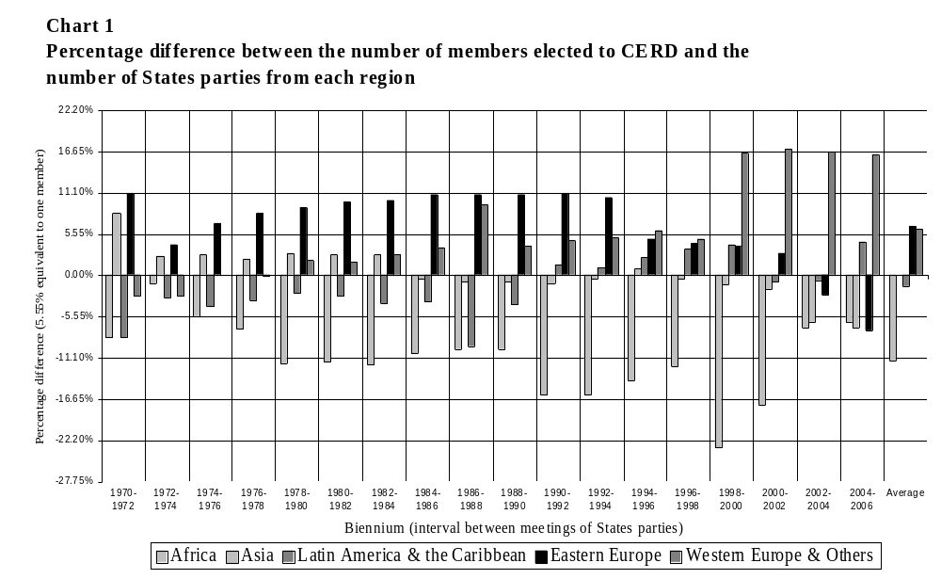

2. Human Rights Committee

31. On average, the distribution of seats in the Human Rights Committee shows Western Europe with three more members, and Africa with two less members, than would be expected statistically.

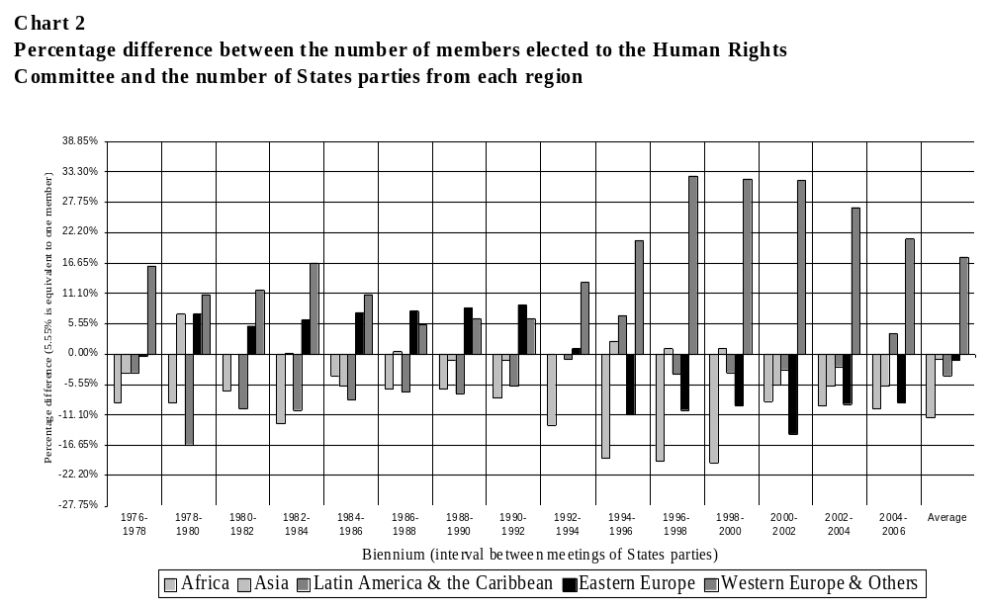

3. Committee on the Elimination of Discrimination against Women

32. On average, the distribution of seats on CEDAW reveals Western Europe having two more members, and both Africa and Latin America and the Caribbean having one less member, than would be expected statistically.
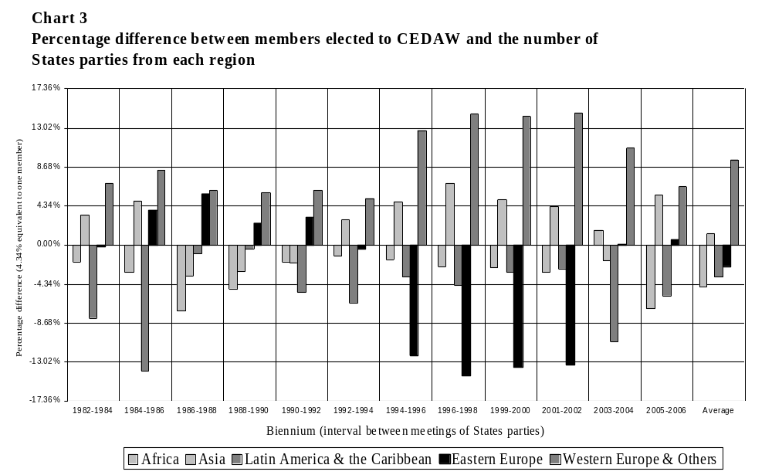

4. Committee against Torture

33. On average, Asia has achieved a perfect correspondence between the percentage of States parties and the percentage of members from each region in CAT. Between 2000 and 2004, Western European and other States had almost two more members than would be expected.
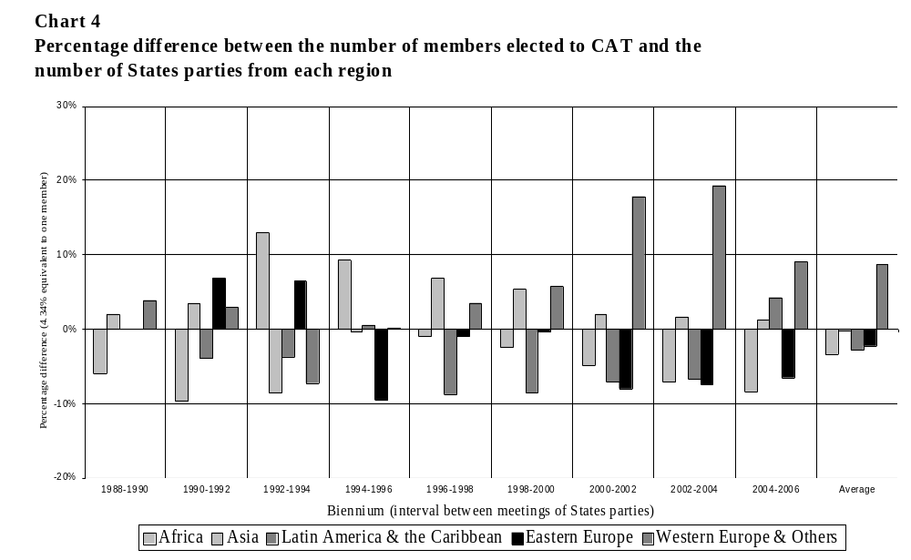

5. Committee on the Rights of the Child

34. On average, Africa and Latin America and the Caribbean have achieved a perfect correspondence between States parties and members of CRC, whereas Western Europe has had on average two more members, and Asia and Eastern Europe one less member, than would be expected statistically.

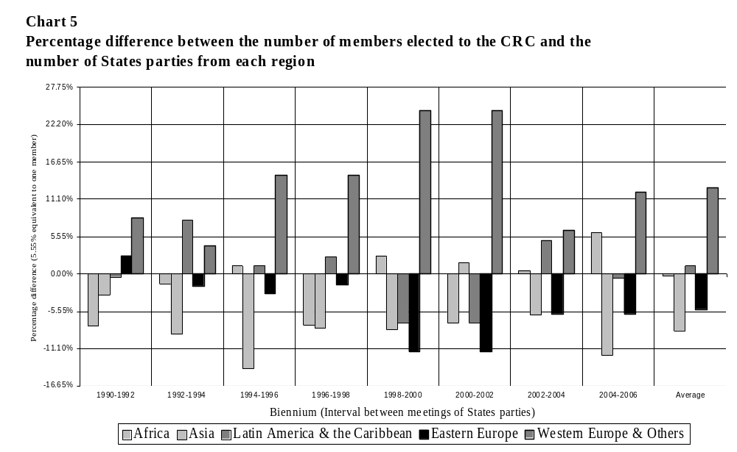 6. Committee on Migrant Workers

35. The 10-member Committee on Migrant Workers has not been in existence long enough to allow clear conclusions to be drawn. Following the first elections, at which only 10 candidates were presented, Asia and Latin America and the Caribbean have more members and Africa and Eastern Europe have fewer members than would be expected statistically. No Western European and other States are parties to the Convention.

V. Election of members of the Committee on Economic, Social and Cultural Rights and the quota system

36. The procedure for the election of members of CESCR is not set out in the Covenant and differs in two respects from the equivalent procedures of the other treaty bodies:
(a) Although candidates are nominated by States parties to the Covenant, members are not elected at a meeting of all States parties but are elected by the 53 members of the Economic and Social Council, by secret ballot;
(b) A quota system, as set out in Council resolution 1985/17, is in operation for the election of members which guarantees each regional group at least three members regardless of the number of States parties in each group. The three remaining positions are available to correct imbalances resulting from disproportionate ratification by regional groups.
37. Within the membership of CESCR, despite the quota system, Africa has been short by at least one member since 1989. On average, all other groups have been slightly overrepresented, but not to an extent that could be corrected.
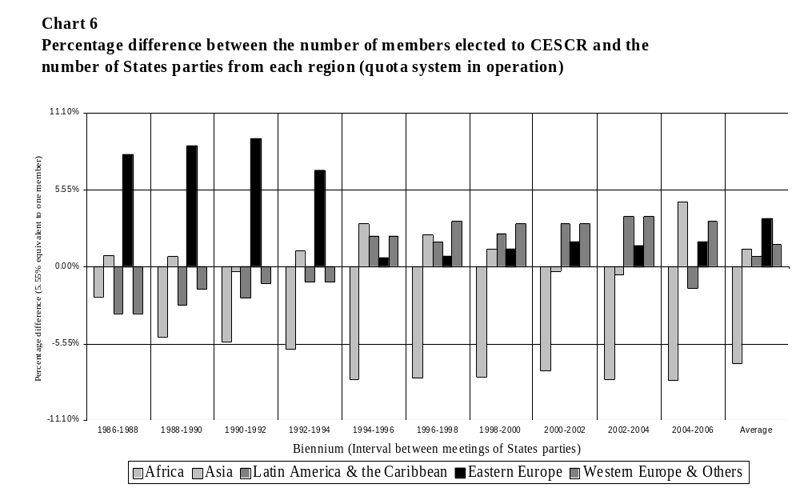

38. The CESCR quota system has not achieved equitable distribution of seats for African States and will require adjustment to be able to ensure an equitable distribution between all regional groups as the Covenant progresses towards universal ratification. The quota system allocates three seats to each regional group, leaving only three to correct imbalances. The Eastern European Group (which has already universally ratified the Covenant) has less than half as many States parties to the Covenant as the African Group.

Table 7
The CESCR quota system and universal ratification of the Covenant

 | Africa | Asia | Latin America | Eastern Europe | Western Europe | Total
Number of States parties | 48 | 26 | 22 | 27 | 28 | 151
Percentage of total States parties | 32% | 17% | 15% | 18% | 19% | n.a.
Expected allocation on the basis of current percentage of States parties | 6  (5.8) | 3  (3.1) | 3  (2.7) | 3  (3.2) | 3  (3.4) | 18
Allocation guaranteed by quota system | 3 | 3 | 3 | 3 | 3 | 18 — including  3 for correction
Current allocation following 2004 election | 4 | 4 | 3 | 3 | 4 | 18
Number of States per regional group | 53 | 52 | 22 | 33 | 29 | 191
Percentage of States parties on universal ratification | 28% | 28% | 12% | 17% | 15% | n.a.
Expected allocation on universal ratification | 5 | 5 | 2 | 3 | 3 | 18

VI. Conclusion

39. Under the terms of the six core human rights treaties that establish a treaty body, the modalities for the election of treaty body members is a matter for the States parties. The General Assembly may wish to forward the present report to the chairperson of the next meeting of States parties of each treaty. The resolution, and the present report, will also be provided to the chairperson of the seventeenth meeting of chairpersons of human rights treaty bodies as he prepares the agenda of the eighteenth meeting, to be held in June 2006.

Annex I

Regional Groups

The statistics contained in the present report were calculated on the basis of the following regional groups. Membership of the regional groups is not fixed and this list does not constitute official recognition of the composition of these groups.

African States (53 States)

Algeria
Angola
Benin
Botswana
Burkina Faso
Burundi
Cameroon
Cape Verde
Central African Republic
Chad
Comoros
Congo
Côte d’Ivoire
Democratic Republic of the Congo
Djibouti
Egypt
Equatorial Guinea
Eritrea
Ethiopia
Gabon
Gambia
Ghana
Guinea
Guinea-Bissau
Kenya
Lesotho
Liberia

Libyan Arab Jamahiriya
Madagascar
Malawi
Mali
Mauritania
Mauritius
Morocco
Mozambique
Namibia
Niger
Nigeria
Rwanda
Sao Tome and Principe
Senegal
Seychelles
Sierra Leone
Somalia
South Africa
Sudan
Swaziland
Togo
Tunisia
Uganda
United Republic of Tanzania
Zambia
Zimbabwe

Asian States (52 States)

Afghanistan
Bahrain
Bangladesh
Bhutan
Brunei Darussalam
Cambodia
China
Cyprus

Democratic People’s Republic of Korea
Fiji
India
Indonesia
Iran (Islamic Republic of)
Iraq
Japan
Jordan

Kazakhstan
Kuwait
Kyrgyzstan
Lao People’s Democratic Republic
Lebanon
Malaysia
Maldives
Marshall Islands
Micronesia (Federated States of)
Mongolia
Myanmar
Nauru
Nepal
Oman
Pakistan
Papua New Guinea
Philippines
Qatar

Republic of Korea
Samoa
Saudi Arabia
Singapore
Solomon Islands
Sri Lanka
Syrian Arab Republic
Tajikistan
Thailand
Timor-Leste
Tonga
Turkmenistan
Tuvalu
United Arab Emirates
Uzbekistan
Vanuatu
Viet Nam
Yemenª

Eastern European States (22 States)

Albania
Armenia***
Azerbaijan***
Belarus
Bosnia and Herzegovina****
Bulgaria
Croatia****
Czech Republic*
Estonia***
Georgia***
Hungary

Latvia***
Lithuania***
Poland
Republic of Moldova***
Romania
Russian Federation***
Serbia and Montenegro****
Slovakia*
Slovenia****
The former Yugoslav Republic of Macedonia****
Ukraine

Latin American and Caribbean States (33 States)

Antigua and Barbuda
Argentina
Bahamas
Barbados
Belize
Bolivia
Brazil
Chile
Colombia
Costa Rica
Cuba

Dominica
Dominican Republic
Ecuador
El Salvador
Grenada
Guatemala
Guyana
Haiti
Honduras
Jamaica
Mexico
Nicaragua
Panama
Paraguay
Peru
Saint Kitts and Nevis
Saint Lucia

Saint Vincent and the Grenadines
Suriname
Trinidad and Tobago
Uruguay
Venezuela (Bolivarian Republic of)

Western European and other States (29 States)

Andorra
Australia
Austria
Belgium
Canada
Denmark
Finland
France
Germany**
Greece
Iceland
Ireland
Israel
Italy
Liechtenstein

Luxembourg
Malta
Monaco
Netherlands
New Zealand
Norway
Portugal
San Marino
Spain
Sweden
Switzerland
Turkey
United Kingdom of Great Britain and
Northern Ireland
United States of America

Member of no regional group

Kiribati

Palau

Note: Both Palau and Kiribati are included in the Asian Group for the purposes of this analysis, notwithstanding that they do not formally adhere to this group.

Total: 191 Member States

States parties that are not members of the United Nations

Cook Islands^{b}
Holy See^{c}
Niue^{b}

Defunct former States parties

Czechoslovakia*
German Democratic Republic**
Union of Soviet Socialist Republics***
Yugoslavia****

* Czechoslovakia ceased to exist on 1 January 1993, on which date the Czech Republic and Slovakia, as successor States to the former Czechoslovakia, considered themselves bound by the multilateral treaties deposited with the Secretary-General to which Czechoslovakia was party. Both States are within the Eastern European Group.
** The German Democratic Republic acceded to the Federal Republic of Germany on 3 October 1990, resulting in one less State within the Eastern European Group.
*** The Russian Federation, as of 24 December 1991, maintained full responsibility for the rights and obligations of the USSR under the multilateral treaties deposited with the Secretary-General. The territory which formerly constituted the USSR, entirely within the Eastern European Group, is now represented by the Russian Federation and 12 other independent States, seven within the Eastern group (Armenia, Azerbaijan; Estonia, Georgia, Latvia, Lithuania and the Republic of Moldova) and five within the Asian group (Kazakhstan, Kyrgyzstan, Tajikistan, Turkmenistan and Uzbekistan). Belarus (as the Byelorussian SSR) and Ukraine (as the Ukrainian SSR) were each founding members of the United Nations in their own right.
**** The following States succeeded to the treaty rights and obligations with effect from the dates indicated previously undertaken by the Socialist Federal Republic of Yugoslavia: Bosnia and Herzegovina (6 March 1992), Croatia (8 October 1991), Serbia and Montenegro (27 April 1992), Slovenia (25 June 1991) and the former Yugoslav Republic of Macedonia (17 September 1991). The Socialist Federal Republic of Yugoslavia ceased to exist upon the independence of these five successor States.
ª On 22 May 1990, the Yemen Arab Republic and the People’s Democratic Republic of Yemen merged to form the Republic of Yemen. Between 6 April 1989 and 22 May 1990, both States were parties to the International Convention on the Elimination of All Forms of Racial Discrimination, resulting in an increase in the number of States parties in the Asian group.
^{b} Cook Islands and Niue are self-governing territories in free association with New Zealand. The Convention on the Elimination of All Forms of Discrimination against Women was applied by New Zealand to the Cook Islands and Niue at the time of its ratification of the Convention on 10 January 1985. The Secretary-General, as depositary of multilateral treaties, recognized the full treaty-making capacity of the Cook Islands in 1992 and of Niue in 1994. Both States are parties to the Convention on the Rights of the Child. Currently, the Cook Islands and Niue are not parties to the Convention on the Elimination of All Forms of Discrimination against Women in their own right. For the purpose of this study, both States are included with the other Pacific States in the Asian group, notwithstanding that New Zealand is part of the Western group.
^{c} The Holy See has observer status at the United Nations and is a party to three human rights conventions: International Convention on the Elimination of All Forms of Racial Discrimination, Convention against Torture and Convention on the Rights of the Child. It does not adhere to a regional group.

Annex II

Number of four-year terms served, by nationality

 | Nationality of member | Region | Number of terms*
 | Egypt (formerly United Arab Republic) | AF | 31
 | Ecuador | LAC | 23
 | Germany (Federal Republic of) | WEO | 23
 | France | WEO | 21.5
 | Argentina | LAC | 16.5
 | Philippines | AP | 15
 | Union of Soviet Socialist Republics | EE | 15
 | Cyprus | AP | 14.5
 | China | AP | 13.5
 | United Kingdom of Great Britain and Northern Ireland | WEO | 13.5
 | India | AP | 13
 | Russian Federation | EE | 12.5
 | Tunisia | AF | 12.5
 | Yugoslavia | EE | 12.5
 | Japan | AP | 12
 | Bulgaria | EE | 11
 | Canada | WEO | 11
 | Nigeria | AF | 11
 | Italy | WEO | 10.5
 | Mauritius | AF | 10.5
 | Ghana | AF | 10
 | Mexico | LAC | 10
 | Romania | EE | 9
 | Senegal | AF | 9
 | Sweden | WEO | 9
 | Australia | WEO | 8.5
 | Pakistan | AP | 8.5
 | Denmark | WEO | 8
 | Burkina Faso (formerly Upper Volta) | AF | 7.5
 | Spain | WEO | 7.5
 | Peru | LAC | 7.5
 | Cuba | LAC | 7
 | Jamaica | LAC | 7
 | Netherlands | WEO | 7
 | Costa Rica | LAC | 6.5
 | Portugal | WEO | 6.5
 | Brazil | LAC | 6
 | Greece | WEO | 6
 | Israel | WEO | 6
 | Poland | EE | 6
 | United States of America | WEO | 6
 | Colombia | LAC | 5.5
 | Panama | LAC | 5.5
 | Norway | WEO | 5.5
 | Austria | WEO | 5
 | German Democratic Republic | EE | 5
 | Cameroon | AF | 4.5
 | Chile | LAC | 4.5
 | Jordan | AP | 4.5
 | Sri Lanka | AP | 4.5
 | Switzerland | WEO | 4.5
 | Algeria | AF | 4
 | Barbados | LAC | 4
 | Ethiopia | AF | 4
 | Finland | WEO | 4
 | Indonesia | AP | 4
 | Venezuela (Bolivarian Republic of) | LAC | 4
 | Bangladesh | AP | 3.5
 | Guyana | LAC | 3.5
 | Hungary | EE | 3.5
 | Republic of Korea | AP | 3.5
 | Rwanda | AF | 3.5
 | South Africa | AF | 3.5
 | Zimbabwe | AF | 3.5
 | Kenya | AF | 3
 | Kuwait | AP | 3
 | New Zealand | WEO | 3
 | Nepal | AP | 3
 | Nicaragua | LAC | 3
 | Turkey | WEO | 3
 | Belarus | EE | 2.5
 | Benin | AF | 2.5
 | Guinea | AF | 2.5
 | Iran (Islamic Republic of) | AP | 2
 | Lebanon | AP | 2
 | Malta | WEO | 2
 | Mongolia | AP | 2
 | Syrian Arab Republic | AP | 2
 | Togo | AF | 2
 | Uruguay | LAC | 2
 | Czechoslovakia | EE | 1.5
 | Morocco | AF | 1.5
 | Qatar | AP | 1.5
 | Slovenia | EE | 1.5
 | Belgium | WEO | 1
 | Croatia | EE | 1
 | Czech Republic | EE | 1
 | Guatemala | LAC | 1
 | Iraq | AP | 1
 | Mali | AF | 1
 | Paraguay | LAC | 1
 | Saint Kitts and Nevis | LAC | 1
 | Saudi Arabia | AP | 1
 | Serbia and Montenegro | EE | 1
 | Sudan | AF | 1
 | Swaziland | AF | 1
 | United Republic of Tanzania | AF | 1
 | Thailand | AP | 1
 | Uganda | AF | 1
 | Azerbaijan | EE | 0.5
 | El Salvador | LAC | 0.5
 | Ireland | WEO | 0.5
 | Malaysia | AP | 0.5
 | Singapore | AP | 0.5
 | Ukraine (formerly Ukrainian SSR) | EE | 0.5
 | Viet Nam | AP | 0.5
 | Total |  | 623

* Half terms arise where, in accordance with the treaty provisions, a member receives a two-year term following the first election for a treaty body. Since data are provided to the end of 2006, half terms are also shown for current members whose terms run beyond 2006.

Note:
AF = African group
AP = Asian group (including the Pacific States)
EE = Eastern European group
LAC = Latin American and the Caribbean group
WEO = Western European and other States group

Annex III

Number of members elected to serve on the human rights treaty bodies and number of States parties eligible to vote at meetings of States parties, by regional group

Explanatory notes

For each committee, the first table compares the number of States parties eligible to vote with the number of committee members by regional group, shown with percentages of the total at the time of each election. The second table shows the difference in the percentages obtained from the first table, expressed as a positive or negative percentage value, which represents the degree to which the geographic distribution of membership equates to the number of States parties from each regional group.
The grand totals at the foot of each of the following charts (shown in bold) are provided for statistical purposes only and should be read with caution. The total number of States parties per region is a cumulative total which should be read as the maximum number of votes that could have been cast in all elections. Similarly, the total number of members per regional group should be read as the total number of two-year periods served; this figure is doubled to calculate the total number of four-year terms served (as shown in annex II).
The composition of each regional group has fluctuated over the years. Since it has not been possible to determine the precise composition of each group at the time of each election, the following calculations are based on the composition of the regional groups as of 14 April 2005. Nevertheless, calculations for the Eastern European group do incorporate States parties that existed at the time of earlier elections but have since been dissolved (Czechoslovakia, the German Democratic Republic, Yugoslavia). The Union of Soviet Socialist Republics is included in the Eastern European group although many of its successor States belong to the Asian group.

A. Committee on the Elimination of Racial Discrimination (CERD)

1. Number of members elected to CERD and number of States parties eligible to vote, by regional group

 | Africa |  |  |  | Asia |  |  |  | Latin America and the Caribbean |  |  |  | Eastern Europe |  |  |  | Western Europe and Others |  |  |  | Total
Biennium | States parties |  | Members |  | States parties |  | Members |  | States parties |  | Members |  | States parties |  | Members |  | States parties |  | Members |  | States parties | Members
1970-1972 | 9 | 26% | 3 | 17% | 9 | 25% | 6 | 33% | 7 | 20% | 2 | 11% | 6 | 17% | 5 | 28% | 5 | 14% | 2 | 11% | 35 | 18
1972-1974 | 13 | 23% | 4 | 22% | 11 | 20% | 4 | 22% | 11 | 20% | 3 | 17% | 7 | 13% | 3 | 17% | 14 | 25% | 4 | 22% | 56 | 18
1974-1976 | 20 | 28% | 4 | 22% | 14 | 19% | 4 | 22% | 15 | 21% | 3 | 17% | 7 | 10% | 3 | 17% | 16 | 22% | 4 | 22% | 72 | 18
1976-1978 | 25 | 29% | 4 | 22% | 17 | 20% | 4 | 22% | 17 | 20% | 3 | 17% | 7 | 8% | 3 | 17% | 19 | 22% | 4 | 22% | 85 | 18
1978-1980 | 32 | 34% | 4 | 22% | 18 | 19% | 4 | 22% | 18 | 19% | 3 | 17% | 7 | 7% | 3 | 17% | 19 | 20% | 4 | 22% | 94 | 18
1980-1982 | 35 | 34% | 4 | 22% | 20 | 19% | 4 | 22% | 20 | 19% | 3 | 17% | 7 | 7% | 3 | 17% | 21 | 20% | 4 | 22% | 103 | 18
1982-1984 | 37 | 34% | 4 | 22% | 21 | 19% | 4 | 22% | 22 | 20% | 3 | 17% | 7 | 6% | 3 | 17% | 21 | 19% | 4 | 22% | 108 | 18
1984-1986 | 39 | 33% | 4 | 22% | 27 | 23% | 4 | 22% | 24 | 20% | 3 | 17% | 7 | 6% | 3 | 17% | 22 | 18% | 4 | 22% | 119 | 18
1986-1988 | 39 | 32% | 4 | 22% | 28 | 23% | 4 | 22% | 25 | 21% | 2 | 11% | 7 | 6% | 3 | 17% | 22 | 18% | 5 | 28% | 121 | 18
1988-1990 | 39 | 32% | 4 | 22% | 28 | 23% | 4 | 22% | 25 | 21% | 3 | 17% | 7 | 6% | 3 | 17% | 22 | 18% | 4 | 22% | 121 | 18
1990-1992 | 41 | 33% | 3 | 17% | 29 | 23% | 4 | 22% | 26 | 21% | 4 | 22% | 7 | 6% | 3 | 17% | 22 | 18% | 4 | 22% | 125 | 18
1992-1994 | 42 | 33% | 3 | 17% | 29 | 23% | 4 | 22% | 27 | 21% | 4 | 22% | 8 | 6% | 3 | 17% | 22 | 17% | 4 | 22% | 128 | 18
1994-1996 | 42 | 31% | 3 | 17% | 29 | 21% | 4 | 22% | 27 | 20% | 4 | 22% | 16 | 12% | 3 | 17% | 22 | 16% | 4 | 22% | 136 | 18
1996-1998 | 42 | 29% | 3 | 17% | 33 | 23% | 4 | 22% | 27 | 19% | 4 | 22% | 18 | 12% | 3 | 17% | 25 | 17% | 4 | 22% | 145 | 18
1998-2000 | 43 | 29% | 1 | 6% | 35 | 23% | 4 | 22% | 27 | 18% | 4 | 22% | 19 | 13% | 3 | 17% | 25 | 17% | 6 | 33% | 149 | 18
2000-2002 | 44 | 29% | 2 | 11% | 37 | 24% | 4 | 22% | 27 | 18% | 3 | 17% | 21 | 14% | 3 | 17% | 25 | 16% | 6 | 33% | 154 | 18
2002-2004 | 47 | 29% | 4 | 22% | 37 | 23% | 3 | 17% | 28 | 17% | 3 | 17% | 22 | 14% | 2 | 11% | 27 | 17% | 6 | 33% | 161 | 18
2004-2006 | 48 | 28% | 4 | 22% | 40 | 24% | 3 | 17% | 30 | 18% | 4 | 22% | 22 | 13% | 1 | 6% | 29 | 17% | 6 | 33% | 169 | 18
Total | 637 | 31% | 62 | 19% | 462 | 22% | 72 | 22% | 403 | 19% | 58 | 18% | 202 | 10% | 53 | 16% | 378 | 18% | 79 | 24% | 2082 | 324

Note: Elections of members are governed by article 18 of the Convention. Members are elected for terms of four years, except for the terms of nine of the members elected at the first election, which expired after two years. States parties meet every two years to elect nine members. The first elections were held in January 1970. Terms run from 19 January of the year of election to 18 January four years later, with elections at a meeting of States parties held in January every two years.

2. Percentage difference between numbers of members elected to CERD and States parties, by regional group

One member is equivalent to 5.55 per cent of the total membership of 18 members.

Biennium | Africa | Asia | Latin America and the Caribbean | Eastern Europe | Western Europe and Others
1970-1972 | -8% | 8% | -8% | 11% | -3%
1972-1974 | -1% | 3% | -3% | 4% | -3%
1974-1976 | -6% | 3% | -4% | 7% | 0%
1976-1978 | -7% | 2% | -3% | 8% | 0%
1978-1980 | -12% | 3% | -2% | 9% | 2%
1980-1982 | -12% | 3% | -3% | 10% | 2%
1982-1984 | -12% | 3% | -4% | 10% | 3%
1984-1986 | -11% | 0% | -4% | 11% | 4%
1986-1988 | -10% | -1% | -10% | 11% | 10%
1988-1990 | -10% | -1% | -4% | 11% | 4%
1990-1992 | -16% | -1% | 1% | 11% | 5%
1992-1994 | -16% | 0% | 1% | 10% | 5%
1994-1996 | -14% | 1% | 2% | 5% | 6%
1996-1998 | -12% | -1% | 4% | 4% | 5%
1998-2000 | -23% | -1% | 4% | 4% | 17%
2000-2002 | -17% | -2% | -1% | 3% | 17%
2002-2004 | -7% | -6% | -1% | -3% | 17%
2004-2006 | -6% | -7% | 4% | -7% | 16%
Average | -11% | 0% | -1% | 7% | 6%

B. Human Rights Committee (HRC)

1. Number of members elected to HRC and number of States parties eligible to vote, by regional group

 | Africa |  |  |  | Asia |  |  |  | Latin America and the Caribbean |  |  |  | Eastern Europe |  |  |  | Western Europe and Others |  |  |  | Total
Biennium | States parties |  | Members |  | States parties |  | Members |  | States parties |  | Members |  | States parties |  | Members |  | States parties |  | Members |  | States parties | Members
1977-1979 | 9 | 26% | 3 | 17% | 7 | 20% | 3 | 17% | 7 | 20% | 3 | 17% | 6 | 17% | 3 | 17% | 6 | 17% | 6 | 33% | 35 | 18
1979-1981 | 12 | 26% | 3 | 17% | 7 | 15% | 4 | 22% | 13 | 28% | 2 | 11% | 7 | 15% | 4 | 22% | 8 | 17% | 5 | 28% | 47 | 18
1981-1983 | 14 | 23% | 3 | 17% | 10 | 17% | 3 | 17% | 16 | 27% | 3 | 17% | 7 | 12% | 3 | 17% | 13 | 22% | 6 | 33% | 60 | 18
1983-1985 | 16 | 24% | 2 | 11% | 11 | 16% | 3 | 17% | 18 | 27% | 3 | 17% | 7 | 10% | 3 | 17% | 15 | 22% | 7 | 39% | 67 | 18
1985-1987 | 20 | 26% | 4 | 22% | 13 | 17% | 2 | 11% | 19 | 25% | 3 | 17% | 7 | 9% | 3 | 17% | 17 | 22% | 6 | 33% | 76 | 18
1987-1989 | 23 | 29% | 4 | 22% | 13 | 16% | 3 | 17% | 19 | 24% | 3 | 17% | 7 | 9% | 3 | 17% | 18 | 23% | 5 | 28% | 80 | 18
1989-1991 | 24 | 29% | 4 | 22% | 15 | 18% | 3 | 17% | 20 | 24% | 3 | 17% | 7 | 8% | 3 | 17% | 18 | 21% | 5 | 28% | 84 | 18
1991-1993 | 27 | 30% | 4 | 22% | 16 | 18% | 3 | 17% | 20 | 22% | 3 | 17% | 7 | 8% | 3 | 17% | 19 | 21% | 5 | 28% | 89 | 18
1993-1995 | 32 | 30% | 3 | 17% | 18 | 17% | 3 | 17% | 25 | 23% | 4 | 22% | 11 | 10% | 2 | 11% | 22 | 20% | 6 | 33% | 108 | 18
1995-1997 | 38 | 30% | 2 | 11% | 18 | 14% | 3 | 17% | 26 | 21% | 5 | 28% | 21 | 17% | 1 | 6% | 23 | 18% | 7 | 39% | 126 | 18
1997-1999 | 41 | 31% | 2 | 11% | 21 | 16% | 3 | 17% | 27 | 20% | 3 | 17% | 21 | 16% | 1 | 6% | 23 | 17% | 9 | 50% | 133 | 18
1999-2001 | 43 | 31% | 2 | 11% | 22 | 16% | 3 | 17% | 28 | 20% | 3 | 17% | 21 | 15% | 1 | 6% | 25 | 18% | 9 | 50% | 139 | 18
2001-2003 | 44 | 31% | 4 | 22% | 24 | 17% | 2 | 11% | 28 | 20% | 3 | 17% | 21 | 15% | 0 | 0% | 26 | 18% | 9 | 50% | 143 | 18
2003-2005 | 47 | 32% | 4 | 22% | 25 | 17% | 2 | 11% | 28 | 19% | 3 | 17% | 22 | 15% | 1 | 6% | 26 | 18% | 8 | 44% | 148 | 18
2005-2007 | 49 | 32% | 4 | 22% | 26 | 17% | 2 | 11% | 28 | 18% | 4 | 22% | 22 | 14% | 1 | 6% | 27 | 18% | 7 | 39% | 152 | 18
Total | 439 | 26% | 48 | 18% | 246 | 17% | 42 | 16% | 322 | 22% | 48 | 18% | 194 | 13% | 32 | 12% | 286 | 19% | 100 | 37% | 1487 | 270

Note: Elections of members are governed by articles 28-34 of the Covenant. Members are elected for terms of four years, except for the terms of nine of the members elected at the first election, which expired after two years. States parties meet every two years to elect nine members. The first elections were held in September 1976. Terms run from 1 January of the year after election to 31 December four years later, with elections at a meeting of States parties held in September every two years.

2. Percentage difference between number of members elected to HRC and States parties, by regional group

One member is equivalent to 5.55 per cent of the total membership of 18 members.

Biennium | Africa | Asia | Latin America and the Caribbean | Eastern Europe | Western Europe and Others
1977-1979 | -9% | -3% | -3% | 0% | 16%
1979-1981 | -9% | 7% | -17% | 7% | 11%
1981-1983 | -7% | 0% | -10% | 5% | 12%
1983-1985 | -13% | 0% | -10% | 6% | 17%
1985-1987 | -4% | -6% | -8% | 7% | 11%
1987-1989 | -7% | 0% | -7% | 8% | 5%
1989-1991 | -6% | -1% | -7% | 8% | 6%
1991-1993 | -8% | -1% | -6% | 9% | 6%
1993-1995 | -13% | 0% | -1% | 1% | 13%
1995-1997 | -19% | 2% | 7% | -11% | 21%
1997-1999 | -20% | 1% | -4% | -10% | 33%
1999-2001 | -20% | 1% | -3% | -10% | 32%
2001-2003 | -9% | -6% | -3% | -15% | 32%
2003-2005 | -10% | -6% | -2% | -9% | 27%
2005-2007 | -10% | -6% | 4% | -9% | 21%
Average | -12% | -1% | -4% | -1% | 18%

C. Committee on the Elimination of Discrimination against Women (CEDAW)

1. Number of members elected to CEDAW and number of States parties, by regional group

 | Africa |  |  |  | Asia |  |  |  | Latin America and the Caribbean |  |  |  | Eastern Europe |  |  |  | Western Europe and Others |  |  |  | Total
Biennium | States parties |  | Members |  | States parties |  | Members |  | States parties |  | Members |  | States parties |  | Members |  | States parties |  | Members |  | States parties | Members
1982-1984 | 4 | 11% | 2 | 9% | 7 | 18% | 5 | 22% | 13 | 34% | 6 | 26% | 10 | 26% | 6 | 26% | 4 | 11% | 4 | 17% | 38 | 23
1984-1986 | 9 | 16% | 3 | 13% | 7 | 13% | 4 | 17% | 20 | 36% | 5 | 22% | 10 | 18% | 5 | 22% | 10 | 18% | 6 | 26% | 56 | 23
1986-1988 | 21 | 25% | 4 | 17% | 14 | 16% | 3 | 13% | 23 | 27% | 6 | 26% | 10 | 12% | 4 | 17% | 17 | 20% | 6 | 26% | 85 | 23
1988-1990 | 25 | 27% | 5 | 22% | 15 | 16% | 3 | 13% | 25 | 27% | 6 | 26% | 10 | 11% | 3 | 13% | 19 | 20% | 6 | 26% | 94 | 23
1990-1992 | 28 | 28% | 6 | 26% | 15 | 15% | 3 | 13% | 27 | 27% | 5 | 22% | 10 | 10% | 3 | 13% | 20 | 20% | 6 | 26% | 100 | 23
1992-1994 | 30 | 27% | 6 | 26% | 16 | 15% | 4 | 17% | 31 | 28% | 5 | 22% | 10 | 9% | 2 | 9% | 23 | 21% | 6 | 26% | 110 | 23
1994-1996 | 36 | 28% | 6 | 26% | 22 | 17% | 5 | 22% | 33 | 25% | 5 | 22% | 16 | 12% | 0 | 0% | 23 | 18% | 7 | 30% | 130 | 23
1996-1998 | 43 | 28% | 6 | 26% | 29 | 19% | 6 | 26% | 33 | 22% | 4 | 17% | 22 | 15% | 0 | 0% | 24 | 16% | 7 | 30% | 151 | 23
1999-2000 | 46 | 29% | 6 | 26% | 34 | 21% | 6 | 26% | 33 | 20% | 4 | 17% | 22 | 14% | 0 | 0% | 26 | 16% | 7 | 30% | 161 | 23
2001-2002 | 48 | 29% | 6 | 26% | 36 | 22% | 6 | 26% | 33 | 20% | 4 | 17% | 22 | 13% | 0 | 0% | 26 | 16% | 7 | 30% | 165 | 23
2003-2004 | 49 | 29% | 7 | 30% | 40 | 24% | 5 | 22% | 33 | 19% | 2 | 9% | 22 | 13% | 3 | 13% | 26 | 15% | 6 | 26% | 170 | 23
2005-2006 | 51 | 29% | 5 | 22% | 44 | 25% | 7 | 30% | 33 | 19% | 3 | 13% | 22 | 12% | 3 | 13% | 27 | 15% | 5 | 22% | 177 | 23
Total | 390 | 27% | 62 | 22% | 279 | 19% | 57 | 21% | 337 | 23% | 55 | 20% | 186 | 13% | 29 | 11% | 245 | 17% | 73 | 26% | 1437 | 276

Note: Elections of members are governed by article 17 of the Convention. Members are elected for terms of four years, except for the terms of 11 of the members elected at the first election, which expired after two years. States parties meet every two years to elect alternately 11 or 12 members. The first elections were held in April 1982. From 1982 to 1988 these terms ran from 16 April of the year of election to 15 April four years later, with elections usually held at a meeting of States parties in February. From 1 January 1999, the terms were amended to run from 1 January of the year after election to 31 December four years later, with elections at a meeting of States parties now held in August every two years.

2. Percentage difference between number of members elected to CEDAW and States parties, by regional group

One member is equivalent to 4.34 per cent of the total membership of 23 members.

Biennium | Africa | Asia | Latin America and the Caribbean | Eastern Europe | Western Europe and Others
1982-1984 | -2% | 3% | -8% | 0% | 7%
1984-1986 | -3% | 5% | -14% | 4% | 8%
1986-1988 | -7% | -3% | -1% | 6% | 6%
1988-1990 | -5% | -3% | -1% | 2% | 6%
1990-1992 | -2% | -2% | -5% | 3% | 6%
1992-1994 | -1% | 3% | -6% | 0% | 5%
1994-1996 | -2% | 5% | -4% | -12% | 13%
1996-1998 | -2% | 7% | -4% | -15% | 15%
1999-2000 | -2% | 5% | -3% | -14% | 14%
2001-2002 | -3% | 4% | -3% | -13% | 15%
2003-2004 | 2% | -2% | -11% | 0% | 11%
2005-2006 | -7% | 6% | -6% | 1% | 6%
Average | -5% | 1% | -4% | -2% | 9%

D. Committee against Torture (CAT)

1. Number of members elected to CAT and number of States parties, by regional group

 | Africa |  |  |  | Asia |  |  |  | Latin America and the Caribbean |  |  |  | Eastern Europe |  |  |  | Western Europe and Others |  |  |  | Total
Biennium | States parties |  | Members |  | States parties |  | Members |  | States parties |  | Members |  | States parties |  | Members |  | States parties |  | Members |  | States parties | Members
1988-1990 | 4 | 16% | 1 | 10% | 2 | 8% | 1 | 10% | 5 | 20% | 2 | 20% | 5 | 20% | 2 | 20% | 9 | 36% | 4 | 40% | 25 | 10
1990-1992 | 9 | 20% | 1 | 10% | 3 | 7% | 1 | 10% | 11 | 24% | 2 | 20% | 6 | 13% | 2 | 20% | 17 | 37% | 4 | 40% | 46 | 10
1992-1994 | 10 | 17% | 3 | 30% | 5 | 8% | 0 | 0% | 14 | 24% | 2 | 20% | 8 | 14% | 2 | 20% | 22 | 37% | 3 | 30% | 59 | 10
1994-1996 | 16 | 21% | 3 | 30% | 8 | 10% | 1 | 10% | 15 | 19% | 2 | 20% | 15 | 19% | 1 | 10% | 23 | 30% | 3 | 30% | 77 | 10
1996-1998 | 19 | 21% | 2 | 20% | 12 | 13% | 2 | 20% | 17 | 19% | 1 | 10% | 19 | 21% | 2 | 20% | 24 | 26% | 3 | 30% | 91 | 10
1998-2000 | 23 | 22% | 2 | 20% | 15 | 15% | 2 | 20% | 19 | 18% | 1 | 10% | 21 | 20% | 2 | 20% | 25 | 24% | 3 | 30% | 103 | 10
2000-2002 | 29 | 25% | 2 | 20% | 21 | 18% | 2 | 20% | 20 | 17% | 1 | 10% | 21 | 18% | 1 | 10% | 26 | 22% | 4 | 40% | 117 | 10
2002-2004 | 34 | 27% | 2 | 20% | 23 | 18% | 2 | 20% | 21 | 17% | 1 | 10% | 22 | 17% | 1 | 10% | 26 | 21% | 4 | 40% | 126 | 10
2004-2006 | 38 | 28% | 2 | 20% | 25 | 19% | 2 | 20% | 21 | 16% | 2 | 20% | 22 | 16% | 1 | 10% | 28 | 21% | 3 | 30% | 134 | 10
Total | 182 | 23% | 18 | 20% | 114 | 15% | 13 | 14% | 143 | 18% | 14 | 16% | 139 | 18% | 14 | 16% | 200 | 26% | 31 | 34% | 778 | 90

Note: Elections of members are governed by article 17 of the Convention. Members are elected for terms of four years, except for the terms of five of the members elected at the first election, which expired after two years. States parties meet every two years to elect five members. The first elections were held in November 1987. Terms run from 1 January of the year after election to 31 December four years later, with elections at a meeting of States parties held in September every two years.

2. Percentage difference between number of members elected to CAT and States parties, by regional group

One member is equivalent to 10 per cent of the total membership of 10 members.

Biennium | Africa | Asia | Latin America and the Caribbean | Eastern Europe | Western Europe and Others
1988-1990 | -6% | 2% | 0% | 0% | 4%
1990-1992 | -10% | 3% | -4% | 7% | 3%
1992-1994 | 13% | -8% | -4% | 6% | -7%
1994-1996 | 9% | 0% | 1% | -9% | 0%
1996-1998 | -1% | 7% | -9% | -1% | 4%
1998-2000 | -2% | 5% | -8% | 0% | 6%
2000-2002 | -5% | 2% | -7% | -8% | 18%
2002-2004 | -7% | 2% | -7% | -7% | 19%
2004-2006 | -8% | 1% | 4% | -6% | 9%
Average | -3% | 0% | -3% | -2% | 9%

E. Committee on Economic, Social and Cultural Rights (CESCR)

1. Number of members elected to CESCR and number of States parties, by regional group

 | Africa |  |  |  | Asia |  |  |  | Latin America and the Caribbean |  |  |  | Eastern Europe |  |  |  | Western Europe and Others |  |  |  | Total
Biennium | States parties |  | Members |  | States parties |  | Members |  | States parties |  | Members |  | States parties |  | Members |  | States parties |  | Members |  | States parties | Members
1986-1988 | 20 | 24% | 4 | 22% | 13 | 16% | 3 | 17% | 21 | 26% | 4 | 22% | 7 | 9% | 3 | 17% | 20 | 26% | 4 | 22% | 82 | 18
1988-1990 | 24 | 27% | 4 | 22% | 14 | 16% | 3 | 17% | 22 | 25% | 4 | 22% | 7 | 8% | 3 | 17% | 20 | 24% | 4 | 22% | 88 | 18
1990-1992 | 26 | 28% | 4 | 22% | 14 | 17% | 3 | 17% | 23 | 24% | 4 | 22% | 7 | 7% | 3 | 17% | 21 | 23% | 4 | 22% | 92 | 18
1992-1994 | 29 | 28% | 4 | 22% | 16 | 16% | 3 | 17% | 24 | 23% | 4 | 22% | 10 | 10% | 3 | 17% | 23 | 23% | 4 | 22% | 104 | 18
1994-1996 | 38 | 30% | 4 | 22% | 17 | 14% | 3 | 17% | 25 | 20% | 4 | 22% | 20 | 16% | 3 | 17% | 24 | 20% | 4 | 22% | 127 | 18
1996-1998 | 40 | 30% | 4 | 22% | 19 | 14% | 3 | 17% | 27 | 20% | 4 | 22% | 21 | 16% | 3 | 17% | 24 | 19% | 4 | 22% | 132 | 18
1998-2000 | 41 | 30% | 4 | 22% | 21 | 15% | 3 | 17% | 27 | 20% | 4 | 22% | 21 | 15% | 3 | 17% | 25 | 19% | 4 | 22% | 136 | 18
2000-2002 | 42 | 30% | 4 | 22% | 24 | 17% | 3 | 17% | 27 | 19% | 4 | 22% | 21 | 15% | 3 | 17% | 26 | 19% | 4 | 22% | 141 | 18
2002-2004 | 44 | 30% | 4 | 22% | 25 | 17% | 3 | 17% | 27 | 19% | 4 | 22% | 22 | 15% | 3 | 17% | 26 | 19% | 4 | 22% | 145 | 18
2004-2006 | 45 | 30% | 4 | 22% | 26 | 18% | 4 | 22% | 27 | 18% | 3 | 17% | 22 | 15% | 3 | 17% | 27 | 19% | 4 | 22% | 148 | 18
Total | 349 | 29% | 40 | 22% | 191 | 16% | 31 | 17% | 252 | 21% | 39 | 22% | 158 | 13% | 30 | 17% | 236 | 21% | 40 | 22% | 1195 | 180

Note: Elections of members are governed by Economic and Social Council resolution 1985/17. Members are elected for terms of four years, except for the terms of nine of the members elected at the first election, which expired after two years. States parties nominate candidates, but it is the members of the Council that elect nine members every two years at one of their regular meetings. The first elections were held in May 1986. Terms run from 1 January of the year after election to 31 December four years later.

2. Percentage difference between number of members elected to CESCR and States parties, by regional group

One member is equivalent to 5.55 per cent of the total membership of 18 members.

Biennium | Africa | Asia | Latin America and the Caribbean | Eastern Europe | Western Europe and Others
1986-1988 | -2% | 1% | -3% | 8% | -3%
1988-1990 | -5% | 1% | -3% | 9% | -2%
1990-1992 | -5% | 0% | -2% | 9% | -1%
1992-1994 | -6% | 1% | -1% | 7% | -1%
1994-1996 | -8% | 3% | 2% | 1% | 2%
1996-1998 | -8% | 2% | 2% | 1% | 3%
1998-2000 | -8% | 1% | 2% | 1% | 3%
2000-2002 | -8% | 0% | 3% | 2% | 3%
2002-2004 | -8% | -1% | 4% | 1% | 4%
2004-2006 | -8% | 5% | -2% | 2% | 3%
Average | -7% | 1% | 1% | 3% | 2%

F. Committee on the Rights of the Child (CRC)

1. Number of members elected to CRC and number of States parties, by regional group

 | Africa |  |  |  | Asia |  |  |  | Latin America and the Caribbean |  |  |  | Eastern Europe |  |  |  | Western Europe and Others |  |  |  | Total
Biennium | States parties |  | Members |  | States parties |  | Members |  | States parties |  | Members |  | States parties |  | Members |  | States parties |  | Members |  | States parties | Members
1991-1993 | 26 | 38% | 3 | 38% | 9 | 13% | 1 | 10% | 21 | 30% | 3 | 30% | 5 | 7% | 1 | 10% | 8 | 12% | 2 | 20% | 69 | 10
1993-1995 | 40 | 31% | 3 | 31% | 24 | 19% | 1 | 10% | 28 | 22% | 3 | 30% | 15 | 12% | 1 | 10% | 20 | 16% | 2 | 20% | 127 | 10
1995-1997 | 49 | 29% | 3 | 29% | 41 | 24% | 1 | 10% | 32 | 19% | 2 | 20% | 22 | 13% | 1 | 10% | 26 | 15% | 3 | 30% | 170 | 10
1997-1999 | 52 | 28% | 2 | 28% | 53 | 28% | 2 | 20% | 33 | 17% | 2 | 20% | 22 | 12% | 1 | 10% | 29 | 15% | 3 | 30% | 189 | 10
1999-2001 | 52 | 27% | 3 | 27% | 54 | 28% | 2 | 20% | 33 | 17% | 1 | 10% | 22 | 12% | 0 | 0% | 30 | 16% | 4 | 40% | 191 | 10
2001-2003 | 52 | 27% | 2 | 27% | 54 | 28% | 3 | 30% | 33 | 17% | 1 | 10% | 22 | 12% | 0 | 0% | 30 | 16% | 4 | 40% | 191 | 10
2003-2005 | 52 | 27% | 5 | 27% | 54 | 28% | 4 | 22% | 33 | 17% | 4 | 22% | 22 | 12% | 1 | 6% | 30 | 16% | 4 | 22% | 191 | 18
2005-2007 | 52 | 27% | 6 | 27% | 55 | 29% | 3 | 17% | 33 | 17% | 3 | 17% | 22 | 11% | 1 | 6% | 30 | 16% | 5 | 28% | 192 | 18
Total | 375 | 28% | 27 | 28% | 344 | 26% | 17 | 18% | 246 | 19% | 19 | 20% | 152 | 12% | 6 | 6% | 203 | 15% | 27 | 28% | 1320 | 96

Note: Elections of members are governed by article 43 of the Convention. Members are elected for terms of four years, except for the terms of five of the members elected at the first election, which expired after two years. States parties meet every two years to elect nine members (previously five members). The first elections were held in February 1991. Terms run from 28 February of the year of election to 27 February four years later, with elections at a meeting of States parties held in September every two years.

2. Percentage difference between number of members elected to CRC and States parties, by regional group

Until 2003, one member was equivalent to 10 per cent of the total membership of 10 members; since 2003, one member represents 5.55 per cent of the total membership of 18 members.

Biennium | Africa | Asia | Latin America and the Caribbean | Eastern Europe | Western Europe and Others
1991-1993 | -8% | -3% | 0% | 3% | 8%
1993-1995 | -1% | -9% | 8% | -2% | 4%
1995-1997 | 1% | -14% | 1% | -3% | 15%
1997-1999 | -8% | -8% | 3% | -2% | 15%
1999-2001 | 3% | -8% | -7% | -12% | 24%
2001-2003 | -7% | 2% | -7% | -12% | 24%
2003-2005 | 1% | -6% | 5% | -6% | 7%
2005-2007 | 6% | -12% | -1% | -6% | 12%
Average | 0% | -8% | 1% | -5% | 13%

G. Committee on Migrant Workers (CMW)

1. Number of members elected to CMW and number of States parties, by region

 | Africa |  |  |  | Asia |  |  |  | Latin America and the Caribbean |  |  |  | Eastern Europe |  |  |  | Western Europe and Others |  |  |  | Total
Biennium | States parties |  | Members |  | States parties |  | Members |  | States parties |  | Members |  | States parties |  | Members |  | States parties |  | Members |  | States parties | Members
2004-2005 | 9 | 41% | 3 | 30% | 2 | 9% |  | 20% | 8 | 36% | 4 | 40% | 3 | 14% | 1 | 10% | 0 | - | 0 | - | 22 | 10

Note: Elections of members are governed by article 72 of the Convention. Members are elected for terms of four years, except for the terms of five of the members elected at the first election, which expire after two years. States parties meet every two years to elect five members. The first elections were held in December 2003. Terms run from 1 January of the year after election to 31 December four years later, with elections at a meeting of States parties held in December every two years.

2. Percentage difference between number of members elected to CMW and States parties, by regional group

One member is equivalent to 10 per cent of the total membership of 10 members.

Biennium | Africa | Asia | Latin America and the Caribbean | Eastern Europe | Western Europe and Others
2004-2005 | -9% | 7% | 5% | -3% | 0%

