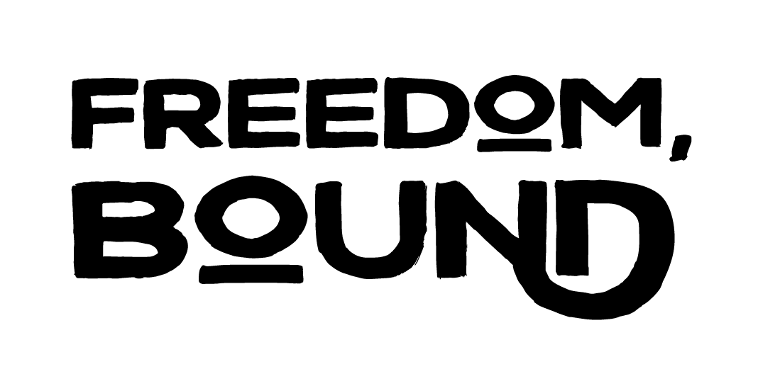
About
Gallery of Solidarity
Data Visualizations
Art as Resistance
https://freedom-bound.org/

“A history of shared struggle for collective liberation
Freedom, Bound is an artistic and historical account of the shared struggle for collective liberation. Inspired by and rooted in the rich legacy of Black-Palestinian solidarity, this multi-media experience considers solidarity both as shared lived reality, and as political choice made time and again throughout history. Through data visualizations and a transhistorical gallery of artifacts, the visitor is invited to consider the inherent interconnectedness and timeless resonance of shared resistance to oppression.
The Freedom, Bound experience is profoundly enriched by contemporary artistic responses to the legacy of Black-Palestinian solidarity. Poets, artists and dancers from Palestine/Israel and the United States responded to a Call to Artists, and through their work, offered reflections on unity between freedom struggles. One commissioned piece, five juried selections, and several additional works of art complement the historic artifacts, and compel the visitor to imagine the world when we win.
Freedom, Bound was initiated by
Adalah - The Legal Center for Arab Minority Rights in Israel with the support of the Cultures of Resistance Network

