ICAHD statement for Nakba Day
Israeli Committee Against House Demolitions
May 14, 2018
https://icahd.org/2018/05/14/icahd-statement-for-nakba-day/

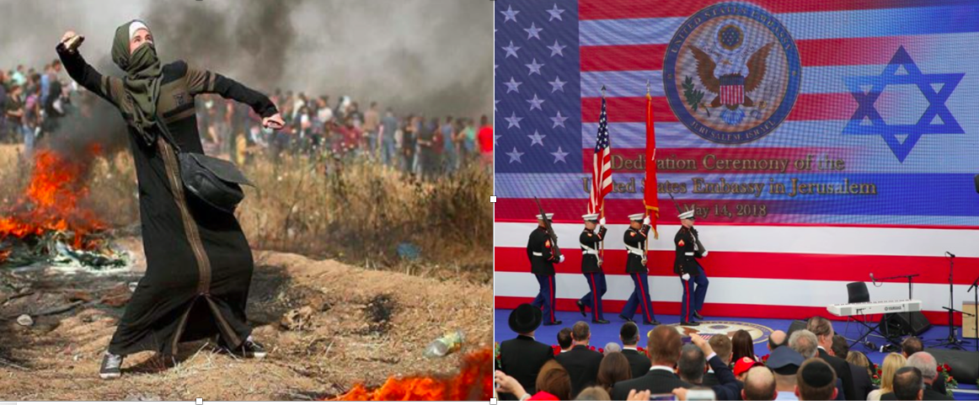
The confluence of two major political events today in Palestine/Israel — the inaugurating of the American Embassy in Jerusalem with the participation of Trump’s Cabinet, members of Congress and Jared & Ivanka Kushner, together with the killing of protesters in Gaza (37 dead and hundreds wounded just in the last few hours) — demonstrate dramatically the ability of powerful oppressors to frame reality in a way that their own actions come across as merely normal, even praiseworthy self-righteousness while delegitimizing and even rendering invisible the truly righteous struggles of the oppressed.

The fact that Nakba Day is marked by triumphalism on the part of Israel with demonstrative support from the US, and the systematic killing and deliberate wounding of Palestinians graphically illustrate that the Nakba is an ongoing crime.
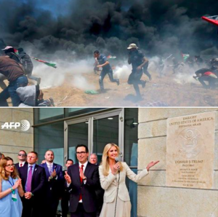
On a higher level, though, it reveals the deep systemic injustice and dysfunction upon which our international political system is based. The Nakba is a purely Palestinian experience that must be resolved by the establishment of a single democratic state based on equal rights, the return of refugees and restorative justice, material as well as political and moral. But it is also the global experience of the world’s peoples, the vast majority of humanity that continues to be impoverished, disenfranchised, displaced, excluded, humiliated, exploited, doomed to poor heath and killed.

On this Nakba Day 2018, ICAHD calls for the end of killing and for the liberation of the Palestinians, for governments to intervene on behalf of the Palestinians based on justice and human rights, for the universal rejection of cynical, destructive American policies in Palestine and throughout the world, and for an International Nakba Day that protests the palestiniazation of us all and for the genuine liberation of the world’s peoples.

