IDF Targets Palestinian Islamic Jihad Terrorist Ahmad Sa’ad
IDF Blog
January 19, 2014
http://web.archive.org/web/20150330032845/http://www.idfblog.com/blog/2014/01/19/idf-targets-gaza-terrorist/

The IDF successfully targeted a terrorist operative involved in recent attacks against Israel. The terrorist was planning further attacks on Israel in the coming days. Ahmad Sa’ad, a senior operative in the Palestinian Islamic Jihad terrorist organization, was in the northern Gaza Strip when an IAF aircraft carried out the mission. The IDF operated in order to eliminate an imminent threat to the lives of Israeli civilians.
Ahmad Sa’ad was a key Palestinian Islamic Jihad operative in the Gaza Strip specializing in rocket launching. Sa’ad is personally responsible for the launching of five rockets towards Ashkelon on January 16, 2014 which were intercepted by the Iron Dome missile defense system.
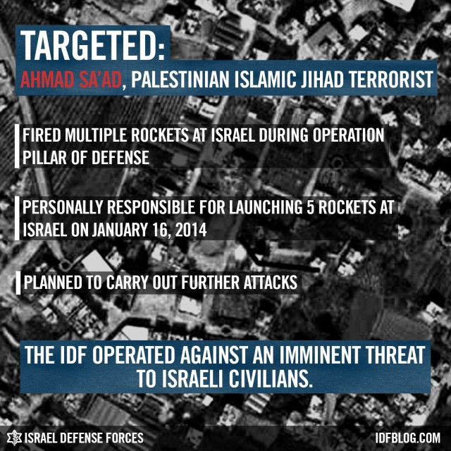
Sa’ad’s terrorist activities over the years include concealing, directing, and launching rockets at southern Israel in numerous incidents including during operation Pillar of Defense in Nov 2012, and multiple launches during an escalation of violence during March 2012. In recent days Sa’ad was involved in substantial planning of launching rockets at Israeli civilians.
“Gaza terrorists must know that there is a personal price to pay when planning and executing terror attacks against Israel,” said Lt. Col. Peter Lerner, IDF Spokesman. “There is no immunity for those that partake in projectile terrorism. The IDF targeted an integral component of the Gaza terrorist mechanism in order to diminish terrorist capabilities and send a clear message of intolerance to the aggression from the Hamas territory.”

