Event Report: Al Quds Day 2017
Islamic Human Rights Commission
October 16, 2017
https://www.ihrc.org.uk/activities/event-reports/11970-event-report-al-quds-day-2017/

This year, the Islamic Human Rights Commission was confronted with aggressive resistance from Zionists and the pro-Israel lobby with demands to put an end to Al Quds Day. The days leading up to the event first saw Zionist news outlets such as the Jewish Chronicle synonymise Al Quds Day as support for extremism and terrorism. This was later picked up by far-right groups petitioning London Mayor Sadiq Khan to ban the demo and thus followed by a barrage of vitriolic media coverage and consequent hateful comments and threats, with the likes of Majid Nawaaz ratcheting toxic anti-Muslim rhetoric on his LBC show.

The unashamed Islamophobic and slanderous campaigns by ‘North London Friends of Israel’ and ‘We Believe in Israel’ to put an end to the annual, peaceful march to raise awareness for the rights of Palestinians was deliberately intended to demonise people of all backgrounds who show solidarity to the Palestinian community.

There were uncanny claims of ‘antisemitism’, ‘the extermination of Jews’, ‘racism and genocide’, ‘terrorist sympathisers’ and ‘violent Jew hatred’.

IHRC were forced to write to the police after seeing the above violent comments and threats. The above are just a sample of the number received.

The Zionist campaign was to demonise Al Quds Day to the extent of equating it with terrorism while in reality we were advised that the use of Hezbollah flags for example is not illegal. IHRC also put up guidance and advice for demonstrators regarding the use of flags.

IHRC are thoroughly grateful to the supporting organisations and speakers who remained vigilant and supportive throughout despite pressures and attempts of intimidation by far-right Zionists. The supporting organisations include Union of Islamic Students Association in the UK, Islamic Students Association in London, Ahlulbayt Islamic Mission, Cambridge Stop the War Coalition, Friends of Al-Aqsa, InMinds, Jews for Boycotting Israeli Goods, Muslim Association of Britain, Neturei Karta UK, Scottish Palestine Solidarity Campaign and Stop the War Coalition.

An open letter was also written to London Mayor to Sadiq Khan with a number of notable signatories:

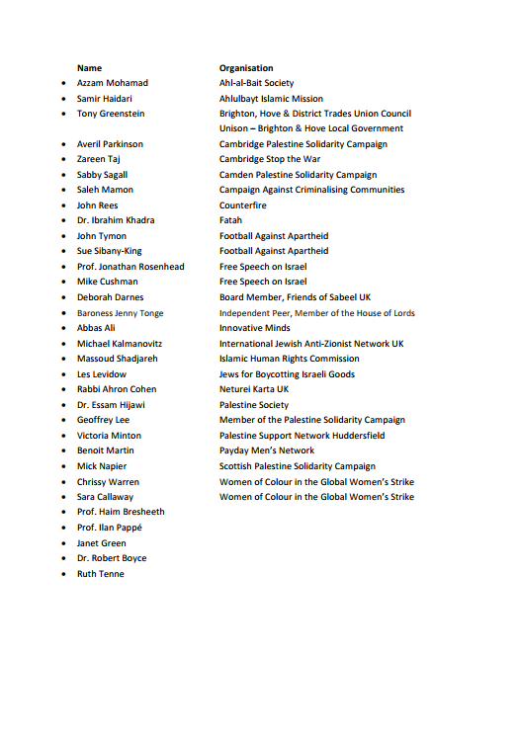
The majority of these signatories were from the Jewish community, including four Jewish professors.

This was the Mayor’s letter of response:

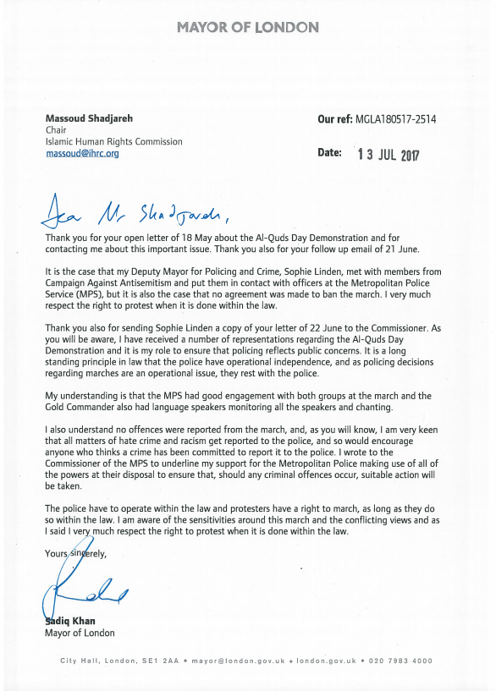

IHRC are also appreciative of the support and publicity via the Al Quds Day billboards in Luton and numerous TV channels that aired the trailer:

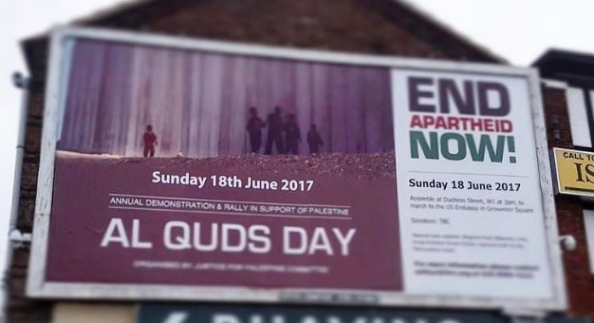
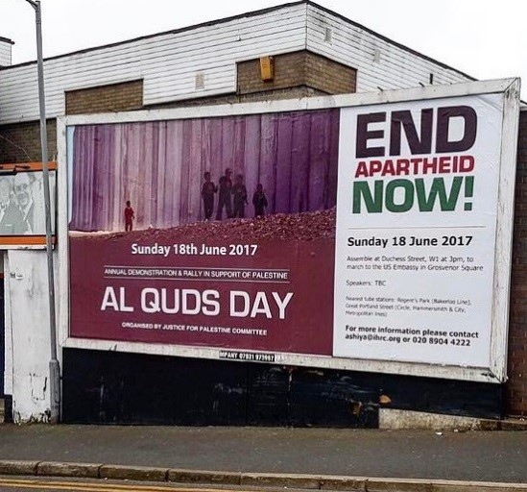

The sun was scorching this Al Quds Day on Sunday 18 June 2017 with temperatures as high 30°C and yet hundreds united in support of the Palestinian struggle and against Israeli apartheid. From all over the UK, fasting Muslims, non-Muslims, students, activists and families of all ages gathered to rally through London to the US Embassy. Coaches packed with demonstrators came from Manchester, Newport, Birmingham, Southend-on-Sea, Crawley, Ilford, Harrow, Glasgow, Nottingham, Bradford, Luton and Watford.

The march started off from Duchess Street through to Regent Street, Oxford Street, New Bond Street and ended at Grosvenor Square outside the American Embassy. As Pro-Palestine demonstrators were walking towards the embassy, bellicose Zionist counter-demonstrators decided to walk in front of peaceful Al Quds Day marchers which inevitably and intentionally incited tensions between the two crowds.

During the march, Al Quds Day marchers stopped in the middle of the streets and sat on the floor to hold a minute’s silence for the survivors, deceased and the injured of the heartrending Grenfell Tower fire. At this point Zionist supporters chose to start dancing in front of the seated demonstrators, making a mockery of what was supposed to be a moment of solemnity. A hypocritical decision considering earlier comments by North London Friends of Israel called for ‘togetherness’ in the light of recent events[1].

A beautiful recitation of verses of the Qur’an were first delivered by Mr Massoomi. Mick Napier from the Scottish Palestine Solidarity Campaign travelled for 5 hours from Edinburgh to speak about the injustices Palestinians have to endure. Napier mentioned it has been 10 years since the siege of Gaza, 10 years of ongoing genocide and 100 years since Britain gave Palestine to European colonialists.
Shaykh Usama Ghani from the USA was next to speak. He summarised in a few words why we gather every year for Al Quds Day: because we are against oppression, state-sponsored terrorism and open air prisons and we want everyone in the USA, in the UK, in Saudi Arabia and Israel to know that we stand for justice. Naomi Wimborine-Idrissi from Jews for Boycotting Israeli Goods spoke about sharing our wishes, as Jewish UK citizen, to see peace and justice in the land of Palestine and Jerusalem, a place that is precious to people of the Christian, Muslim and Jewish faiths. Naomi Wimborne-Idrissi highlighted that Israel’s inhumane siege of the Gaza Strip cannot be allowed to continue and Israel must be held to account for its treatment of Palestinians. Those who speak for Palestine, including Jews are continuously being censored. Furthermore Naomi mentioned leading members of the Conservative party who support Israel because it serves their military and financial interests.

Michael Kalmanovitz from the International Jewish Anti-Zionist Network spoke about Israelis as apologists for the mass murder of women, children, men, land and water theft, house demolitions, mass incarcerations, mass hunger and the forced displacement of thousands of Palestinian people. Furthermore, Michael Kalmanovitz went on to say Israelis are also apologists for the weaponisation of anti-Semitism that has been used to attack Jeremy Corbyn, the left and the boycott movement and to downgrade every other form of racism.

Sandra Wafta from InMinds talked about the horrors of Israeli occupation: through torture and imprisonment. Sandra mentioned that more than 400 children are kept in Israeli prisons where they are abused by the Israeli army. Next to speak was Rabbi Cohen who recognised the importance and unity of Al Quds Day by stating that we in unison are in support of the opposition to the Israeli regime and the tragic occupation of Zionist Palestine and there are thousands gathering similarly all over the world.

Shaykh Bahmanpour also took to the stage, followed by Sara Russell. Sara Russell did the photography at Al Quds Day – astounding photos which truly captured the spirit of harmony, solidarity, peace and justice. Sara also mentioned a future exhibition on Palestine by a Palestinian photographer due to take place at the IHRC Gallery in December 2017. More details will follow in due time.

The penultimate speaker was Shabbir Lakha from Stop the War Coalition. Shabbir delivered an incredibly moving speech about the hypocrisy of the UK government and the continuous oppression of Palestinians. He stated that this was the 38th year Al Quds Day is commemorated internationally and this year specifically is of great significance in relation to Palestine as we have just passed the 50th year anniversary of the Six-Day War and we received atrocious coverage by the UK media. Outlets such as the BBC mentioned it as if it was a heroic victory with zero mention of the illegal occupation of the entirety of Palestine and of 150,000 Palestinians being expelled from their own land.

In addition, Shabbir discussed the 100th year of the Balfour Declaration will be later this year, which he described as a ‘shameful moment of British history where the foreign secretary pledged to the Zionist federation that he would build a Jewish homeland in Palestine… [which] directly contradicted the promise they made to Palestine 2 years prior in the same McMohan Correspondence.’ Shabbir expanded on the hypocrisy of the British government whereby the government supplies weapons to Israel so they can bomb and gun down innocent Palestinians using white phosphorus and chemical weapons which are illegal. Shabbir mentioned this is the same government that let Grenfell Tower burn. Furthermore, despite such challenges Shabbir remained positive, stating that with the recent election, the political landscape has clearly shifted with Jeremy Corbyn’s achievement in the biggest electoral slide since 1945 – Corbyn being someone who is a lifelong supporter of the Palestinian cause and who has also spoken at Al Quds Day several times in the past. Shabbir went on to say regarding the Labour manifesto, that it has explicitly pledged to immediately recognise the state of Palestine, and to condemn and oppose the occupation and the siege of Gaza and to commit to actual, meaningful negotiations. Shabbir ended with stating that we have truth and resilience is on our side, ‘learnt by the Palestinian people who continue to stand against oppression.’

Last to speak was Massoud Shadjareh, Chair of the Islamic Human Rights Commission. Massoud Shadjareh highlighted that whomsoever speaks about the atrocities committed by the Israeli government and the illegal occupation of Palestine are wrongly demonised as anti-Semite or terrorist and that we are only interested in justice, nothing else. Furthermore, Massoud stated that these are the last days of Zionism as the world has woken up to the systematic oppression.

The success of Al Quds Day 2017 was greatly due to the tenacity of Nazim Ali who led hundreds of peaceful demonstrators to the US Embassy.

After Al Quds Day, the importunate vilification from Zionists did not cease. Over 30 articles had been written before, during and after the event and about a third of the articles were written in Israel, all of which consistently called for bans of the internationally commemorated Al Quds Day.

IHRC believes the impact of the demonstration – whether or not it receives resistance – is a positive indication that people strongly aspire for the freedom of Palestine and are fervently resisting illegal occupation. A video has been produced to look at the increasingly hostile campaign against Al Quds Day

This struggle will continue and we are already in conversation with the Metropolitan Police with regards to next year’s event.

