Palestine Legal
October 20, 2016
http://palestinelegal.org/news/2016/9/19/uc-berkeley-reinstates-course-on-palestine

UC Berkeley Reinstates Course on Palestine
October 20, 2016
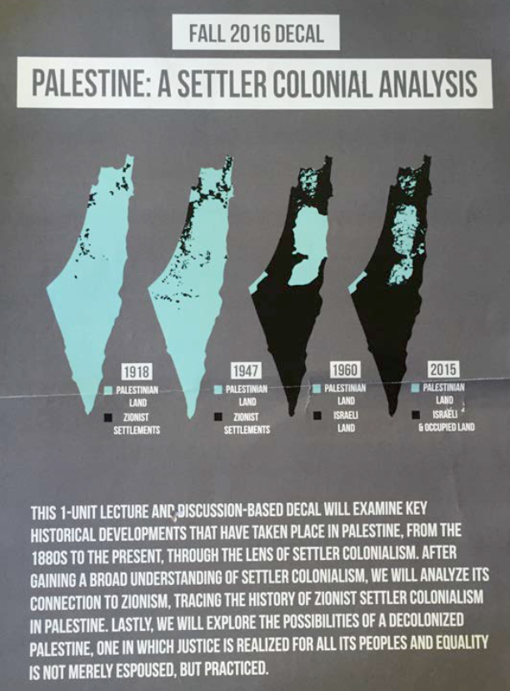
"Palestine: A Settler-Colonial Analysis" course poster

Updated October 20
One month after suspending, and then reinstating a student-led course on Palestine, the university has taken no action to repair the damages to the educational environment. Palestine Legal wrote to the university again on October 18, 2016 to demand the university apologize and remedy the rights violations. The letter explains,
"Mere reinstatement of the course is insufficient without further steps to remedy the harms done, and we request that the university take several immediate actions, including apologizing to Mr. Hadweh and issuing written clarifications to applicable university policies."
The full letter is available here.
University of California Berkeley (Cal) reinstated a student-led course on Palestine this morning following an outcry over its arbitrary suspension last week. The suspension, taken in apparent response to pressure from Israel advocacy groups, was widely condemned -- by students, professors, and observers -- as a violation of academic freedom, shocking, and unjustifiable.
Palestine Legal sent a letter to Cal Chancellor Dirks Friday, on behalf of Paul Hadweh, the student facilitator, warning that the suspension infringed on First Amendment rights and principles of academic freedom. The letter demanded immediate reinstatement and an apology to the students.
Executive Dean of the College of Letters and Science, Carla Hesse, announced in a statement that the course is reinstated.
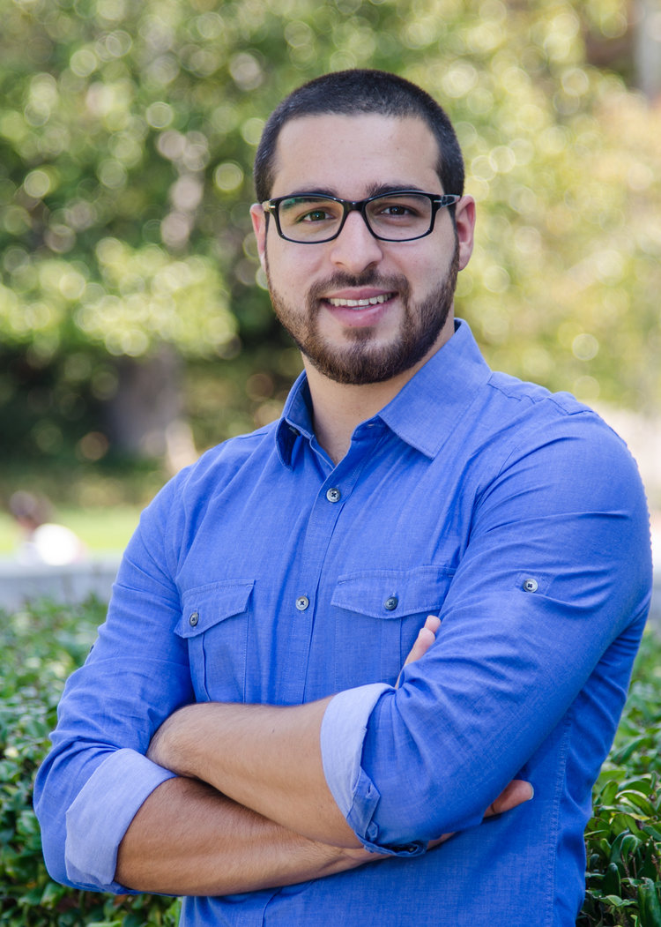
Paul Hadweh, student facilitator of the course "Palestine: A Settler-Colonial Analysis"
“I hope we can now focus on the challenging intellectual and political questions that this course seeks to address,” said Paul Hadweh, the course facilitator and Cal senior whose family is originally from Bethlehem.
“I await an apology from Chancellor Dirks, and Dean Hesse,” explained Hadweh. “The university threw me under the bus, and publicly blamed me, without ever even contacting me. It seems that because I’m Palestinian studying Palestine, I’m guilty until proven innocent. To defend the course, we had to mobilize an international outcry of scholars and students to stand up for academic freedom. This never should have happened.”
Liz Jackson, staff attorney with Palestine Legal who represents Paul Hadweh, added, “This is a victory for Paul who spent 8 months going through all the recommended and mandated procedures to facilitate a course. It’s also a victory for the 26 students who enrolled and had their academic studies severely disrupted, and for students and scholars across the U.S. who are facing a coordinated attack on the right to speak and study freely about Palestine-Israel.”
Echoing the concerns of Israel advocacy groups, Cal Chancellor Nicholas Dirks had justified the suspension with concern that Hadweh’s course “espoused a single political viewpoint and appeared to offer a forum for political organizing.”
Jackson explained, “The university’s response should have been that academic freedom protects the rights of faculty and students to tackle difficult and even controversial questions. The extra scrutiny on scholarship relating to Palestine is obvious here. The university does not censor Israeli studies classes because they have a ‘political agenda’ or ‘ignore history’, although that case can also be made.”
For more reading on UC Berkeley:
Open Letter to the UC Berkeley Administration Regarding Academic Freedom From Every Student of Ethnic Studies 198
UC Berkeley’s ban on Palestine course ‘McCarthyist’
UC Berkeley Suspends Class on Colonialism in Palestine
UC Berkeley reinstates Palestine course, but tried to change content
Berkeley’s Choice To Nix Palestinian Course Disgusts Me as a Jewish Alum

