Palestine Solidarity Campaign
September 15, 2016
https://www.palestinecampaign.org/events/contesting-visualization-gaza/

Contesting the Visualisation of Gaza
Posted on September 15, 2016
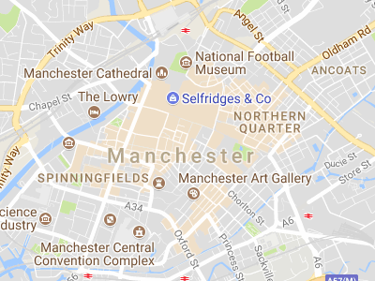
Friends Meeting House
Mount Street - Manchester
Details

Date
15/09/2016
7:00 pm - 9:00 pm
Location
Friends Meeting House
Mount Street
Manchester

Was the mainstream media biased towards Israel? Did they present photographs of Palestinians as both a political and social “other”?
Anandi Ramamurthy will examine whether the BBC used photographs of “Operation Protective Edge” to support an Israeli PR agenda. She will also look at how Palestinians and their supporters used photographs on social media and at public demonstrations to challenge the corporate media’s control over the visual mediation of the bombing.
Anandi Ramamurthy is Senior Lecturer in Media at Sheffield Hallam University. She has written extensively on race, imperialism and representation, and is the author of Imperial Persuaders: Images of Africa and Asia in British Advertising and Black Star: Britain’s Asian Youth Movements.
