Seminar Teaches IDF Officers How to Protect Gaza’s Civilian Population in Combat Situation
IDF Blog
July 17, 2013
http://web.archive.org/web/20151119151332/https://www.idfblog.com/blog/2013/07/17/seminar-teaches-idf-officers-how-to-protect-gazas-civilian-population-in-combat-situation/

You’re an officer in a battalion running a ground operation in the Gaza Strip. A hospital in the middle of Gaza City calls to say a Palestinian woman needs to be evacuated immediately from the city in order to save her life. You are responsible for the area. What do you do?
Thirty-five officers from a variety of IDF brigades and battalions learned how to handle this situation, and numerous others, in a seminar run by the Coordination and Liaison Administration (CLA) for Gaza today. The officers had already passed a week-long course run by the School for Coordination and Liaison Affairs, which trained them for a variety of coordination and liaison tasks vis-à-vis the Palestinian civilian population.
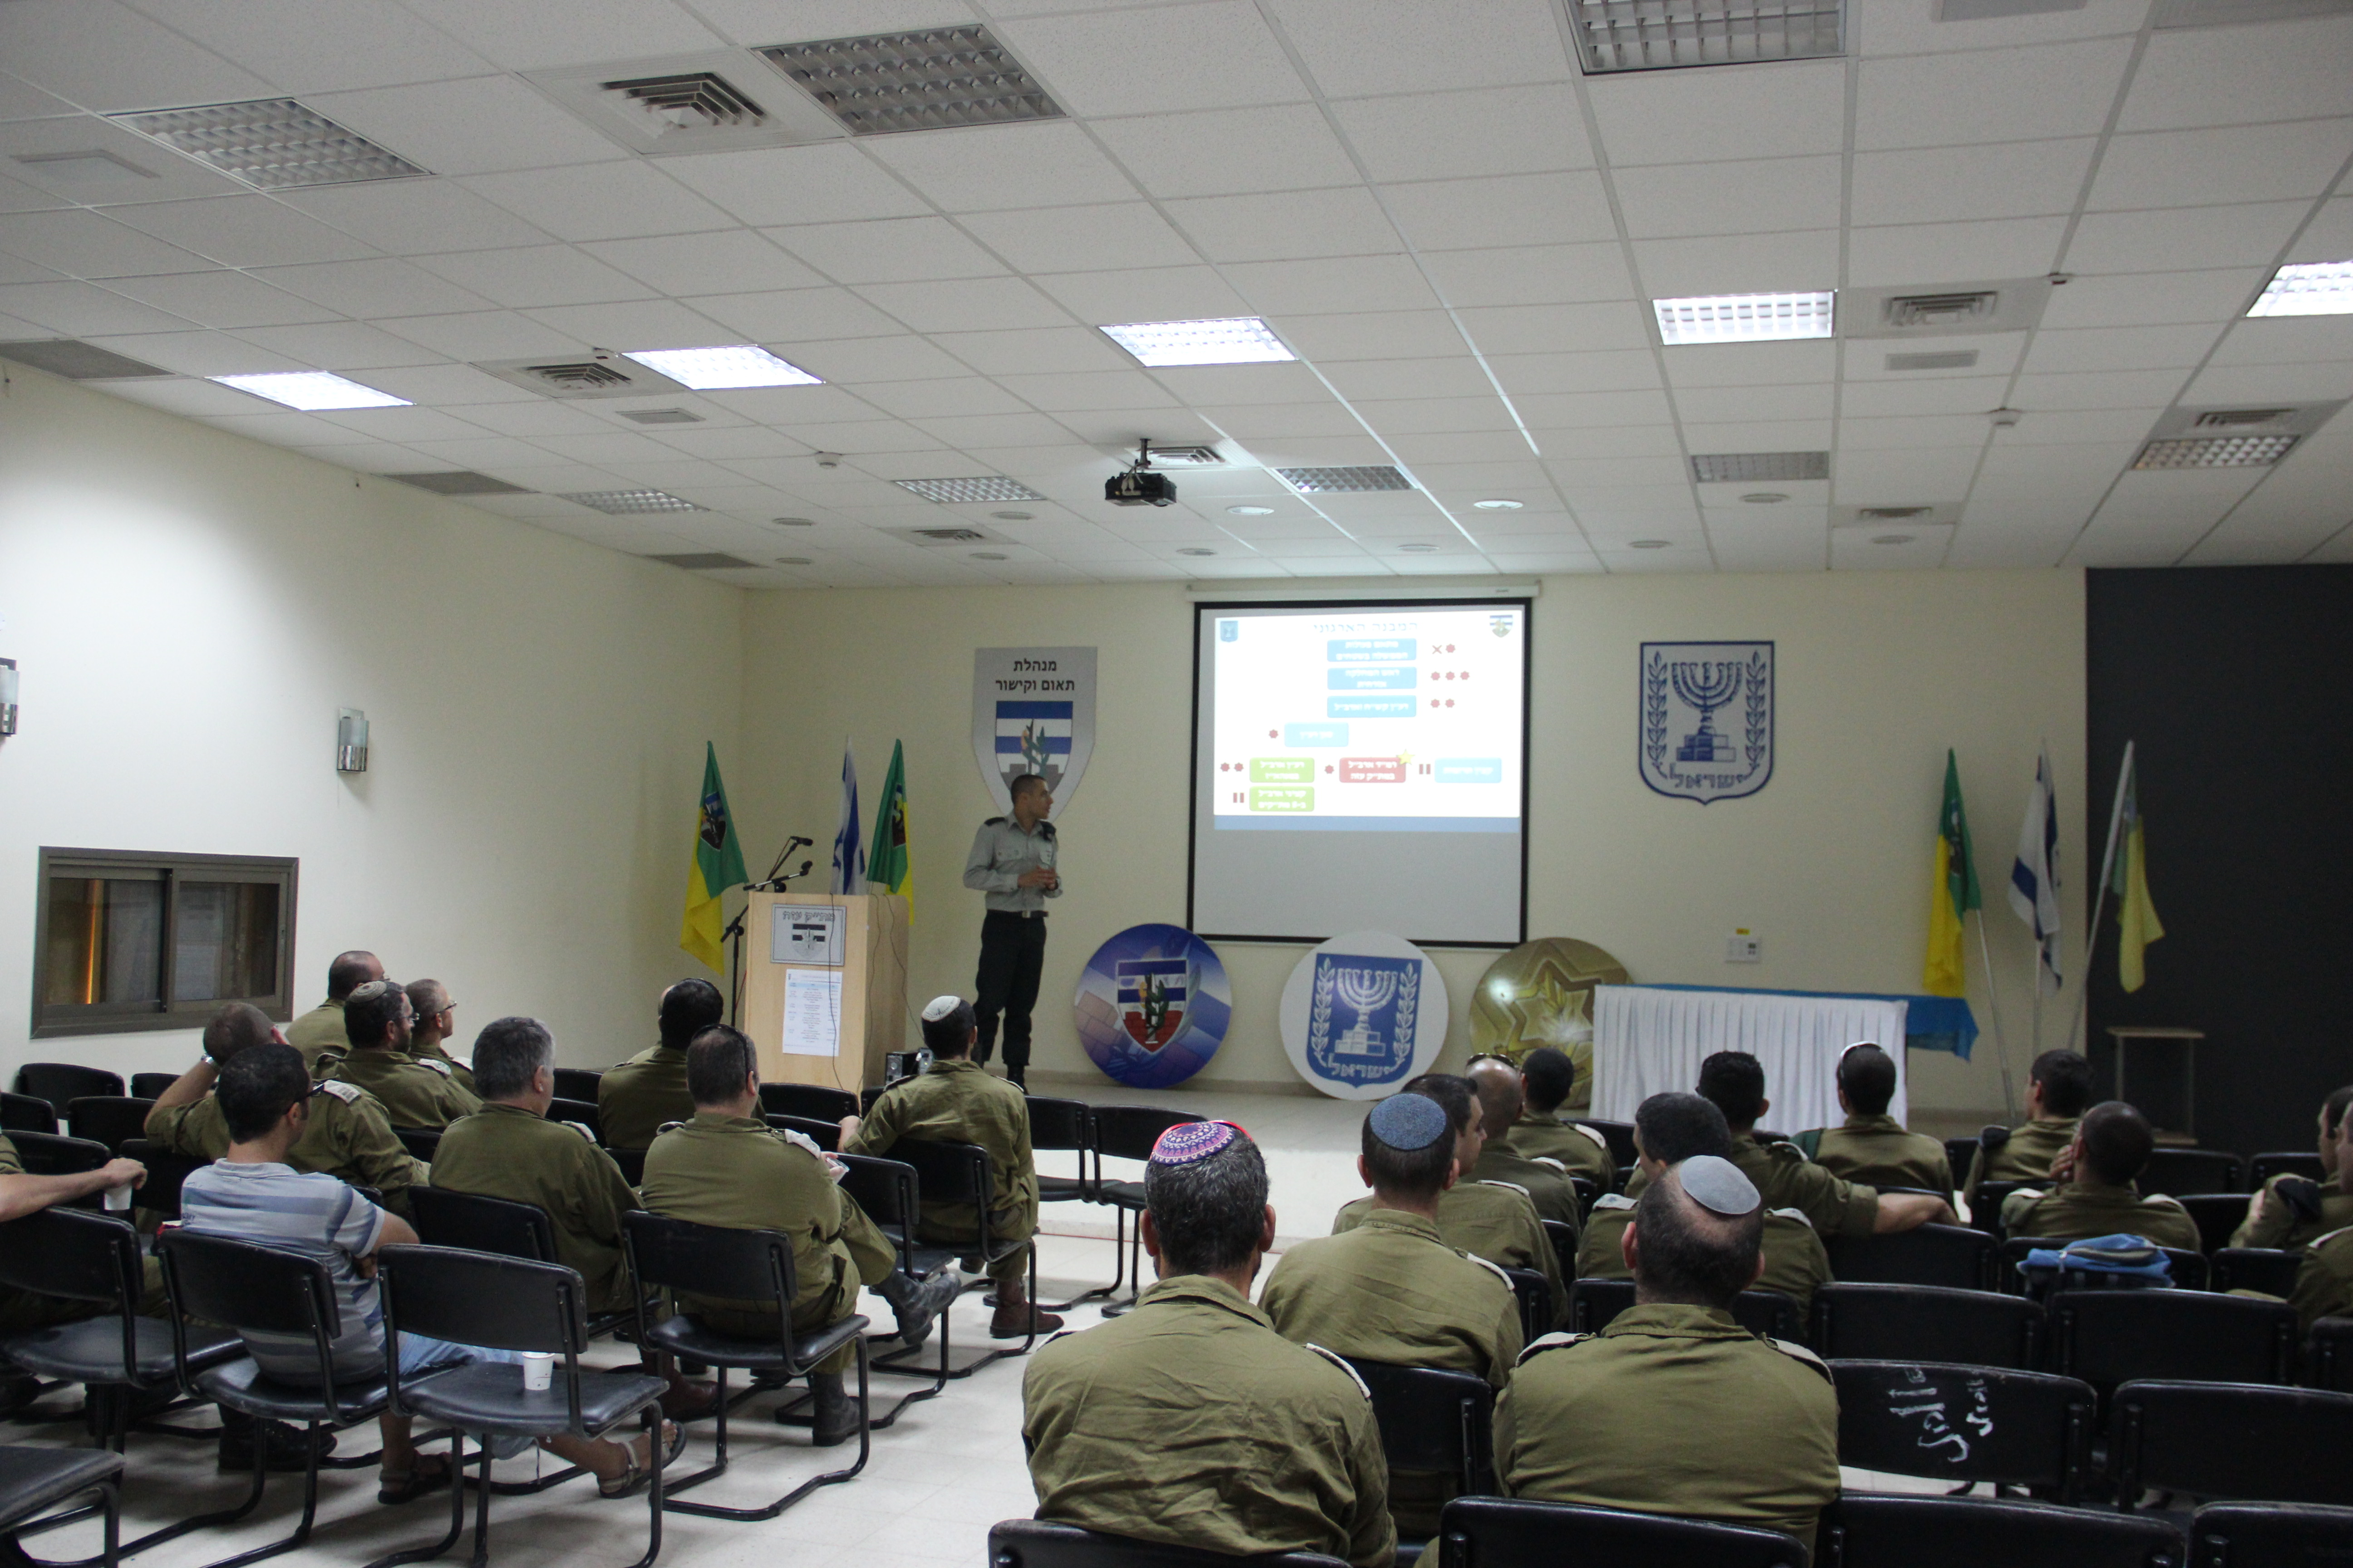
“The purpose of this day is to close a circle and connect them to the operational arena,” said Maj. Eyal Dror, Deputy Head of the Gaza CLA’s Operations Division. “Our goal is to make them familiar with us and what we do – we are in charge of the civilian effort during combat in the Gaza Strip in any possible scenario.”
These officers are tasked with an enormous responsibility: to protect Palestinian civilians on the ground, no matter how difficult that may be.
“During an operation, these officers are in charge of evacuating the wounded, finding shelter for refugees, coordinating representatives of international organizations who want to visit a specific area, and assisting and treating innocent bystanders,” Maj. Dror said. He explained that the officers work with the understanding that taking care of the civilian population also contributes to the IDF’s operational effort, and gives IDF forces the legitimacy to continue their operations.
The seminar is designed to help turn the theory that the officers learn into practical, useful information.
“We talk about what is required of the officer when he is operating in the field, and how I can help him as commander in charge – for example, giving him relevant information about the civilian population in the area where his battalion is operating,” said Maj. Dror. “We also talk about how to deal effectively with international organizations operating in Gaza – for example, how to ensure that an ambulance that needs to leave from Gaza City in order to evacuate a wounded person can do it as fast as possible in order to prevent her condition from worsening. Another important topic is warning civilians in the area if you are about to undertake an operation so that no bystanders are harmed.”
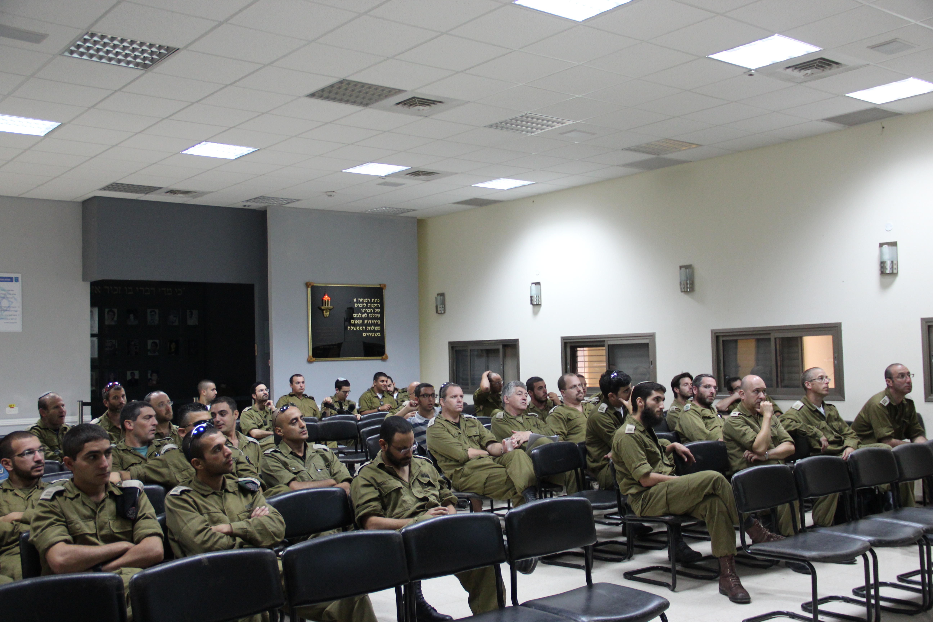
The seminar equips participants with a wealth of practical details and background information. including facts and figures about the area, highly advanced maps of civilian populations in the Gaza Strip, how to deal with prisoners in Arabic and the locations of clinics.
The goal is simple, Maj. Dror explained: to make sure not to harm the civilian population during an operation.
“We know that the enemy – Hamas and other terror organizations – understands that the IDF is an ethical army, and therefore they fight from within the civilian population in order to make our work more difficult,” he said. “The enemy wants us to shoot at hospitals and schools, and hurt innocent bystanders, in order to put international pressure on us.”
He emphasized the importance of training in achieving this objective. “At the end of the day, our challenge – as the people who are responsible for issues relating to the civilian population of Gaza – is to explain to the army how important it is not to injure civilian bystanders, and if a bystander is injured by mistake, how important it is to evacuate her to a hospital as quickly as possible.”
Seminar participant Cpt. (res.) Shela Katz, married with five children, is the director of International Studies at Givat Washington College, and serves in the IDF reserves as a civilian population officer in the Negev Brigade. “Today, in combat, especially in a populated area like the Gaza Strip, [taking care of] humanitarian needs helps the operation in a time of emergency,” he said. “The role of the civilian population officer is an essential one, because the success of a military operation depends on the humanitarian situation.”
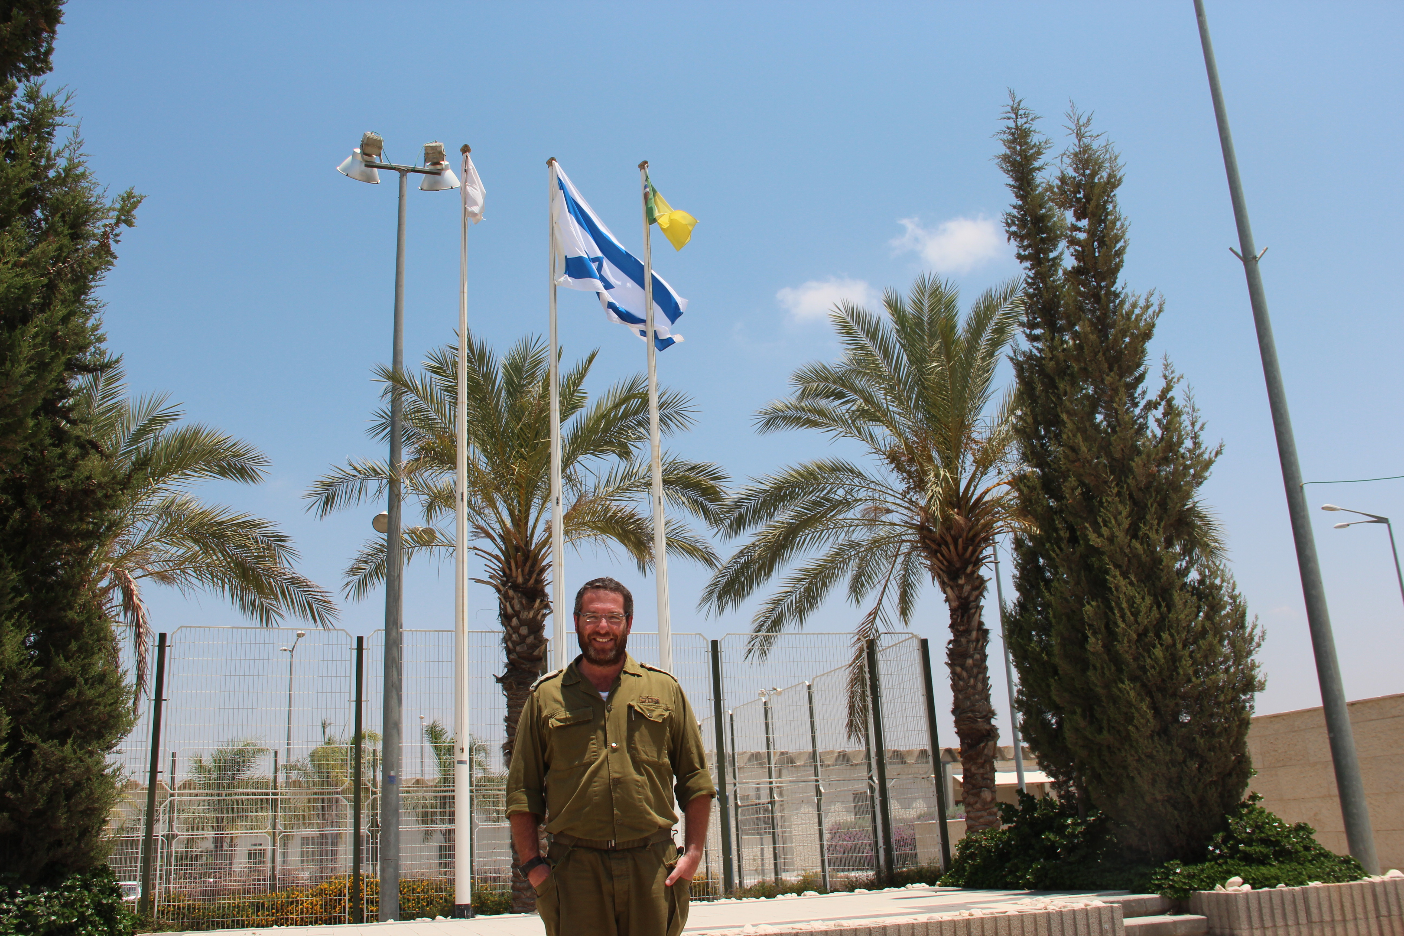
Cpt. (res.) Shela Katz at the seminar today
All of the officers who attended the seminar were extremely positive about it, Maj. Dror said. “They understand the responsibility that they hold, and they understand that the opportunity to learn how we operate is critical in ensuring that our efforts [to protect the civilian population] are successful.”

