NGO Action News
April 7, 2017
https://unispal.un.org/ngoactionnews.nsf/1c0b3ab87dc4f2f8852568f8007759fd/b891297341a80e82852580fb007b4432?OpenDocument

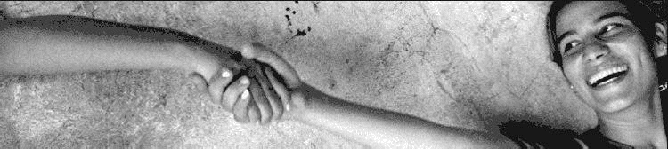
NGO ACTION NEWS
Global

• On 21 April, Pax Christi International - the International Catholic Peace Movement - is organizing in Brussels a discussion on “Nonviolence: A Style of Politics for Peace”. The event follows a panel discussion held at the UN in New York on 2 March.
• Linking the Jewish feast of freedom to the need to end the occupation, the Israel-Diaspora Initiative “Save Israel. Stop the Occupation” (SISO) has published a Jubilee Haggadah – the text guiding the Passover Seder meal – with contributions from 30 Jewish authors from throughout the world in English and Spanish while Jewish Voice for Peace (JVP) is offering a Liberatory Passover Haggadah
• On 3 April, Human Rights Watch issued a report setting out the implications of movement restrictions on the ability of human rights organizations to document alleged violations of international human rights and humanitarian law in the Gaza Strip (“Unwilling or Unable – Israeli Restrictions on Access to and from Gaza for Human Rights Workers”).
• On 30 March, the Housing and Land Rights Network of Habitat International issued its Land Times issue 15 with a focus on the efforts of civil society organizations to develop both local and global norms and practices on the basis of the right to adequate housing and other human rights related to natural resources.

Middle East

• Hamoked-Center for the Defence of the Individual has published a time line setting out developments regarding the Wall and its associated permit regime from the time plans to build a West Bank wall were first devised in the 1990s till March 2017 (“The Permit Regime in the ‘Seam Zone’ – Time Line”).
• To mark World Health Day on 7 April, Al Haq issued a statement drawing attention to the impact of closure policies on the rights of patients to access urgently needed medical treatment.
• On 6 April, the Palestinian Center for Human Rights (PCHR) issued a statement condemning the execution of three men in Gaza, accused of collaborating with Israel (“Justice is Indivisible: Extra-judicially Applying Death Sentences will not Lead to Justice and Security”).
Europe
• From 15 May to 3 July, Medical Aid for Palestine (MAP) is calling for 50 Days of Action to mark 50 years of occupation.

North America
• As part of the Obliterated Families Project, from 2 April to 10 May, the American Friends Service Committee (AFSC) is sponsoring a US speaking tour with photojournalist Anne Paq and journalist Ala Qandil, who are working to highlight the stories of people in Gaza. Speaking engagements in New York are planned on 12 and 14 April.
• On 6 April, the US Campaign for Palestinian Rights issued a policy paper entitled
“Moving the US Embassy to Jerusalem: Historical, Legal and Policy Considerations”.
• On 31 March, the Australian Friends of Palestine Association (AFOPA) announced the results of commissioned researched on Australian attitudes toward Palestine and Israel (“New Polls Show Australians want Real Action on Palestine”).

