US Campaign for Palestinian Rights
April 6, 2017
https://uscpr.org/will-trump-move-embassy-jerusalem/

Will Trump Move the Embassy to Jerusalem?

The Trump administration is still giving “serious consideration” to moving the US Embassy to Israel from Tel Aviv to Jerusalem.
And the decision to do so could be coming soon. In 1995, Congress passed the Jerusalem Embassy Act, which mandates an embassy move unless the president signs a waiver every six months declaring that doing so would harm national security.
For the past 22 years, Presidents Bill Clinton, George W. Bush and Barack Obama signed the waiver and kept the US Embassy in Tel Aviv.
And for good reason. Moving the embassy would be tantamount to recognizing Israeli sovereignty over Jerusalem, an act which would legitimize Israel’s ethnic cleansing of Palestinians from West Jerusalem in 1948 and its denial of Palestinian refugee rights.
It would also legitimize Israel’s violations of international law in East Jerusalem since 1967, including demolishing Palestinian homes and building illegal settlements.
The most recently signed waiver expires at the end of May, after which the president will have to decide whether to extend it or begin the process of moving the embassy to Jerusalem—one of his signature campaign pledges.
Today we’re releasing a policy paper, Moving the US Embassy to Jerusalem: Historical, Legal, and Policy Considerations, detailing the seven-decade-long bipartisan policy of not recognizing Israeli sovereignty over any portion of Jerusalem and laying out the case for why moving the embassy would be a grave mistake.
Click here or on the picture below to read the report.
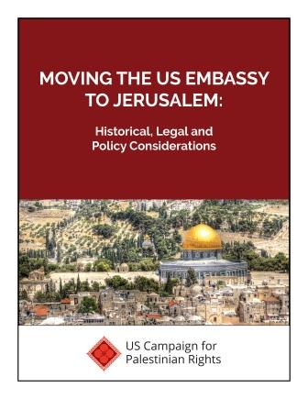
Did you know?
• The Truman administration wrote a detailed plan for the internationalization of Jerusalem
• The Nixon administration determined that East Jerusalem is under Israeli military occupation
• The Obama administration successfully argued before the Supreme Court that Congress cannot force the president to recognize Jerusalem as Israel’s capital
These are just a few of the many interesting facts we dug up from the archives and declassified documents. Check out the policy paper to learn more about why every president since 1948 has refused to move the US embassy to Jerusalem.
And please share the policy paper on Facebook and Twitter.
We also hope you’ll use this policy paper to:
• Send to the editorial board of your local newspaper to ask for an editorial opposing moving the embassy
• Write letters-to-the-editor and op-eds for your local paper opposing the move
• Send to your Members of Congress to ask them to make statements opposing the move
Thanks for checking out our policy paper.
Sincerely,

JOSH RUEBNER
Policy Director
P.S.: We’re also excited to launch this new and improved, interactive Congressional scorecard. Find out how your Members of Congress ranked on major pieces of legislation related to Israel and the Palestinians in the previous Congress. And stay tuned for the upcoming release of a scorecard for the current Congress.
P.P.S: If you appreciate our publication of these educational resources to raise awareness about Palestinian rights, then please consider making a tax-deductible contribution today to support our work.

