US Campaign for Palestinian Rights
September 8, 2017 (accessed)
https://uscpr.org/campaigns/50actions/

Enough! Week of Action June 5-10!
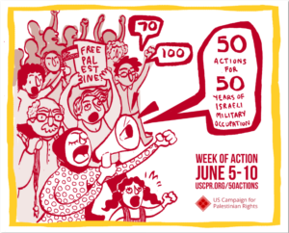2017 marks 10 years of Israel’s blockade of Gaza; 50 years of Israel’s military occupation of Gaza and the West Bank, including East Jerusalem; 70 years since the Nakba and ethnic cleansing of Palestine began following the partition of the land against the will of the indigenous people; and 100 years since the Balfour Declaration, which set the stage for the Zionist movement to colonize Palestine and later to establish a Jewish state.
During the June 5-10 week of action, from coast to coast, in the midwest, and in the south, groups were #Marking50, calling for an end to Israel’s occupation and all forms of its ongoing ethnic cleansing of Palestine as part of a commitment to justice for all Palestinians, whether in historic Palestine or in exile.
Read our report on the week here.
Israel’s actions since 1967 make clear that the occupation was never meant to be temporary. It is not an aberration. It is the latest extension of Israel’s ethnic cleansing and subjugation of Palestinians, which continues to this day.
The week of action was a response to a call from Palestinians to send a clear message: Enough is enough and Israel must end all its oppression of Palestinians for freedom, justice, and equality to prevail.

