US Campaign for Palestinian Rights
June 16, 2017
https://uscpr.org/what-a-week/

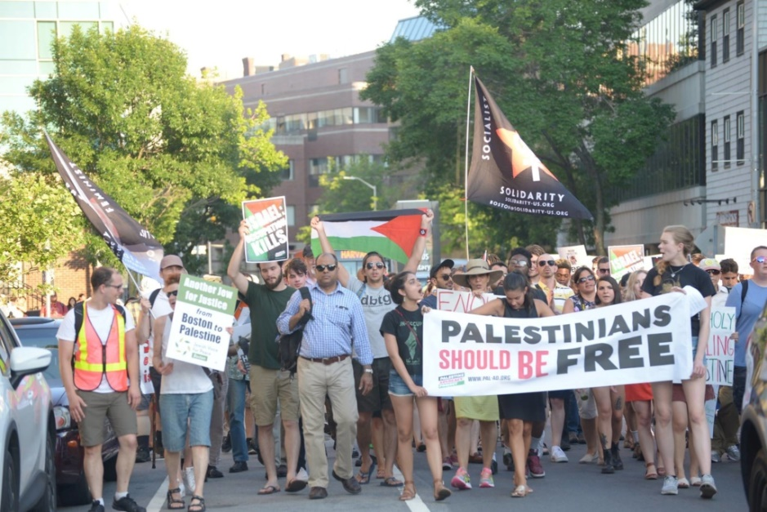

16 JunWhat a week

- Written by Ramah Kudaimi
- Categorised Action Alerts

The occupation is now a half century old, and people are saying ENOUGH!
During the June 5-10 week of action, from coast to coast, in the midwest, and in the south, groups were #Marking50, calling for an end to Israel’s occupation and all forms of its ongoing ethnic cleansing of Palestine.
The actions were diverse, creative, and inspiring, catering to the unique context of each location. Check out our new online album of week of action images!
Chico, CA NYC Portland, ME
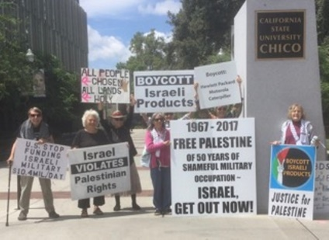 | 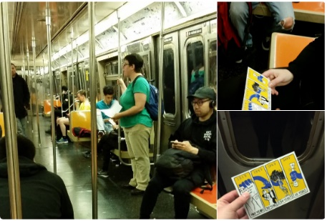 | 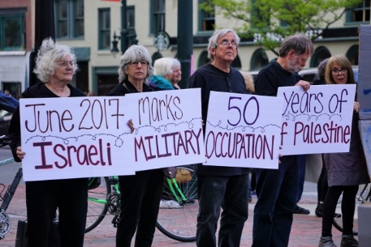
Here is a sampling of the more than 50 actions that occurred:
Demonstrations and rallies took place in Hilton Head, SC; Ashland, OR; Wilmington, DE; Santa Fe, NM; Tucson, AZ; Philadelphia, PA; San Francisco, San Mateo, and Santa Cruz, CA; Greenfield, MA; Washington, DC; and many other cities. In Cambridge, MA, 250 people shut down a major street for an hour.
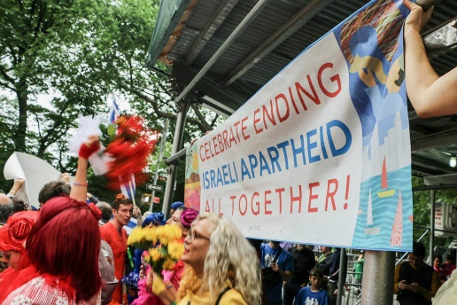
There were six demonstrations in the state of New York alone, including a series of creative direct actions by member group Jewish Voice for Peace disrupting the Celebrate Israel Parade in Manhattan and calling out the Israeli-NYPD #deadlyexchange; while in Brooklyn, activists from Librarians and Archivists for Palestine read Palestinian poetry on the subway to honor Palestinian life.
Two member groups fasted and held a solidarity iftar (breaking of the fast).
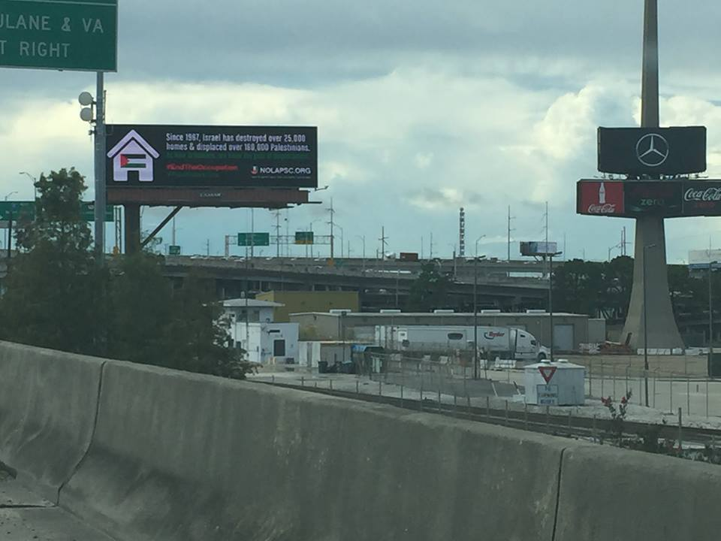
In Boston and New Orleans, member groups put up educational billboards to reach the masses, while members in Columbia, MO and Richmond, VA published articles for the local media while USCPR Executive Director Yousef Munayyer published this piece in The New Yorker.
During a powerful Congressional briefing in Washington, DC, member groups in Chicago gathered for a watch party! Meanwhile, groups in Missouri, Maine, and Washington, D.C. met with Members of Congress.
Educational events and workshops were held by groups in Wichita, KS; St. Louis, MO; Durham, NC; Knoxville, TN; Northfield, MN; Austin, TX; Madison and Wausau, WI; Richmond, VA; Albany, NY; Los Angeles and Chico, CA; and beyond!
Amnesty International launched a major new campaign; churches nationwide have been passing resolutions and becoming HP-free; Kairos-USA launched a new online portal, and the US Campaign kicked off its 2017 political education curriculum, Together We Rise: Palestine as a Model of Resistance.
Here is an online album of images from these creative actions!
Hats off to the amazing work of all the groups who took part in #Marking50. Together we show the growing opposition to Israel’s occupation and apartheid regime, and the broad support for freedom, justice, and equality for the Palestinian people.

