The Situation of the Children of Palestine – Conditions, Legal Issues and Possible Actions
By: Odile Hugonot Haber
Women’s International League for Peace and Freedom
Undated
https://wilpfus.org/news/updates/situation-children-palestine-%E2%80%93-conditions-legal-issues-and-possible-actions

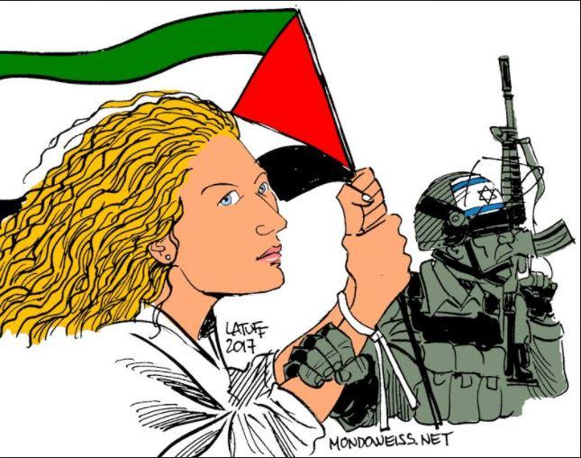

Postings have been circulating on Facebook, and articles online around the world, about the plight of Ahed Tamimi, a sixteen-year-old Palestinian girl who lives in the West Bank. She has been imprisoned by the Israelis, along with her mother and other members of her family. Accounts state that more than two dozen Israeli soldiers engaged in a raid on the family home around 3:00 am one morning, pounding on the front door until it was opened by Ahed’s father. The soldiers then took the child away without allowing anyone from the family to accompany her. Her mother was arrested later that day, when she went to visit Ahed in prison.

Ahed is not, by far, the only Palestinian child in the West Bank who has been taken by the Israeli military and imprisoned under Israeli military law, which is the law being used to prosecute these children and, in fact, all Palestinians in the West Bank. The reason for Ahed’s arrest appears to have been due to Israeli government embarrassment when, frustrated and angry with the military lobbing tear gas cannisters at her family’s house and injuring a member of her family (who remains in a hospital in a coma), Ahed reached out and slapped an Israeli soldier. That slap was captured on video and has been seen around the world. Ahed was arrested in the middle of the next night.

There is a United Nations Convention on the Rights of the Child that has been in place since 1990, which Israel has been ignoring with impunity since that time, despite UN Member States obligation to conform to its proscriptions in all actions regarding children within each State.

However, according to the website of Defense for Children International (“DCI”), the following conditions have existed and still exist today, with regard to the treatment by Israel of Palestinian children in “the Occupied Palestine Territory:”

“Since 1967, Palestinian children in the Occupied Palestinian Territory have been living under Israeli military law and prosecuted in military courts.”

“In the West Bank, there are two separate legal systems operating in the same territory. The sole factor in determining which laws apply to a person is his or her nationality and ethnicity.”

“Israeli military law, which fails to ensure and denies basic and fundamental rights, is applied to the whole Palestinian population. Israeli settlers living in the West Bank are subject to the Israeli civilian and criminal legal system.”

“Israel is the only country in the world that automatically prosecutes children in military courts that lack basic and fundamental fair trial guarantees. Since 2000, at least 8,000 Palestinian children have been arrested and prosecuted in an Israeli military detention system notorious for the systematic ill-treatment and torture of Palestinian children.”

“Around 500-700 Palestinian children are arrested, detained and prosecuted in the Israeli military court system each year.”

“The majority of Palestinian child detainees are charged with throwing stones, and three out of four experience physical violence during arrest, transfer or interrogation. No Israeli child comes into contact with the military court system.”

How and why does this happen?

It appears that, simply because they can do so with impunity, the Israeli government and military arrested this child because their authority and actions were put under scrutiny and they were embarrassed by this girl’s slap of an Israeli soldier who had been part of a group attacking her family and home.

“Ahed Tamimi Has Become the Symbol of a New Generation of Palestinian Resistance,” shouts the headline of the article by Ben Ehrenreich dated December 24, 2017, on The Nation magazine’s website, with this subheading, “It would be far better, however, if she could just be a child.”

It explained that she lives in the West Bank, in the village of Nabi Saleh, next to the settlement of Halamish. Several years ago, when the nearby Israeli settlers confiscated a spring that runs in the valley and had been giving its waters to the village nearby, many people from the villages started an unarmed resistance. The Israeli border police came in and disbanded the group marching and her cousin Mustafa Tamimi was shot in the face and killed by a tear gas cannister fired from the back of an Israeli vehicle.

Resistance from the village and aggressions by the Israelis had gone on for more than three years when, suddenly, recently, and captured on video, this girl child was shown slapping an Israeli soldier twice, embarrassing the Israeli military and government as the video went viral around the world. Ahed was then arrested on December 20, along with her mother and cousin, Nour, and is characterized as “very defiant,” even though she endured numerous attacks and incursions into her family life, the deaths of her uncle and cousin, and other attacks involving family, friends and neighbors.

Read the full article here. If you have access to the website for Haaretz, read the open letter from Ahed’s father, Bassem, to his daughter, written as an Opinion piece, dated December 29, 2017.

There are several petitions, including the one at this link, to protest this treatment of Ahed and other Palestinian children at the hands of the Israeli military.

In addition to the alleged international protections under the United Nations Convention on the Rights of the Child, one of our own Members of the House of Representatives has introduced legislation focused on this unacceptable situation regarding children in Palestine. The bill is H.R. 4391, Promoting Human Rights by Ending Israeli Military Detention of Palestinian Children Act. Information about this newly-introduced legislation, including its full text, is available here. It is sponsored by Representative Betty McConnell (D-MN), and as of December 29, 2017, there are 19 co-sponsors.

This bill prohibits US assistance to Israel from being used to support the military detention, interrogation, or ill-treatment of Palestinian children in violation of international humanitarian law (the UN Convention on the Rights of the Child, for instance) or the use against Palestinian children of:

torture, inhumane, or degrading treatment;
physical violence or psychological abuse;
incommunicado or administrative detention;
solitary confinement;
denial of parental or legal access during interrogations; or
force or coercion to obtain a confession.
Please contact your Member of Congress:

See contact information here.
Check the list of co-sponsors here.
If your Member of Congress is a co-sponsor, thank them!
If your Member of Congress is NOT a co-sponsor, ask him or her to co-sponsor H.R. 4391.
In either case, we ask you to ask your Member of Congress to reach out to the State Department to intercede with Israel to ask for this child, Ahed Tamimi, to be released from jail, and for her mother Nariman, and her cousin, Nour, to be released, too.
Middle East Committee Monthly Meetings

The Middle East Committee is re-establishing a standardized monthly call schedule, beginning January 2018. Based on response from the members on the Middle East listserv, it looks like the calls will be Thursday evenings, either the first, third or fourth Thursday of the month. The calls will likely begin at 5:00 pm Pacific / 8:00 pm Eastern time and will be scheduled for one hour.

Members from branches and at-large members who are working on disarmament and end-wars related issues are warmly invited to join us on these Middle East Committee conference calls, to find out more about our Section-wide actions and strategies. Share what you are doing in your community and help us strategize how to best move forward in 2018.

We hope branches will each have at least one member participating in our committee calls each month, so that we can expand our effectiveness throughout the Section and build community. If you are an At-Large member, we hope your participation in our committee calls will help you in your local activism, as well as help you organize WILPF members in your community to establish first a group, and then a local branch!

To make sure you receive notice of the calls, especially if you are not sure whether you are already on the Middle East Committee email list (listserv), please send an email to a Middle East co-chair (below). Please let us know your branch or group or, if you have no branch or group, your city/town and state, and your telephone number. If you have a Thursday evening preference, you could let us know that, too, and we will do our best to accommodate.

Contacts: Middle East Issue Committee Co-Chairs: Odile Hugonot Haber (Ann Arbor branch) (odilehh@gmail.com) and Barbara Taft (Phoenix, Arizona branch) (beejayssite@yahoo.com).

